Downloading your WebCT Vista Grade book
Instructions for faculty at UMass Boston

UMassOnline recommends that you download the student grade book to your desktop computer or storage device for all active online courses at least once a week. Following this important step will protect you as well as your students in the event of a grade challenge.

Follow the instructions below to download your course grade book.

Select Teach Tab view

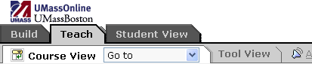

Next, select Grade Book

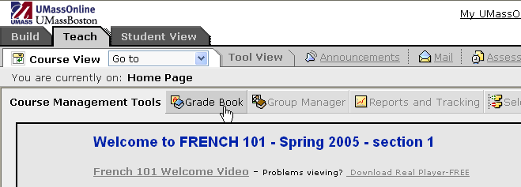
Grade Book

In Grade Book, click Export to Spreadsheet button.

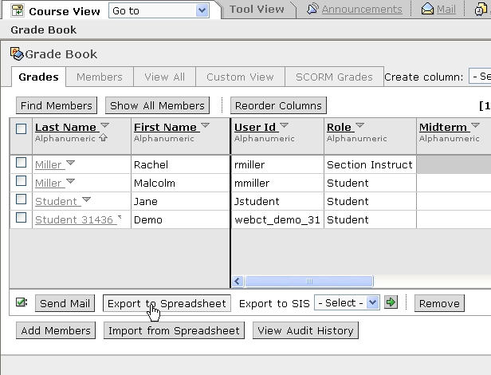
Export to Spreadsheet

From Export to Grade Book page, select All columns radio button, located below Columns to Export.

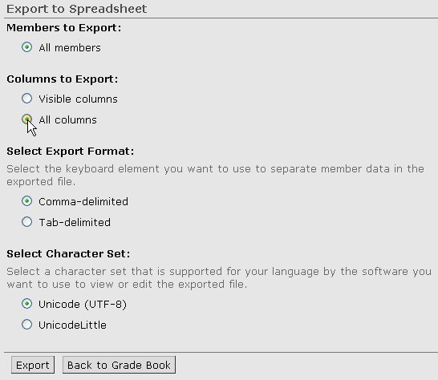
Select All columns radio button

Next click Export.

Click Save at File Download prompt. This will save your grade book in Microsoft Office Excel Comma Separated Values (csv) format.

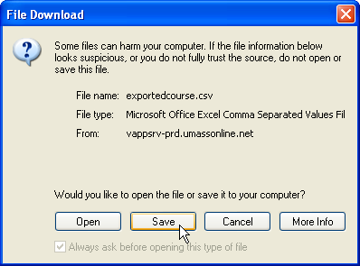

The Save As prompt appears. Type a descriptive title in the File name box. You may want to include the section name followed by semester, for example French101sp05gradebook.csv.

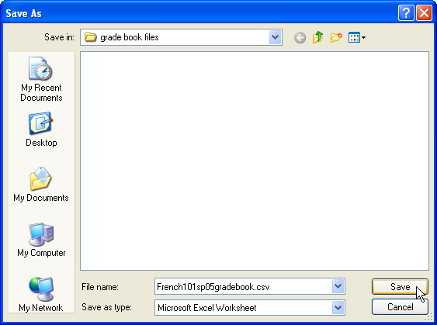

Click Save.

At Download complete prompt, click Close.

Click Back to Grade Book at the bottom of the page to return to Grade Book.

