Faculty Quick Start Guide:
Building Your Course in WebCT Vista

- Preparation
- Join the UMB faculty users group to discuss WebCT issues and download manuals and other files. Email Eileen McMahon, eileen.mcmahon@umb.edu to join.
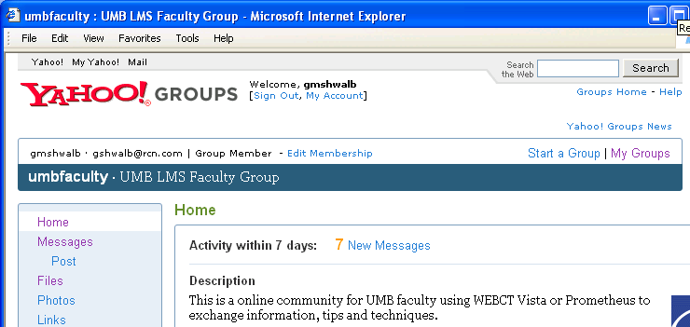

- Visit the web site: www.webct.com/exemplary to look at examples of exemplary WebCT courses.
- Take the instructor practice course that should be listed in your course list in “My UMassOnline Boston.”
- Prepare your files for uploading to WebCT. Filenames should be lower case with no spaces. Use underscores or dashes instead.
- PowerLink: WebCT has developed a utility which allows you to publish directly from Microsoft Office Applications (e.g. Word, Excel). You must have Microsoft Office 2002 or later. See www.webct.com/mspublishing for further information and to download PowerLink.
- Office: You can use MS Office files: Word, Excel, and PowerPoint Documents. If students do not have these applications on their computer, they can download viewers at www.microsoft.com/downloads. However, it is preferable to convert MS Word files to the .rtf format which can be used on different computer types (Windows, Macintosh, etc.) and with other Word Processing Applications.
- Also consider converting files to Acrobat PDF format.
- Use HTML format (web pages) for content files (other than attachments). We recommend Nvu (pronounced N-View) as an easy web editor. You can download it for free at www.nvu.com/index.php.
- If you create HTML files using MS Word, select the “Web Page, Filtered” option when saving your file.
- Dreamweaver: You can develop your course in Adobe (Macromedia) Dreamweaver and publish it directly to WebCT. See our Job Aids for this topic in the UMB faculty users group.

- Breeze: Adobe (Macromedia) Breeze is available for use by UMass Boston faculty. “Breeze” allows you to convert PowerPoint files to an online presentation which you can then link to WebCT.

- Browser Check & Login
- Go to www.boston.umassonline.net to login. We recommend that you type in a secret question when prompted to do so.
- Run Check Browser on My UMassOnline Boston (after logging in to WebCT).
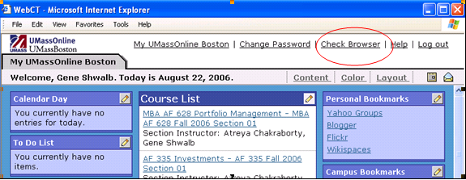
- The results of this check will let you know if your browser is configured properly to use WebCT. It will also provide instructions for correcting any deficiencies. Note especially that Popup blockers must be disabled in order to run WebCT. The script “*.umassonline.net” can added to the pop-up blocker settings instead of typing in the full URL for the WebCT web site.
- See www.webct.com/tuneup for a list of supported Web Browsers for Windows and Macintosh computers.
- Enter the Course Construction Area

- On My UMassOnline Boston, from the “Course List”, click on the section that you are designing.
- The next screen explains the three working environments: Build, Teach, and Student View.
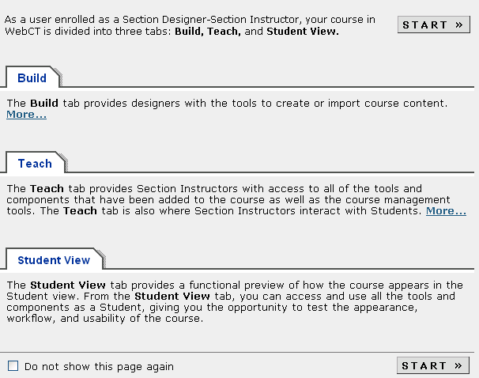

- You can check the box at the bottom: Do not show this screen again.”
- Click Start.

- Uploading Content

- Select the Build tab.
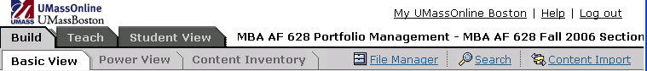
- T he Designer toolbar contains File Manager, Search, and Content Import. Click on File Manager.
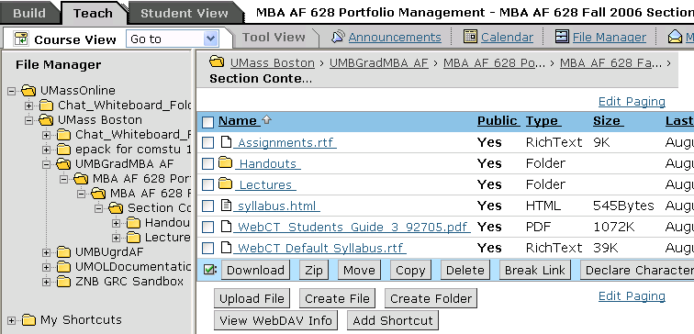

- Note that on the left, you see the directory structure of your section within UMassOnline. On the right, is a screen with your files.
- From the File Manager screen, navigate to the folder into which you want to upload files.
- Click Upload File, located at the lower bar of the File Manager Screen. The Upload File screen appears.
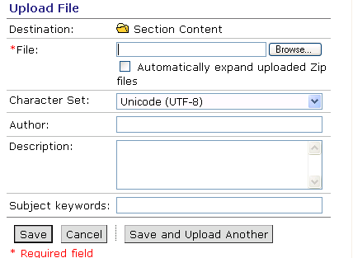
- Next to File, click Browse. Your computer’s file browser appears.
- Locate and select the file you want to upload. File name along with the local path now appear in the File text box.
- If you are uploading a Zip file (a compressed file containing one or more files within it), and you want to unzip the files after uploading, check Automatically expand uploaded Zip files.
- Note: Unzipped files are placed in the folder you selected in step 4.
- Enter Author, Description, and Keywords for this file (optional).
- If you want to upload another to the same folder, click Save and Upload Another. Repeat steps 4 to 10. For a single file, click Save.

Note: Once you upload your files, you need to link them to places in your course in order for students to see them (Home Page, Organizer Pages, Learning Modules).

- Make a Homepage and Add Your Syllabus
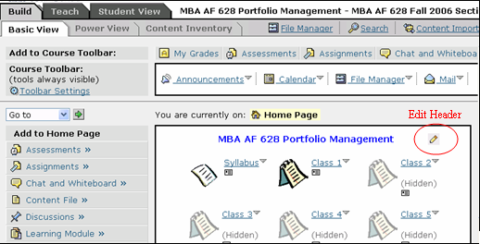
Edit Header

In setting up your course Home Page you need to decide:
- What information you want in the Header and Footer
- What colors and icon sets you want to use for the course
- What icon links you want the students to see on the Home Page
- What tools you want students to have available to them on the Course Toolbar throughout the course

- Add a Header and Footer
- Click on the Build tab and then Basic View.
- Click the “pencil” icon that appears in the header and footer area of the home page to create or edit the Header or Footer.
- Consider adding tech support information to your footer:
  - Email Tech Support: bostonsupport@umassonline.net

  - WebCT Tech Support: 1-800-569-6505
- Customize page layout, colors, and icon sets (Optional)
- In Basic View, click Course Customization which appears toward the bottom of the left hand side of the page.
- Decide how you want to group lessons, assignments, handouts, etc. What icon links do you want students to see when they first login? Are you linking to learning modules, to organizer pages, to single pages of content?
- Decide which Items should appear on the Course Toolbar. You may not need an icon link on the home page (e.g. to discussions) if that item appears on the Course Toolbar.

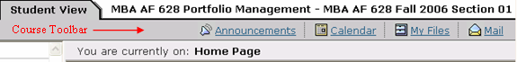

- Add a Syllabus
  - Use the options on the left side of the screen under Add to Home Page.
  - Click on the Syllabus tool.
  - You can choose to build a syllabus in WebCT or select a file that you have already uploaded into your WebCT directory through the File Manager.

- You can add other items to your homepage.
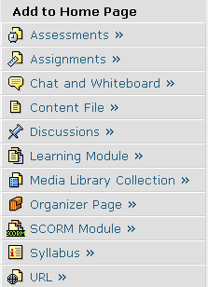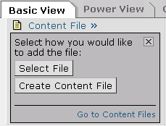

Add Content Files adds a single page of content; Add Organizer Page adds a page like the home page with links to other pages; Add Learning Module adds a set of tools that can be organized with a table of contents menu for navigation. When you select a file through the File Browser, you will see a list of your uploaded files on the right. Check the files(s) you want and click on Add Selected. The files will appear on your homepage.

- Selective Release Map and Criteria

- You can set the dates you want content to be available and visible through the Selective Release Map tool, available from the homepage on the left hand side
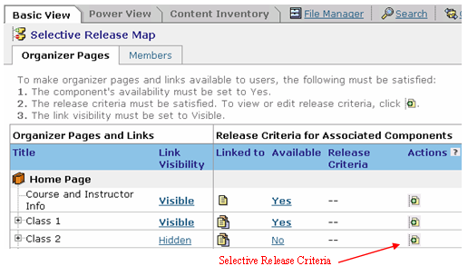
- Once inside the Selective Release Map area, you see a list your Home and Organizer pages. Click on the Expand (plus) symbol “to see the contents of these pages.
- To set Selective Release Criteria, click on the symbol in the Actions column. Release criteria can be defined for:
  - Date
  - Member
  - Group
  - Grade Book

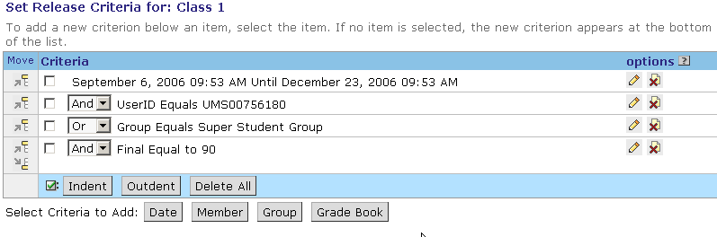

- Mail Forwarding
- You can set up mail forwarding to receive messages in external mail. However, WebCT mail is an internal mail program. You cannot reply to forwarded mail from your external email. You must return to WebCT to reply to the message.
- To set up mail forwarding, click on the Mail icon on the Course Toolbar to enter the Mail tool. .Click the Mail Forwarding icon (envelope with a green arrow). Enter the external email address and click Save. Forwarded mail will appear in your external Inbox as DO_NOT_REPLY@umassonline.net
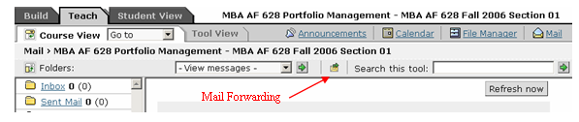

- Resources
•
- UMB Faculty Users Group (a Yahoo! Group)
www.groups.yahoo.com/group/umbfaculty
- UMass Boston WebCT Vista Resources
www.lms.umb.edu/webct.htm
- Technical Support:
bostonsupport@umassonline.net
- Telephone Support:
1-800-569-6505
- WebCT Website Support Home Page
www.webct.com/techsupport
- General assistance with building course
umbgrc@yahoogroups.com

