WebCT Vista 3
Student Quick-Start Guide

What is WebCT? 1
Resources 1
Technical Requirements 1
Web Browsers 1
Pop-up Blockers 1
Trusted Website 1
Other Requirements: 1
Login to WebCT 2
Navigation 2
How to navigate from “My UMassOnline Boston” 2
How to navigate from a Course Home Page or Organizer Page 3
How to navigate with the Breadcrumbs Trail and Course Tool Bar 3
Breadcrumbs Trail 3
Course Tool Bar 3
How to navigate within a Learning Module 4
Action menu 4
Table of Contents 4
Communications Tools 4
Discussion board 4
Managing your messages 5
Viewing messages 5
Creating messages 6
Chat & Whiteboard 6
Mail 6
Assessment tools 8
Quiz, Survey & Self Test 8
Assignments 9
The Calendar 9

What is WebCT?
WebCT (Web Course Tools) is a product that enables an instructor to create and manage Web-based or Web-enhanced courses. Only students registered in a course for which the instructor has chosen to use WebCT may access the course. Check with your instructor for confirmation.

Resources
- UMass Boston WebCT Vista Resources
http://www.lms.umb.edu/webct.htm
- Technical Support:
bostonsupport@umassonline.net
- Telephone Support:
1-800-569-6505
- WebCT Student Resource Center
http://www.webct.com/students

Technical Requirements

Web Browsers
For a list of currently supported browsers for Windows and Macintosh computers see http://www.webct.com/tuneup

Pop-up Blockers
WebCT makes use of pop-up windows. If you have a pop-up blocker installed, please disable it for the WebCT web site. The script “*.umassonline.net” can added to some pop-up blockers settings instead of typing in the full URL for the WebCT web site.

Trusted Website
In order to insure that course documents download correctly using Microsoft Internet Explorer, you should configure WebCT as a trusted site. Here are the steps:

- From the Internet Explorer menu, select Tools.  - Select Internet Options.  - Select the Security tab  - Under "Select a Web content zone to specify its security settings", click the Trusted sites icon.  - Click Sites… | - Uncheck "Require server verification (https) for all sites in this zone".  - Under "Add this Website to the zone:" enter the URL  http://vappsrv-prd.umassonline.net  - Click Add  - Click OK  - Click OK

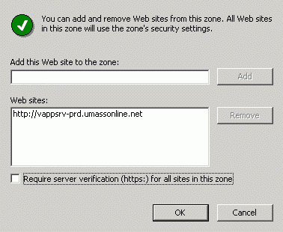

Note: This procedure is not required for non-Microsoft Browsers; Firefox, Safari, etc.

Other Requirements:
After logging in to WebCT, be sure to run “Check Browser” before entering your course.
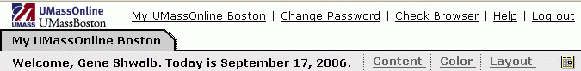
You will receive a message if any other action is necessary to prepare your computer for running WebCT.

Login to WebCT
Open your web browser and enter the following URL (web address):
http://www.boston.umassonline.net/

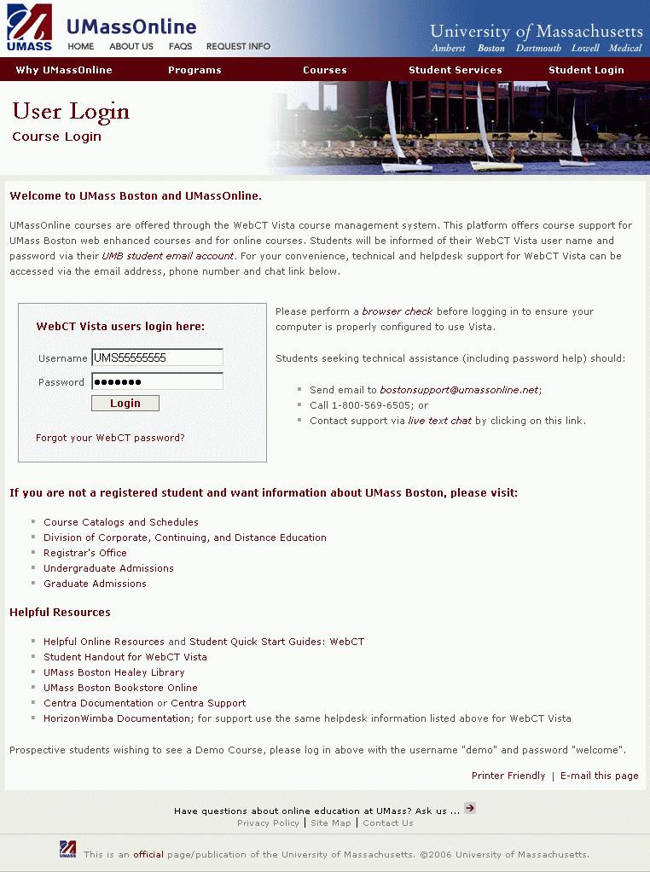
The WebCT Log in page appears:

Your WebCT user ID is normally the same as your Wiser user ID. If you are unsure of your student ID number, go to https://www-sa.umassadmin.net/servlets/iclientservlet/stuss .

Navigation

How to navigate from “My UMassOnline Boston”
From the My UMassOnline Boston Course List you can access all of the courses in which you are enrolled. Select a course.
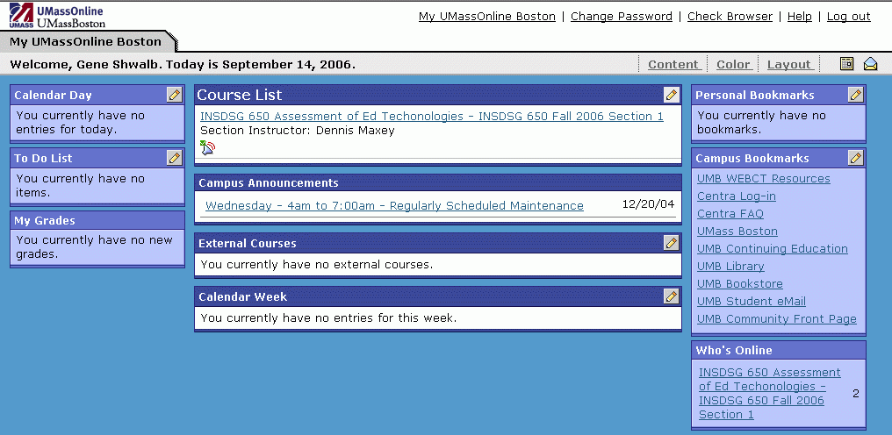

The Course Home Page will appear.
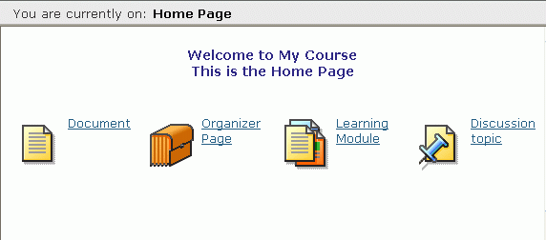
There are several ways to navigate WebCT.
- Home or Organizer Page
- Breadcrumb Page or Course Toolbar
- Learning Module
- Action Menu
- Table of Contents

How to navigate from a Course Home Page or Organizer Page
It is important that you use the internal navigation provided by WebCT: Do NOT use the browser’s navigational features such as the Back, Forward and Refresh buttons.
To navigate through a course, click on an icon or hyperlink that appears on the home page. The page that relates to that link will be displayed.
Clicking an Organizer Page icon will take you to a page which appears similar to a home page and contains additional icons.
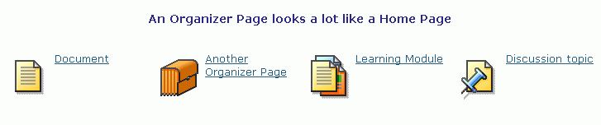

How to navigate with the Breadcrumbs Trail and Course Tool Bar

Breadcrumbs Trail
As you navigate the course, a trail of “breadcrumbs” will be created on the top left of the screen showing the pages you have visited. The word appearing in bold represents the current page. The other breadcrumbs are active links. By clicking on these links you can navigate directly to a specific page.

Course Tool Bar
Using the Home Page icon: Click on the home page icon to go directly to the home page.
Using the Course Menu icon: This will expand the course menu if it is not already visible, or it will collapse the course menu if visible. The course menu will appear to the left of the home page. Click on the links within the course menu to navigate the courses pages.

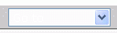 Using the Go To menu: From the course tool bar you can also use the Go To drop down list. Select an Organizer Page (or the Home Page) to which you wish to navigate.

How to navigate within a Learning Module
On the Home Page, icons link to material known as learning Modules.
A Learning Module organizes content through the use of a table of contents.
Within a Learning Module you can navigate using either the Action Menu or the Table of contents.

Action menu
The Action menu will appear to the top right of the page.
- Click the next icon to move onto the next page
- Click the previous icon to return to the previous page
- Click the retrace icon to retrace your navigation path through the learning module
As seen above, other icons may also be available

Table of Contents
The table of contents will appear to the left of page.
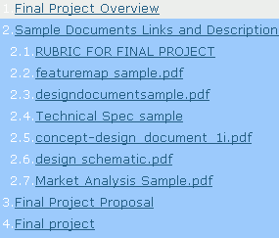
The content of the Learning Module will appear on the main section of the page.

Communications Tools

Discussion board
To get to the discussion board click on the icon if available.
The discussion board is used to communicate with others enrolled in the same course
Discussions are organized into:

Categories: Contain several topics and are the highest level of organization within discussions.
Topics: Contain message threads. All discussion messages are posted to a particular topic.
Message Threads: Collections of messages, incorporating a starting message and all replies to that original message.
Messages: The lowest level/unit within discussions.

Within each category, choose a specific discussion topic by clicking on its linked name.

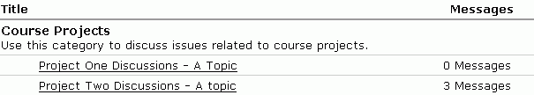
A Category and 2 Topics
Within each topic there may be a number of threads and/or messages
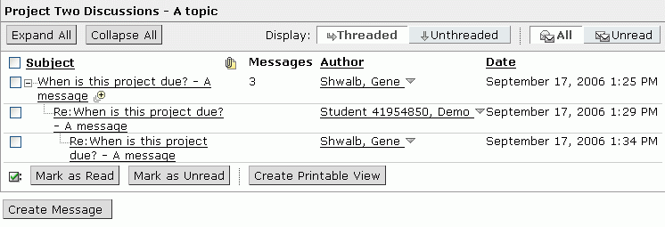
.A Message Thread containing 3 Messages

Managing your messages
The buttons and links available on the Messages screen enable you to:
- Sort Messages (Click on Headings)  - Subject  - Author  - Date  - Show Messages  - All messages  - Unread messages  - Threaded messages  - Unthreaded messages  - Expand All messages  - Collapse all messages | - Sort messages  - Subject  - Author  - Date  - Mark messages  - Read  - Unread  - Printable View  - Create  - Print  - Save as File

Viewing messages
Click the message’s title under the Subject heading.
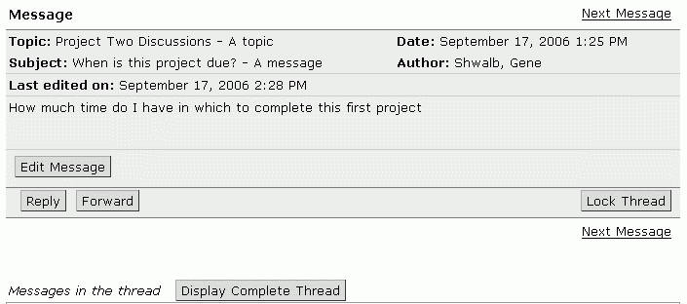
When viewing a message you can:
- Reply to the message
- Forward the message
- Display a complete thread of messages

Creating messages
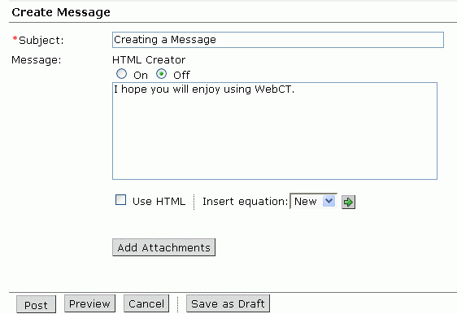
When creating a message you can:
- Attach files  - Preview the message  - Cancel creating/writing the message | - Save the message as a draft  - Post the message  - Format the message using HTML or the HTML Creator.

Chat & Whiteboard
You can use chat to engage in real-time communications with others enrolled in your module. Chat & Whiteboard can be set-up in three different ways:
- Chat & Whiteboard together
- Whiteboard only
- Chat only
Click on the chat icon (if available) to access Chat.
 To access a chat room click on the chat icon for that room.
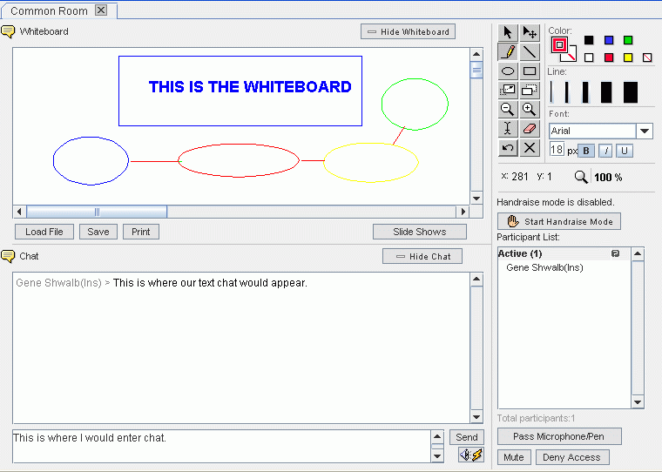
Within the Chat window you can:
- Send messages
- Send URLs
- Send private messages

Mail
Note: The Mail tool is for use in WebCT only: it isn’t your University or outside email account and you can ONLY send messages to your instructor and other students enrolled in your course.
You can forward all of your WebCT email to an outside account by clicking the Mail Forwarding icon.
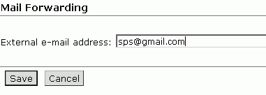

But you will not be able to reply to messages from your outside account.
The mail message screen is very similar to the discussion board screen. Once the mail tool is opened the Messages screen appears.
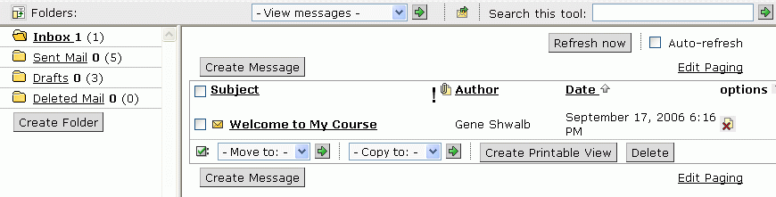

Within the Messages screen you can:
Read mail messages. To read a message click on the subject line of the message you wish to read. A pop-up window will display the message.
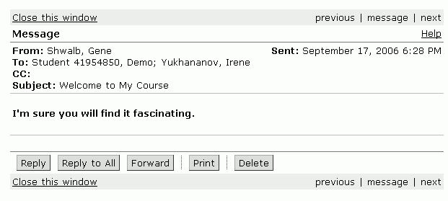
From this window you can:
- Reply to the message
- Forward the message
- Print the message
- Delete the message
Create messages. Click on the Create Message button. The compose message pop-up window will display.
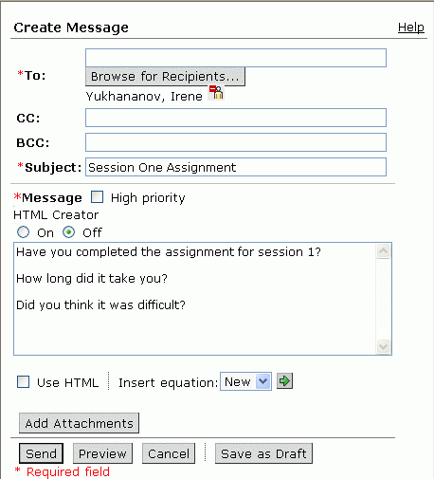
Browse to identify the intended recipients of your message. Use Edit Paging to select the number of names you can view at one time.
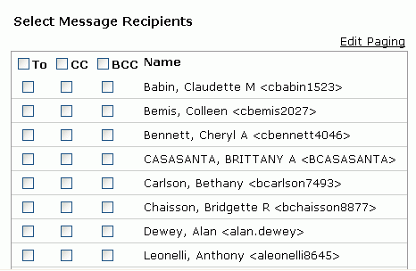
When creating a message you can:
- Attach files
- Preview the message
- Save the message as a draft message (saved to the Drafts folder)
Other Mail Functions:
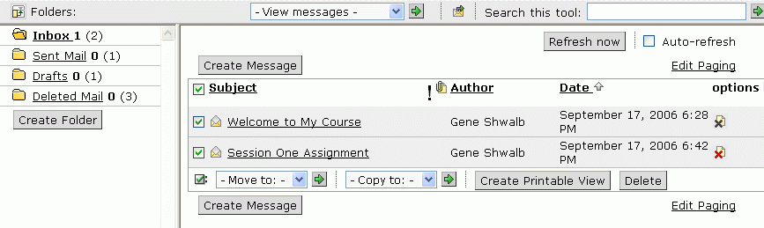
- Copy and move messages  - Create printable view. You can then:  - Print the viewed messages  - Save the viewed messages as a file | - Delete messages (select the messages using the checkboxes then click Delete)  - Manage Mail folders (click Create Folder

Assessment tools
It is important to check when quizzes, self tests and assignments are accessible. Do this as soon as you log on to WebCT Vista so you can plan your workloads around them.

Quiz, Survey & Self Test
Note: The availability of the Quiz, Survey and Self-test tools are dependent upon how your WebCT course has been set-up. Additionally there are differences between these types of assessment:
- Quiz – your responses are graded (check My Grades for your results)
- Survey – your responses are anonymous and upgraded
- Self-test – your responses are not graded
When you access a quiz, survey or self test you will be given information about that assessment (e.g. Availability dates, time limits etc.).
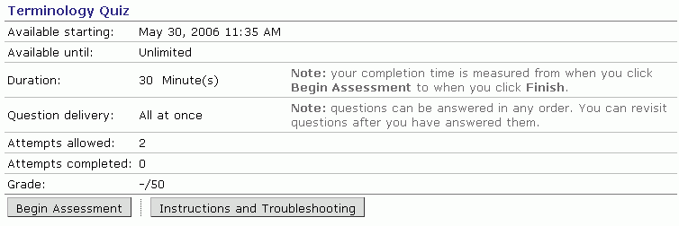
To begin the assessment click Begin Assessment. An Assessment screen will appear:
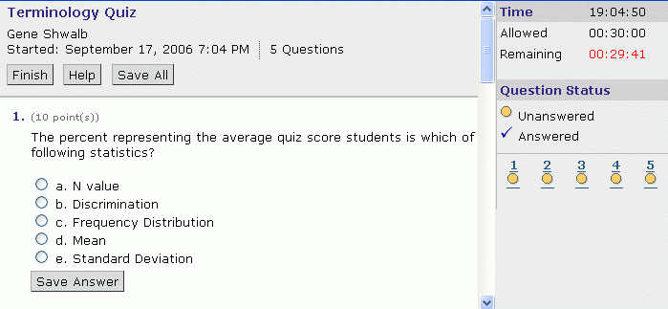
On the right of the screen, time and question status information is displayed
The questions are displayed on the left of the screen

To answer a question you will need to either type, check, or select the appropriate response. Once you have made your response click Save. To move onto the next question click Next Question. When you have completed the assessment click Finish

DO NOT CLICK FINISH unless you are sure you have finished the quiz.

Assignments
Note: The availability of the Assignment tool is dependent upon how your WebCT course has been set-up. Therefore it may not be available.
When you access an assignment a screen similar to that shown below will appear:
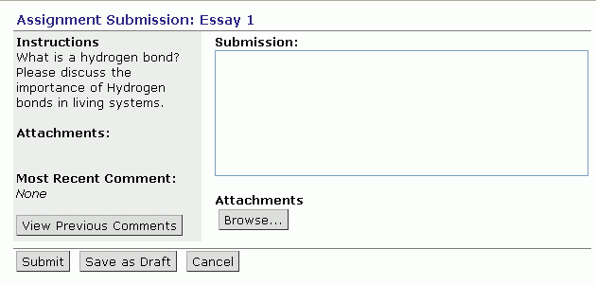
To the left are the instructions and any attachments associated with the assignment for you to download. To right of the screen is a text box where you can enter your assignment submission.

Within the Assignment screen you can:
- Attach files to your submission (click Browse). It is quite possible you’ll be asked to submit an assignment in Word, Excel or Power Point. You attach it here.
- Submit your assignment when ready (click Submit)
- Save a draft of what you have done. You can then come back to work on it at a later time. (click Save as Draft)
- Cancel the submission (click Cancel)

The Calendar
The Calendar can be accessed from:
- The My WebCT page tool bar.
- The Course Tool Bar, if it is available within your module
Once a calendar icon clicked a screen similar to that shown below will
appear:
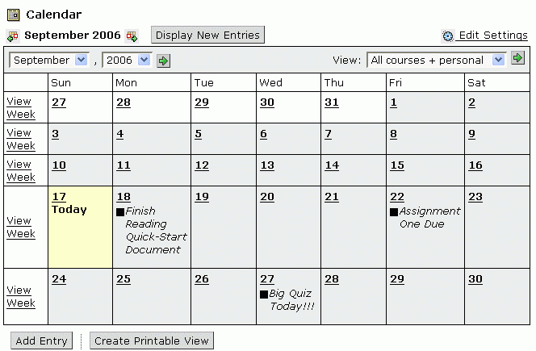

Within the Calendar you can:
- Choose whether to make your entry public or private.
- Create Printable View for a range of dates.
- Customize your view of the Calendar (Edit Settings)
- View the Calendar by month, week or day.

