Add a syllabus to your WebCT Vista course

Creating your syllabus

You can use several programs to create your syllabus. Just remember that your students will need the application you used to create the file installed on their computer as well to view the file. If your syllabus is in Microsoft Word format, students can download a free Microsoft Word Viewer if they don’t have the full version of Microsoft Word at:
http://www.microsoft.com/downloads/. Alternatively, you can save your file as a web page within most word processing programs.

Saving a Word file as a web page

To save a Word document as a web page:
- Open the file in Word
- Select Save As from the File menu.
- Click on the Save as type dropdown box, located below the file name box, and select the “Web Page, Filtered” option. Your file will now have a .htm extension. For example, a copy of my “syllabus.doc” file will now be saved as “syllabus.htm.”

NOTE: Be sure that the file name does not contain spaces, extra dots or special characters.

Add your syllabus to your course home page

From within the course you wish to edit, click on the Build tab and Basic View sub tab.

1. From Add to Home Page menu click on Syllabus

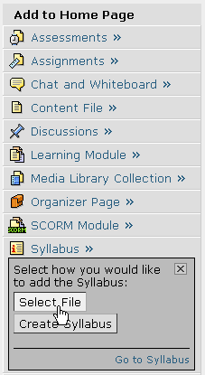

2. Click Select File.
3. Click My Computer

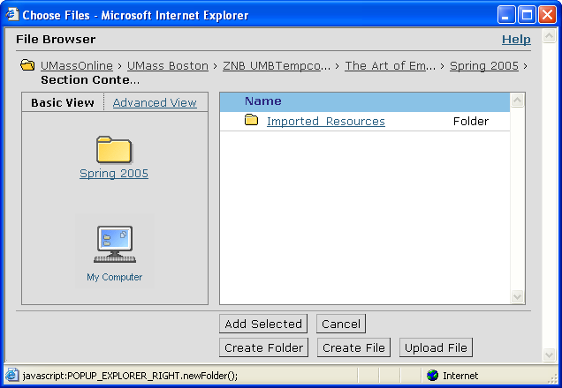
My Computer

4. Browse your computer for the file that you want to add, select the file and click Open.
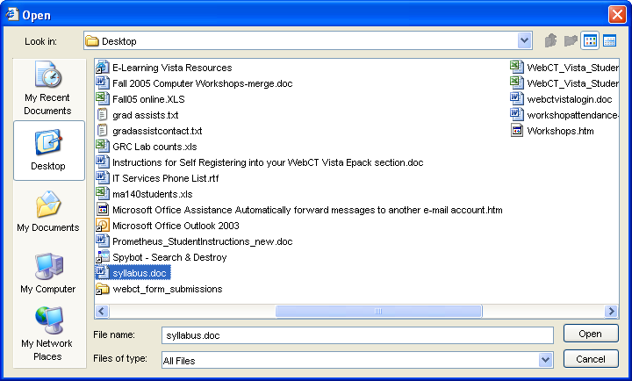

A success message will be displayed below the Basic View sub tab

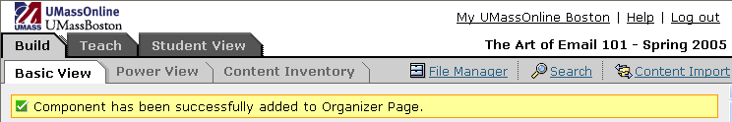

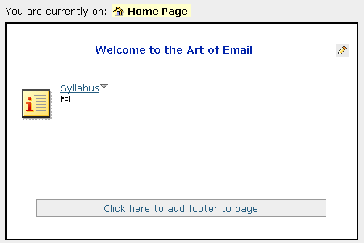
The component you have just added will now appear on your course homepage

To preview the syllabus file you have just added, click Student View tab.

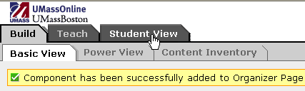

Next, click on the Syllabus icon from your course home page.

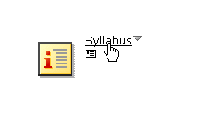
Click Open at the File Download prompt.

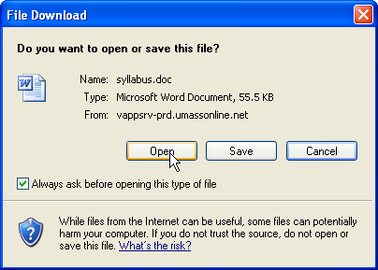

View your Syllabus in Student View

You should now be able to view the syllabus you have just added to your course.

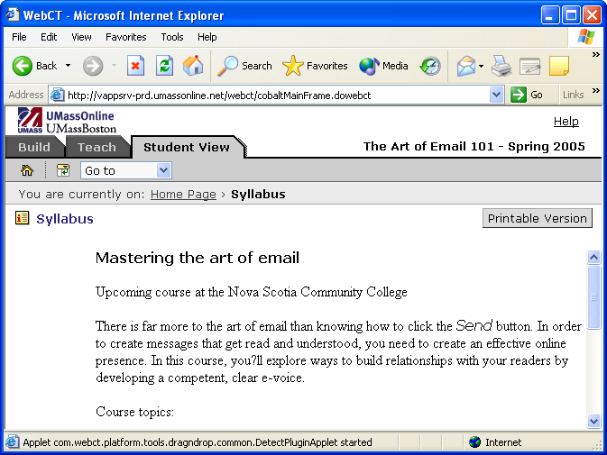

Click on the Build tab to continue designing your course.
Edit your Syllabus

1. Click on the Syllabus link and Edit from the submenu.

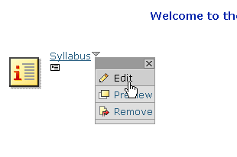
2. From the Syllabus edit page under Select Syllabus
The name of the linked file and file location will appear here.

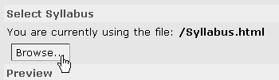

3. Click Browse.

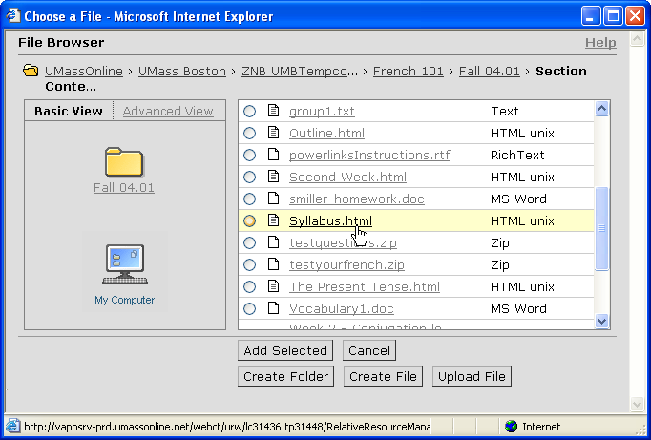

4. Save the file to your computer:
- Right click on the file that you want to edit within the file listing.
- Select Save target as… and save the file to your computer. Edit the document within the program it was created and Save the file.
5. Upload the file into WebCT Vista
- From WebCT Vista edit syllabus page, click Browse.
- Click Upload File.
- Click Browse and select the file you have just updated.
- Click Save.
- At the “Do you want to replace the file?” prompt click Yes to replace the file.

