Linking to Discussion Topic from Learning Module

From within the Build tab, click on the Learning Module you wish to edit.
Click on the Edit option from the submenu that appears.

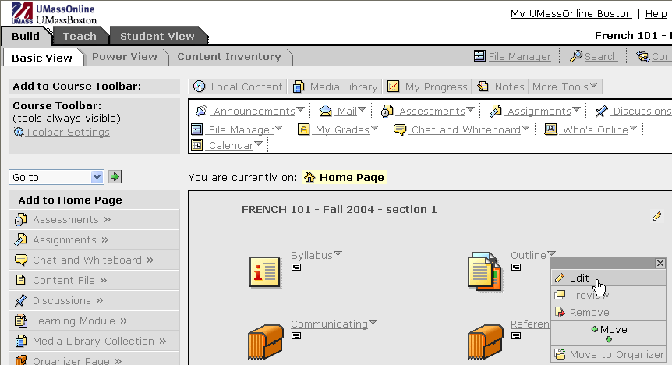

The Learning Module Content window appears.

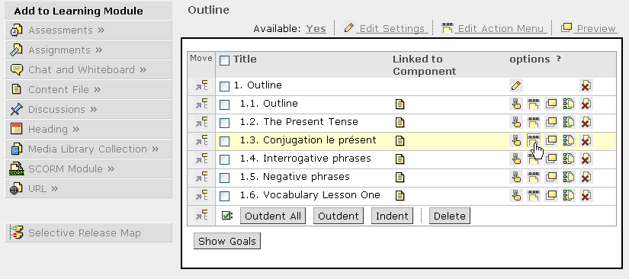
Edit Component Action Menu icon

Click on the Edit Component Action Menu icon beside the title of the component to which you would like to add a discussion link.

The Action Menu Settings option window appears.

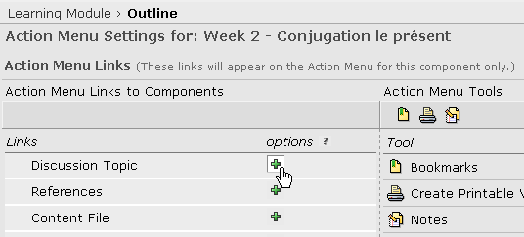
Link to Component icon

Click on the Create Link to Component icon beside Discussion Topic.

Select the discussion topic by clicking on the appropriate checkbox.

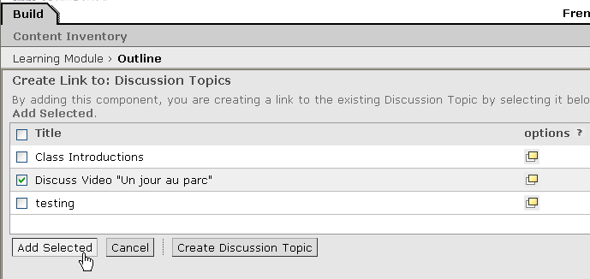

Next, click on the Add Selected button.

You will now see the Action Menu Settings window and the discussion topic that you have selected just below it.

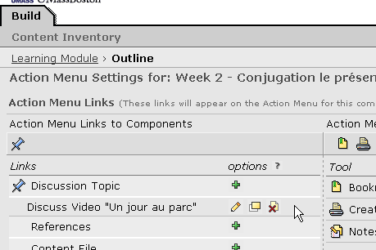

Click on the Done button.

From Student View, the Discussion Topic should now be viewable from the toolbar. When the student clicks on the Discussion Topic icon, s/he can view the appropriate discussion item related to the component linked within the Learning Module.

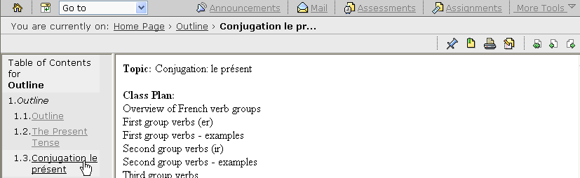
Discussion Topic icon

