Uploading files to your WebCT Vista course using
WebCT PowerLink for Microsoft Office

Software Requirements

- Microsoft Office version 2002 or higher
- WebCT PowerLink for Microsoft Office

Instructions

1. Open the file that you wish to include in your WebCT Vista course within the appropriate Microsoft Office program; Microsoft Word, Microsoft Excel, or Microsoft PowerPoint.

2. Select Send to WebCT from File menu.

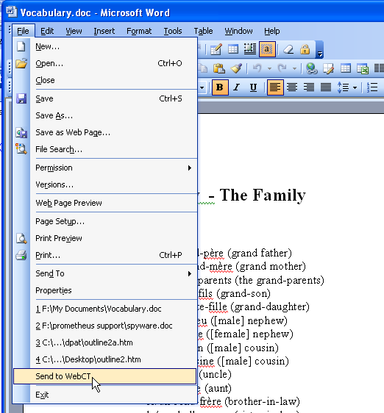

3. Type in http://vappsrv.umassonline.net for the Server URL and click on the Next button.

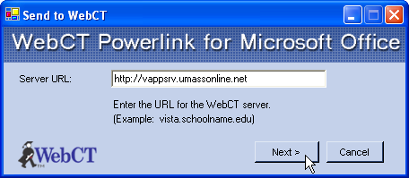

4. Type in your WebCT Vista User Name and Password and click on the Next button.

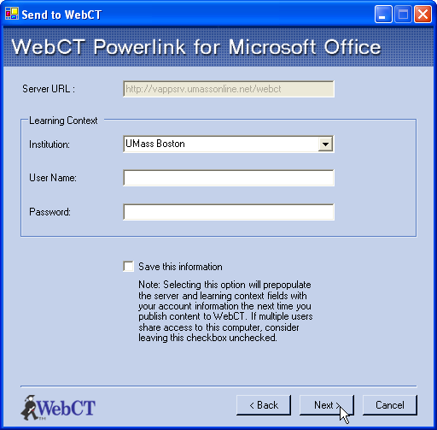

5. Click on the arrow beside the Publish To: drop down box and click on the appropriate WebCT Vista course folder.

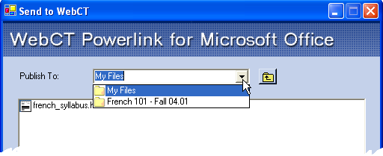

6. Click on the Publish button.

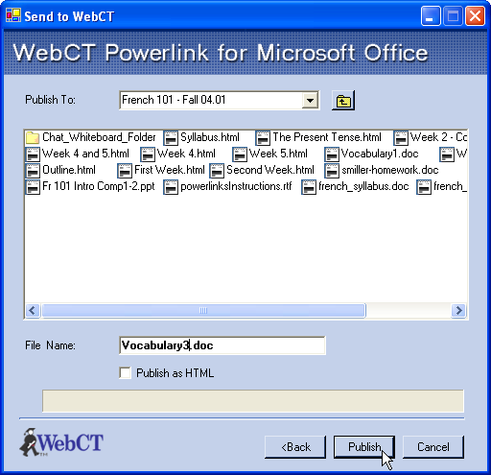

7. Next, click OK to the File Uploaded Successfully prompt.

