Adding alternative questions

First, you must create the alternative questions in the question database:

- Create your alternative questions in the question database.
From Build tab > Content Inventory > Question database

- From category view, create a category called “Alternative Questions” (optional)

- Click on Question View tab

- Select the desired question type from drop down box beside create question. Select the appropriate option and click on the green arrow.

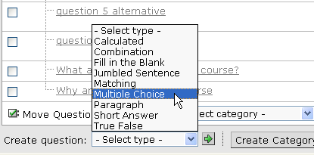

- Create the question and click Save.

- (optional) Click on Category view and move the question into the “alternative questions” category by checking the box next to the question to select it and select “alternative questions” from list box beside Move questions to Category.

Add alternative questions to the assessment

- Go to Assessments by selecting Assessments from the Content Inventory list box, click green arrow. Select the assessment to edit by clicking on the Assessment title link.

- Click on the check box beside the question that you would like to provide alternative questions to.

- Click Add Question Alternatives button at the bottom of the page.

- Click on the check box beside the question under “alternative questions” that you would like to add as an alternative question. Click Add selected.

- You will now see the question you added listed beneath a question set icon for the question you have just edited as illustrated below.

