Looking up Class Numbers in PeopleSoft

Point your internet browser to http://wiser.umb.edu

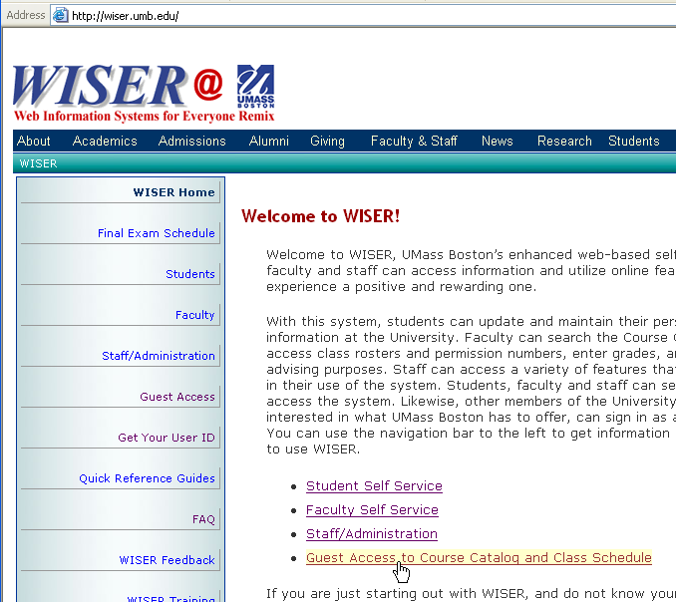

Click on “Guest Access to Course Catalog and Class Schedule” link.

The Guest Access window appears.

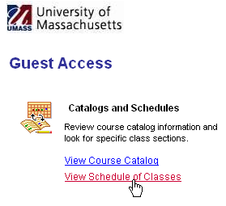
Click on “View Schedule of Classes” link.

The Class Search window appears.
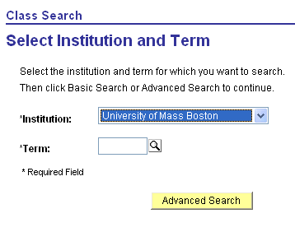
Select University of Mass Boston
Click on Lookup tool icon to select the Term code.
Next, Click Advanced Search.

The Lookup Term window appears.

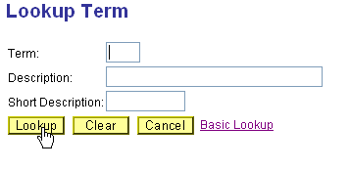
Click Lookup.

The Search Results screen appears.

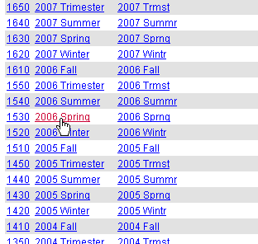
Click on the appropriate term description link. The term code is located beside the term description.

The term code will now be entered in the Term box.

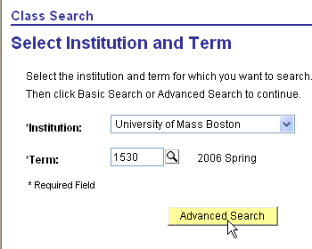
The term code (1530) has been entered for Spring 2006

Click Advanced Search.

The Advanced Class Search screen appears.

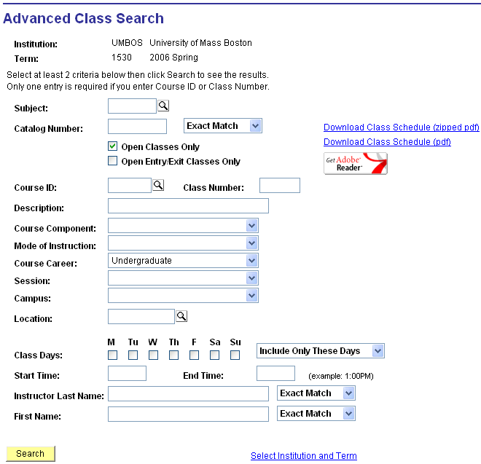

Enter a subject code, it is required for all Advanced Class Searches. If you are unsure of the subject code, use the lookup tool. Enter other search criteria in the appropriate boxes.
Click Search.

The Class Search Results screen will appear.
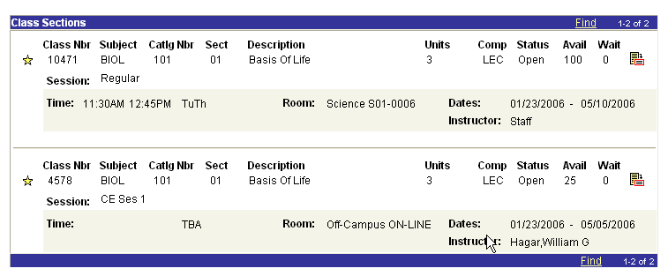
The Class Number is located here.

