Creating Calculated Columns in WebCT Vista
The Grade Book tool in WebCT Vista works very similarly to an Excel spreadsheet. Each column has a name and each row begins with the student’s name. Each cell can contain a numeric or text value.

This is what the columns look like in the Grade Book in the Teach view:

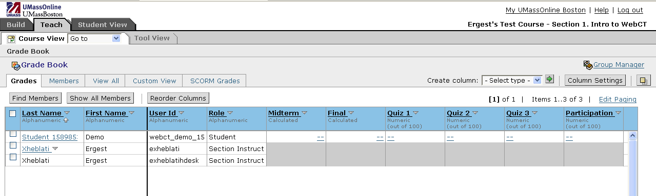
Rows
Columns

You can see clearly that the structure of how columns and rows are laid out, the Grade Book it very closely resembles the structure of Excel.

There are several different column types:

- Alphanumeric: which allows you to enter a short string of letters and numbers (e.g. You could enter an alphanumeric column titled “Email Address” to enter the members’ email address.)
- Calculated: which allows you to enter a formula to calculate the final grade which s composed of columns that contain numerical information such as other calculated columns or simple numeric columns.
- Letter Grade: which allows you to generate a letter grade based on the values of numeric or calculated columns based on a grading scheme which you specify.
- Numeric: which allows you to enter numeric values only. You can specify the number of decimal places which you wish to use from 0 to 3.
- Selection List: which allows you to select the grade from a drop-down list of grades which you specify. You can create both the values and the order in which they appear.
- Text: which allows you to enter any amount of text, words, phrases to describe a student’s grade.

Creating a calculated column

This handout will focus on how to create calculated columns in the Grade Book. Calculated columns allow the instructor to create formulas in them which let you automatically calculate the grade for all students based on grades from quizzes, exams or quizzes based on the structure that they choose. For example, let us assume you would like the grade book to represent a final grade that calculates three quiz grades at 15% each, a midterm at 25% and a final at 30%. You can create a calculated column with a formula which does this automatically.

To create a calculated column to calculate the final grade for each student based on the rules that we have setup above go to your course home page and change the view to Teach:

On the Teach mode homepage, click on your Grade Book, assuming you have set one up with all the columns as above.



In the Grade Book, look for Create Column, from the drop down menu select Calculated…

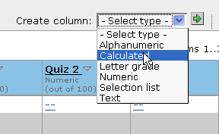
Click the green arrow (Go) button next to that.

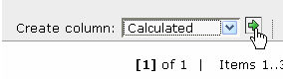

You will be asked for some information. Set the label to anything you want, I’m going to set it to Course Grade. This is the only required piece of information. Check or uncheck the click boxes if you want to display the column on the Grades tab and/or if you want the student to see this column.

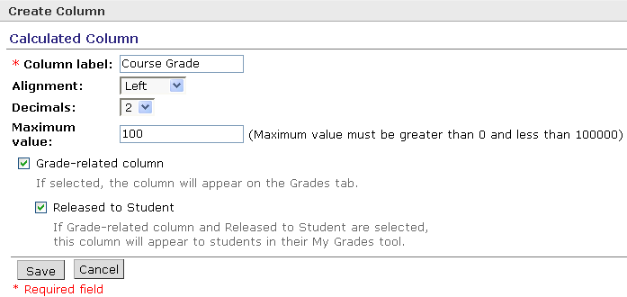

You can change the alignment and the decimals as you wish or you can simply leave them as they are. For Maximum value I will put 100 but you can put whatever you choose. When you are done, click the Save button and you will be taken back to the Grade Book view where the new column should now show up. The next step is to edit the formula. Click on the column name and choose Edit Column Formula
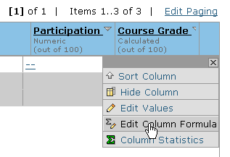

You should get on a page that looks like this:

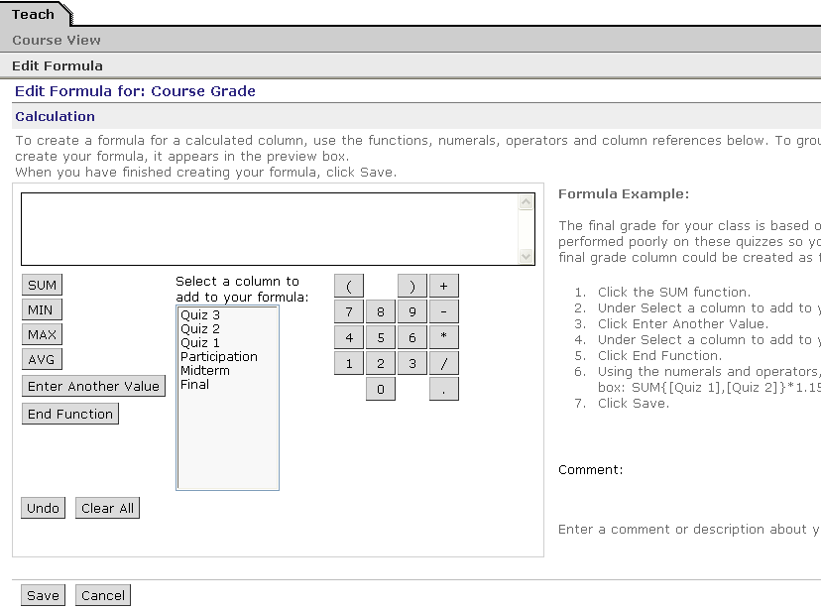
Formula display box. This box displays your formula as you edit it.
Function buttons allow you to enter the formula above
Undo button same as Backspace
The Number Pad allows you to enter numbers into the formula
Column selection box. Choose the columns whose value you want in the formula
You have a formula editor which you cannot type into. The only way to navigate this screen is to use the buttons provided. The SUM, MIN, MAX, AVG buttons are formulas that allow you to calculate the sum, minimum value, maximum value and the average value. The Undo button serves as Backspace since you cannot use the keyboard, and the Clear All button erases the entire formula at once. Be careful with this button!! Number Pad serves the same function as the number pad on your keyboard.

Simple Average Formula

Let us first create a simple formula to so we can see how the formula box works. Suppose we need to find the average grade between the Midterm and the Final. It is important to point out that you need to write the formula out on a piece of paper exactly how it should appear since the editor is not very versatile. In our case the formula looks like this:

AVG{[Midterm],[Final]}

To enter the formula click on the AVG function button:
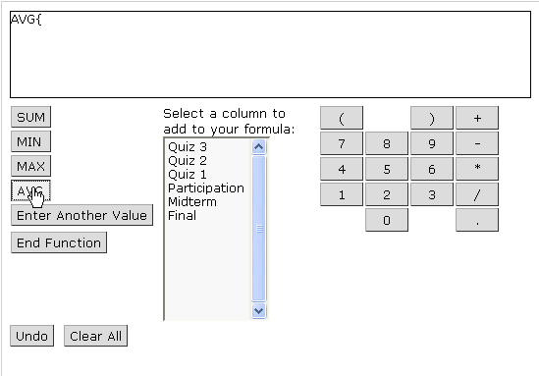

Then click Midterm from the column list:
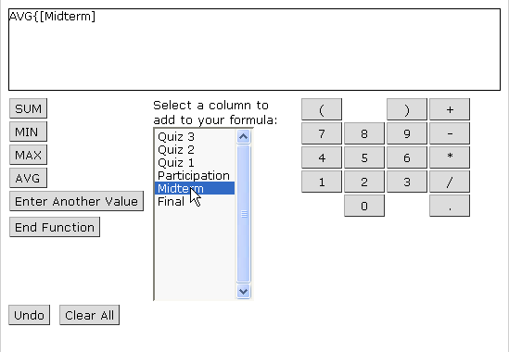

Now we need to enter another column for Final. In order to enter the comma between elements of the function (in our case Midterm and Final) we must click on the Enter Another Value button.

Note: For more complicated formulas, you need to use this button to enter the comma to separate all the elements which can also be encapsulated in parenthesis. We will see an example of this further down
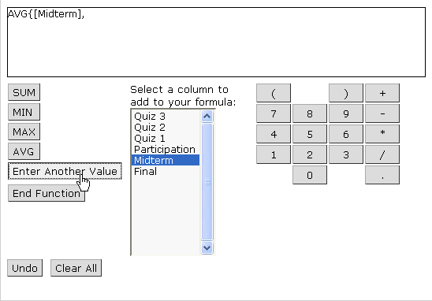

Now we can go ahead and add the Final value:
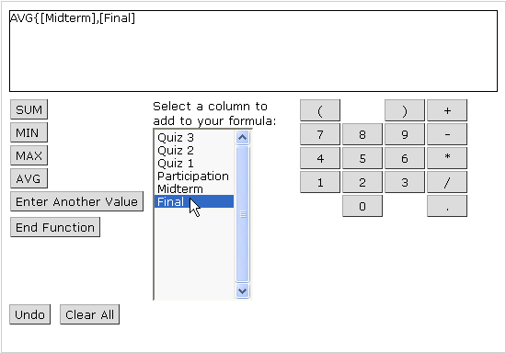

To close the function click on End Function: This will add a closing bracket } to the end of the formula
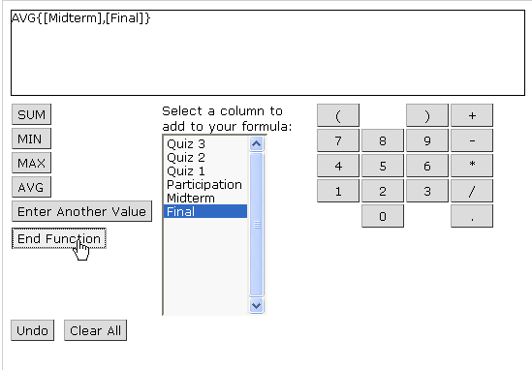

Now we are done with the formula editing so we need to Save and return to the Grade Book:
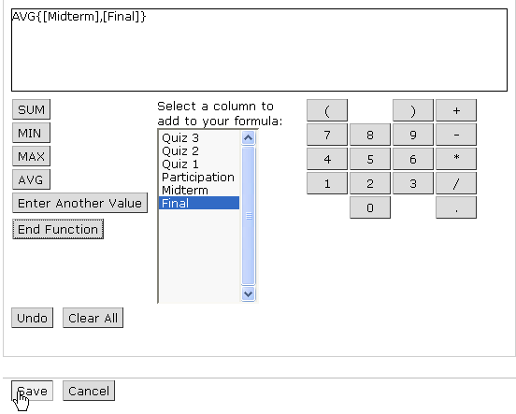

If you make any mistakes, use the Undo button to erase the value and reenter it.

Here is the formula in action with some random values for Midterm and Final:

Weighted Average Formula

To set this up let us assume that there are going to be three quizzes, a midterm and a final. And let’s assume that the grading is similar to the following: Each quiz carries a weight of 10%, the midterm is 20%, the final is 30%, and class participation is 20% Also let’s suppose that you have setup columns in WebCT Vista for all these grades and these columns are of the numeric type with a maximum value of 100 for each. Other maximums can be setup as well, but the calculations need to be different for each.

To create a formula first we have to think it out. In our case Final Grade = 0.1*Quiz1 + 0.1*Quiz2 + 0.1*Quiz3 + 0.2*Midterm + 0.3*Final + 0.2*Participation

Note: 10% = 10/100 = 0.1

The first thing we want to do is write out the formula on paper exactly how it should look like. We can use the SUM function or we can add all the values using the + operator, so the formula can look like this:
SUM{([Quiz 1]*0.1),([Quiz 2]*0.1),([Quiz 3]*0.1),([Midterm]*0.2),([Participation]*0.2),([Final]*0.3)}

or like this:
SUM{([Quiz 1]*0.1),([Quiz 2]*0.1),([Quiz 3]*0.1),([Midterm]*0.2),([Participation]*0.2),([Final]*0.3)}

l

To enter the formula use the buttons just like the example of the average grade above. As mentioned above you cannot edit the formula directly, it has to be done through the buttons provided.

When you are done entering the formula click Save to finish and go back the Grade Book.

If you want to enter the formula by using the SUM function, begin by clicking the SUM button. The following appears in the formula editing bar.
SUM{

To add the column names, click on them on the list next to the buttons. The order does not matter, but is important to include each column and it’s multiplier within parenthesis.
So click on Quiz 1
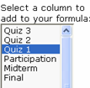

and you have:
SUM{([Quiz 1])

Don’t forget to include it in as parenthesis shown above. Again this is important. Click the Undo button as backspace to delete one element to the left if you make a mistake and forget a parenthesis. It is a little annoying that you have to add everything in the formula by clicking the buttons, but once you get used to it it’s not that hard. Now that we have the first element in the formula, it is easy to add the others. Just click on Enter Another Value, to add a comma and repeat the steps as above to add the other columns with their corresponding multiplier values, and remember to use open and close parenthesis for each element.

When all the elements are added, click on End Function to add the closing bracket } to your function. When done, Click Save to save your formula. Remember that this is not saved automatically so you have to click Save to save your work and return the Grade Book

And the final function looks like this:

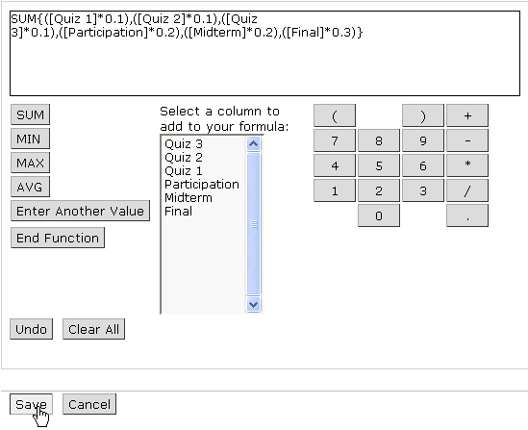

In both examples we get the same result:

