Enabling ActiveX controls for Internet Explorer (PC)

By enabling Active X downloads you are able to view interactive function within WebCt as well as most other web pages.


- Double click on the Internet Explorer (IE) icon

- When the browser loads, click on “Tools” in the drop menu and select “Internet Options”.


- At this point, the Internet Explorer Properties should be displayed
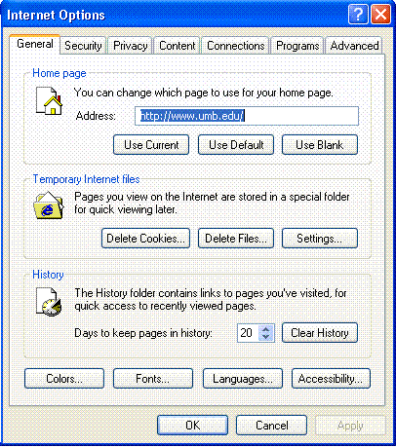

- Click on the Security tab and click the “Custom Level”
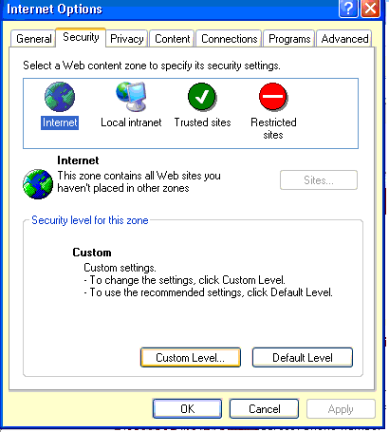

- Next, you will see a scroll-down list with various settings. Scroll to Active X controls and plug-ins.

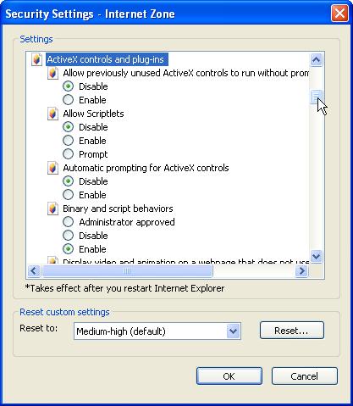

Scroll again until you find the following options and make the following changes:

- Download signed ActiveX controls – select Prompt.
- Run ActiveX controls and Plug-ins – select Enable.
- Download unsigned ActiveX controls – select Disable.

When you’ve done these steps, click “OK”

- A warning will pop-up, click “Yes”

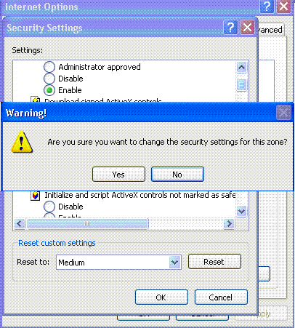

- Click “OK” 8. Click “OK”
