Using Email In WebCT

The Mail is in the toolbar on the top of your window once you login and navigate to your course. Once you click on this button, you will get to your email page. You’ll see a page similar to this on your screen:

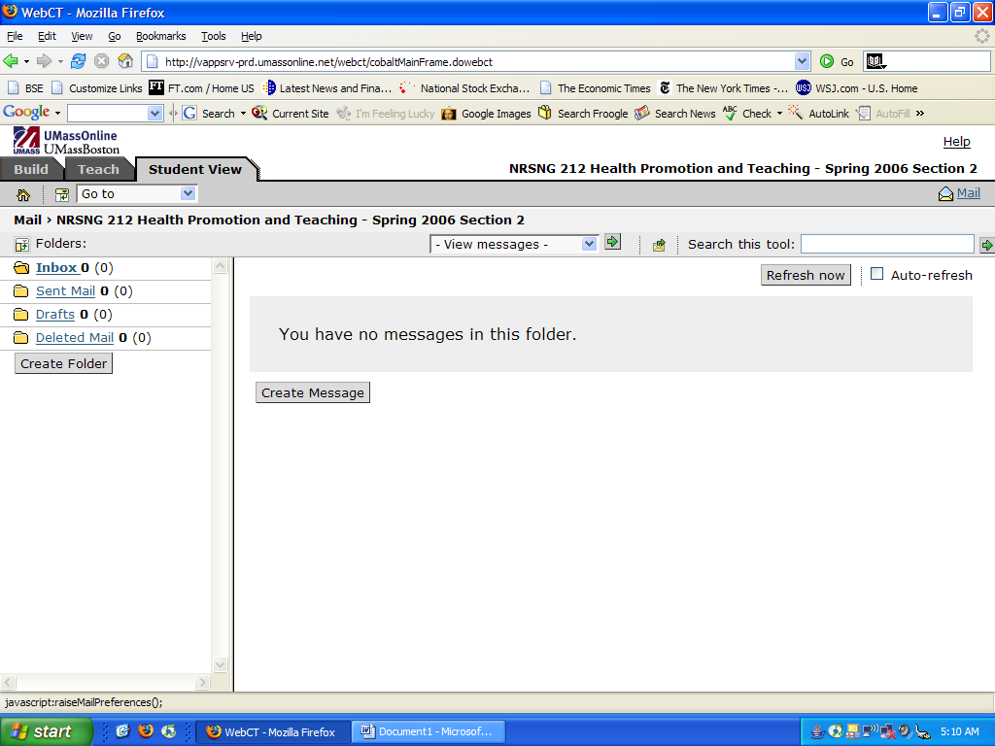

You will see the folders Inbox, Sent Mail, Drafts and Deleted Mail on your left side of the screen. There is also a box in gray with the words ‘Create Folder’ below the above.

Inbox: All your emails will arrive to your inbox folder. By clicking on them, you will be able to read your messages, reply to them, forward them and store them in folders that you may create for future and quick reference. The number within brackets is the total number of emails in the box. The number outside the brackets denotes the number of unopened/unread emails.

Sent Mail: Clicking on sent mail will give you a list of emails that you have sent to other people. The number within brackets is the total number of emails in the box. The number outside the brackets denotes the number of unopened/unread emails.

Drafts: You can type in your emails to be sent at a later time in the future. Once you have finished typing your email, you can use the save as draft button. By choosing this option, you are saving an email that you will be sending out later. Your information will be stored and will not be lost. You may connect anytime thru the internet and send your email. The number within brackets is the total number of emails in the box. The number outside the brackets denotes the number of unopened/unread emails.

Deleted Mail: This is a list of emails you’ve deleted. This is automatic in the sense that you can retrieve emails you’ve deleted earlier. The number within brackets is the total number of emails in the box. The number outside the brackets denotes the number of unopened/unread emails.

Create Folder: You may want to create a new folder with any other name. To create a new folder, click on Create Folder below the deleted Mail button on the left of your screen. This will in turn open up a new pop-up window like this.

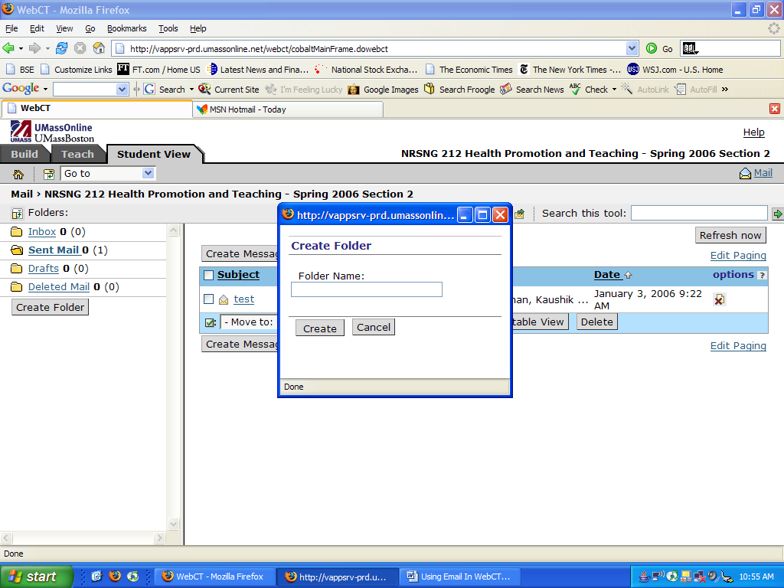

You can type in the name you want for the folder and click Create. Your folder is created. Clicking Cancel will close the window without the folder being created.

SORTING MESSAGES:

The messages in your folders can be sorted in 3 different ways.

- Clicking on Subject will rearrange the messages in either alphabetical order (ascending or descending).
- Clicking on To will arrange the emails in the order of the person(s) who you received it from.
- Clicking Date will arrange the emails in chronological order.
VARIOUS BUTTONS/OPTIONS & WHAT THEY MEAN/HOW TO USE THEM

I will go thru this by describing the buttons and their uses to you with illustrations.

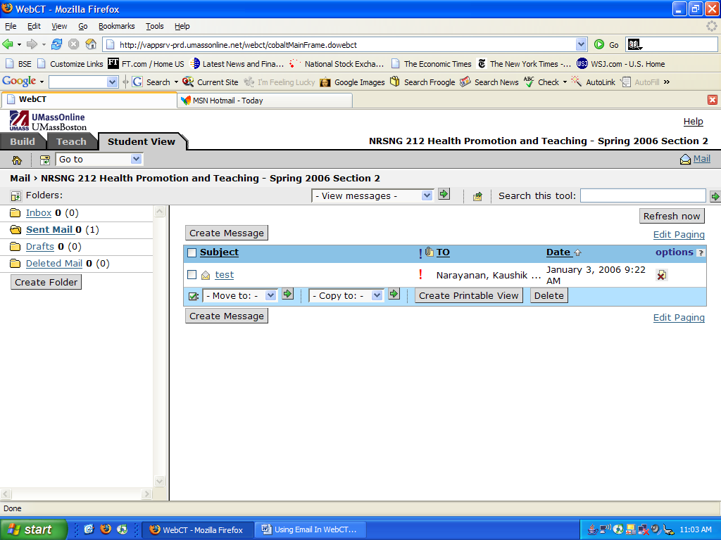

I already have briefly explained the folders in the left corner of the screen viz., inbox, sent mail, drafts and deleted mail. Now, lets go to the main body of the screen.

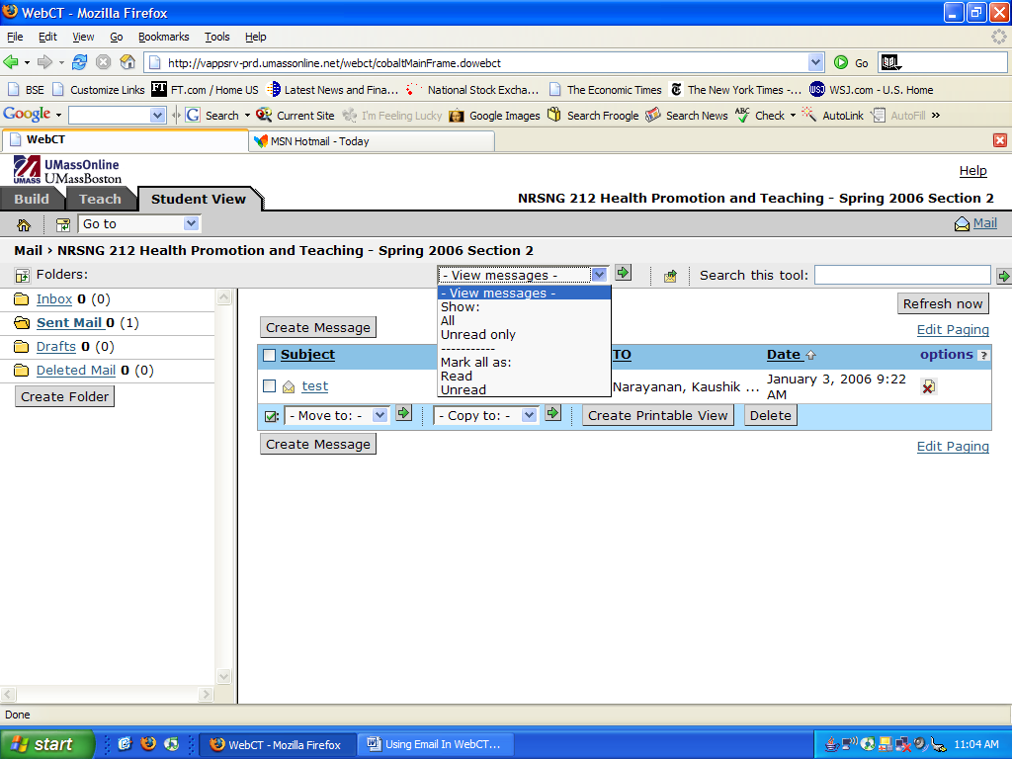

By clicking on the drop down menu on the right/center of the screen, you will see the various options namely, Show: All, Unread Only; Mark all as: Read and Unread.

Show: All means that you will see all your messages. This includes ones you’ve opened and read, responded to, etc.
Show: Unread Only means that you will only see the emails that have not been opened by you yet.
Mark all as: Read will mark all messages as opened/read and consequently if you choose Show: Unread Only you will not see any messages.
Mark all as: Unread will convert even the mails you’ve opened as new/unread/unopened emails.

Before choosing to Mark all as read or unread, make sure you are aware as you will not be able to reverse this action.

MAIL FORWARDING:

If you want to forward your emails to another email address, you can do so by clicking on the icon situated between the View Messages drop down menu and the Search this tool: box. This mail forwarding icon has an envelope with a green arrow on the top. Clicking on this will open a pop-op window as follows.
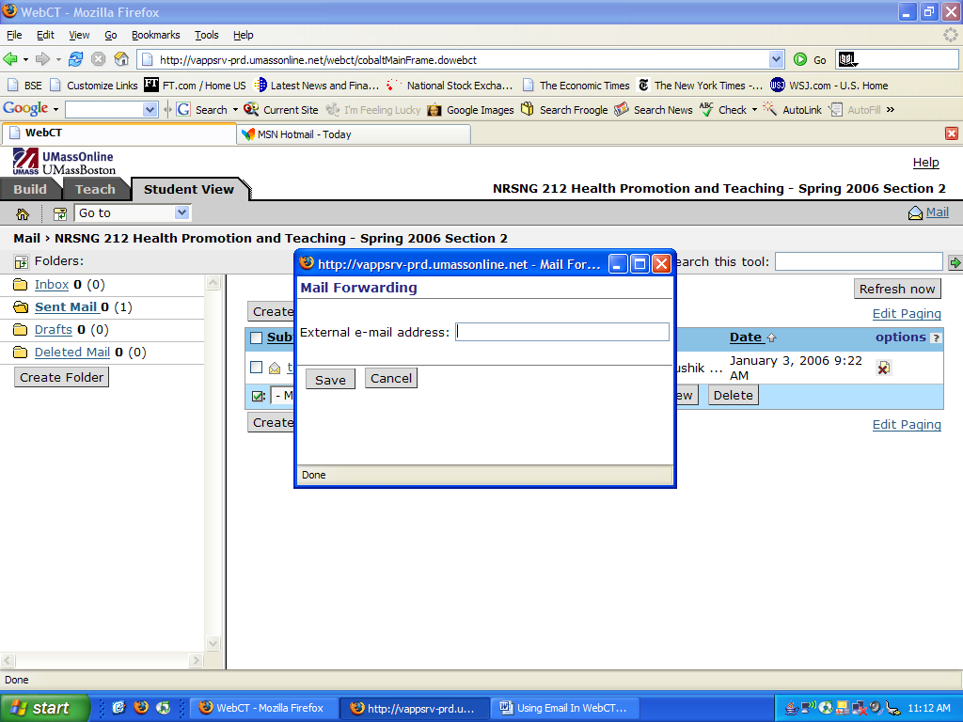

Once you enter the email address you want your mails to be forwarded to, click Save and you will receive all your future emails to the address you entered. Clicking on Cancel will cancel this option and no emails will be forwarded. However, be aware that by opting to utilize this forwarding function, you will not be able to respond to these messages from your forwarded email addresses.

THE SEARCH TOOL:

This is found just below the toolbar on the upper-right part of the screen. You can do a basic search and an advanced search. If you want to search among your messages you need to type in your search and click on the right green arrow next to the box. If it is an invalid search, then you will see something like this.

Now you can choose the Advanced Search options.

Here, you can do either-Start a New Search or you may even search within the search results. There is a red asterisk near Search. This means that this field can’t be left blank. Moreover, you can by checking/unchecking fields, and, choosing to include/exclude fields, determine the scope of your search in the Search Area which includes Title, Author, Subject and Full Text of the email.

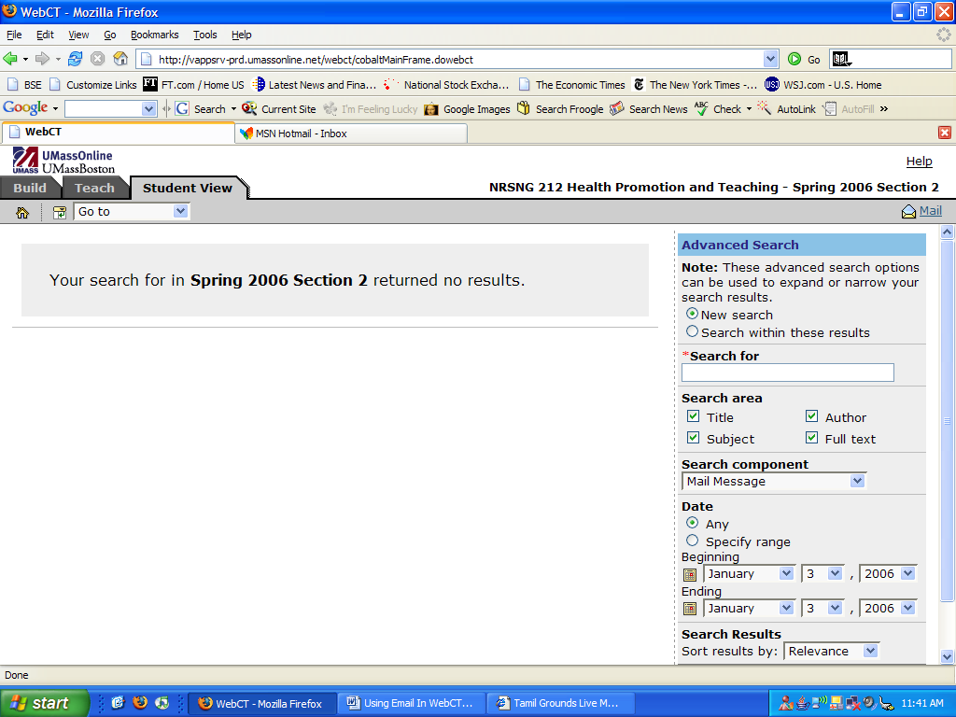

The Search Component drop down menu gives the following options.

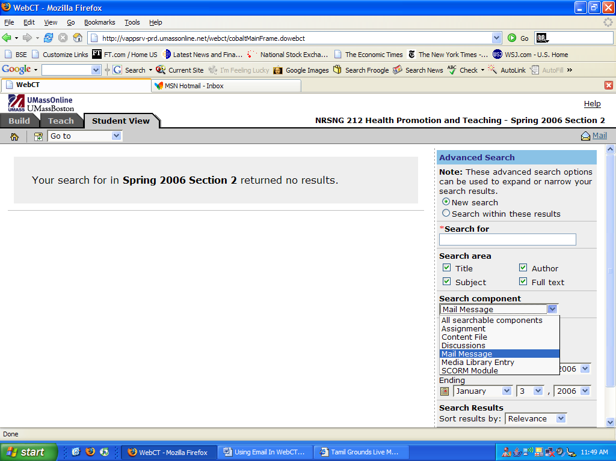

This dropdown menu gives you the option to choose the sub-module of your search. For higher number of results, choose All searchable components.

The last option in this search feature is the date range. You may choose any or choose the from and to date ranges to narrow your search. The calendar icon on the left gives you the option to just click on the date too.

Sorting your search results:

Lastly, search results may be sorted in different ways namely, Relevance, Title, Component, Author or Date.
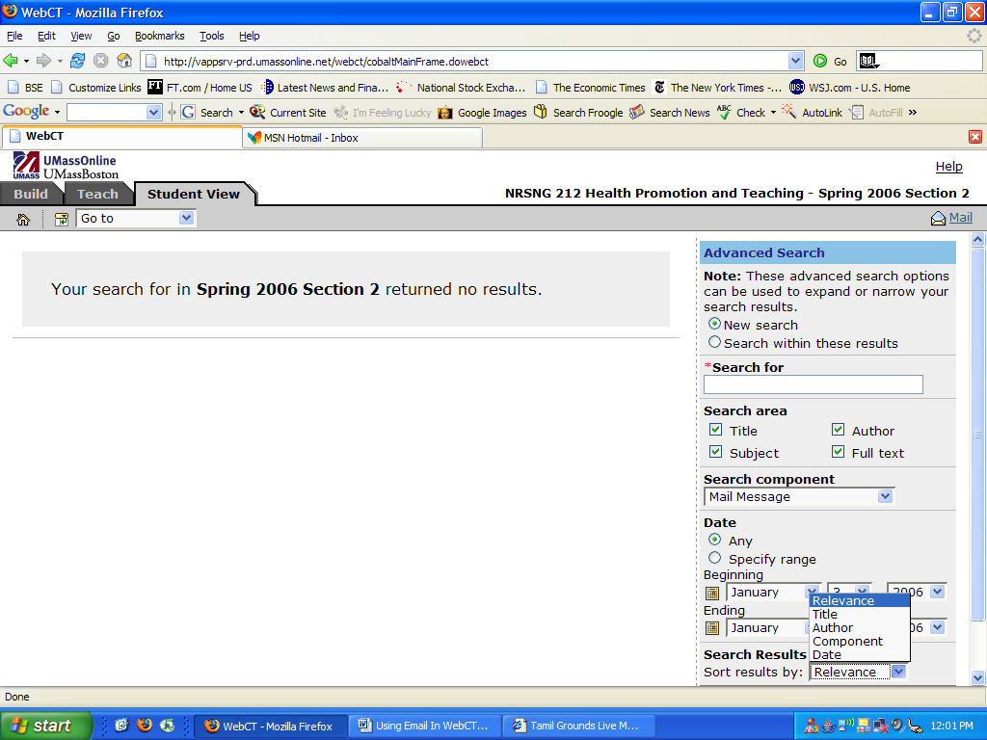

Once you choose your search criteria, click search and you’ll find your results.

Again, you can sort your results with a specific number of records per page. You can get to this option by clicking on Edit Paging. This is illustrated below.
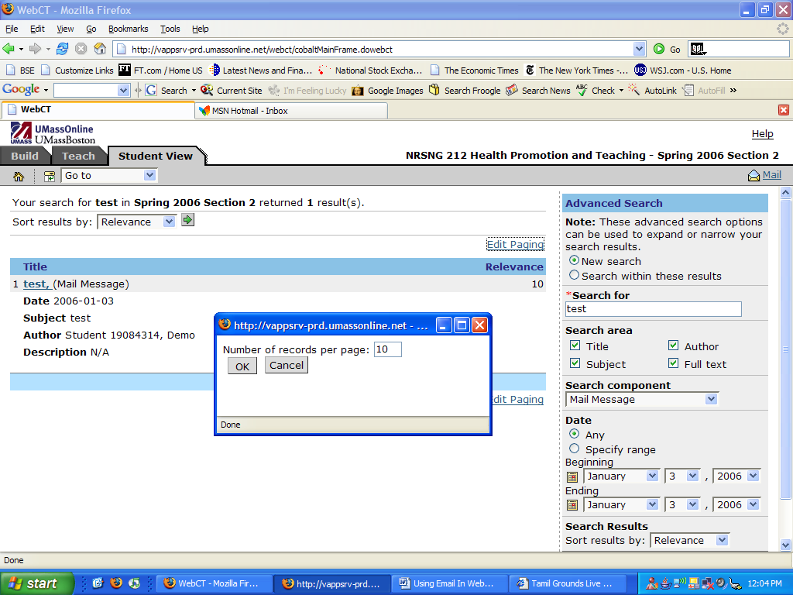

Composing Mails:

From your inbox page, you can see two gray boxes with the words Create Message. To send an email/compose mail, click Create Message and it will open up a box like this.

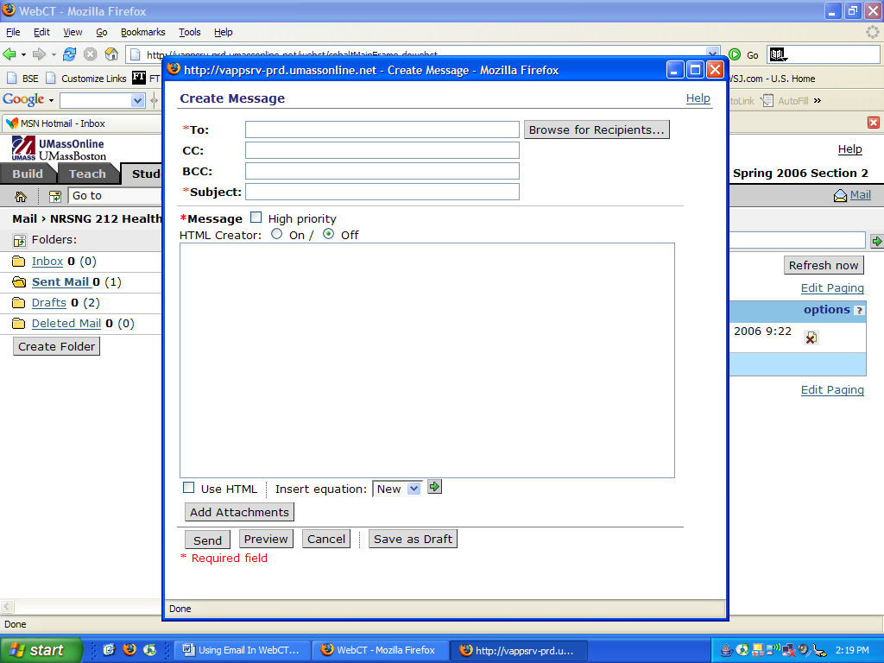

The email id in the To box is the recipient of the email. You can either fill in the email id of the person by hand or you can click on Browse for Recipients… …which gives you the list of email ids of students who are in your course.

Please bear in mind that there has to be at least one email id in the To box, and the Subject box can not be empty.

You may choose to send the email with high importance or not. If you choose the mail to be of high importance, then the recipient(s) will see a red exclamation mark indicating that the message is off high importance.

The HTML Creator option is for the purpose of graphics. If you are planning to just type in text, it can be set to off. But if you want to make bold, italicize, etc, then you set it to on.

You can also insert an equation( like say, a mathematical equation) by clicking on the green arrow next to the drop-down menu in the New Equation at the bottom of the message content.

You may also add attachments as follows:

Click on Add Attachments and you will see something like the following. Here, you have various choices. You could upload a file from your computer. You could upload a file which already exists in the server. You could create a new file and upload it. You could create a new folder. You can click cancel to not attach any files.

Once you’ve selected the attachment, click Add Selected. Then you are ready to send your email, with or without attachments. You also have the option to preview your email-you can do this by clicking on the preview button on the bottom of the screen.

You can save this email as a drat and send it at a later point in time.

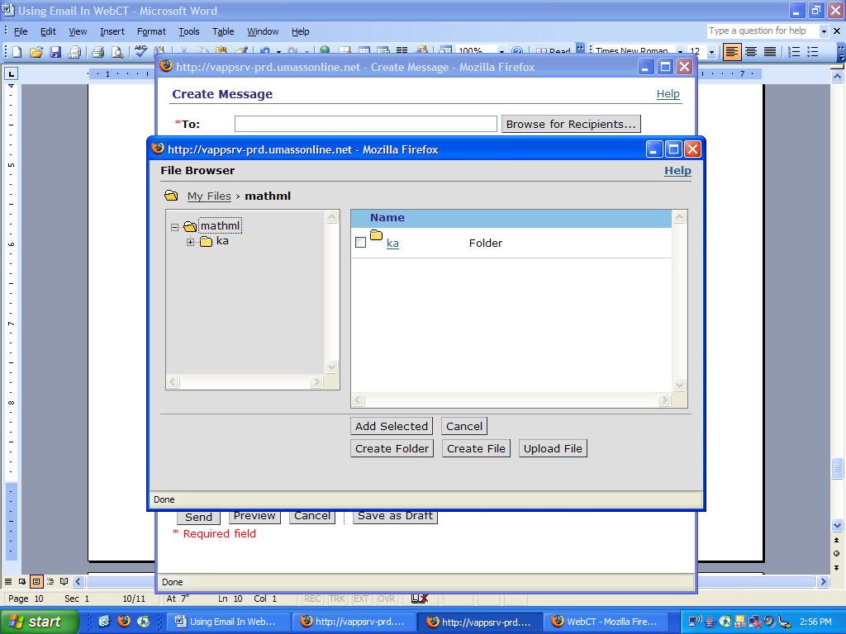

EMPTYING DELETED ITEMS FOLDER:

All emails you delete will remain in the deleted items folder until they are manually deleted. To do this, click on the deleted items older on the left of your screen. Check all messages and click delete. You will be asked in a pop-up window if you are sure you want to delete them. Clicking ok will permanently delete the files. Please be noted that you can not reverse this action.

SOME OTHER POINTERS WHILE USING WEBCT

- Run a browser check by clicking on the tab once you go to boston.umassonline.net and login. This will help you see if cookies are enabled, pop-ups allowed, etc.
- Please check that your anti-virus software doesn’t hinder your WebCT program from performing to its fullest.
- Contact the support team if you experience any problems.

