Copy Course Content from Prometheus

This handout will cover copying and pasting content from the various areas of your course; Syllabus, Outline, etc. to a Word document. See Download Files from Prometheus Files Area for instructions on downloading files from Prometheus.

Access the content you wish to copy, for example Outline, Session 1.

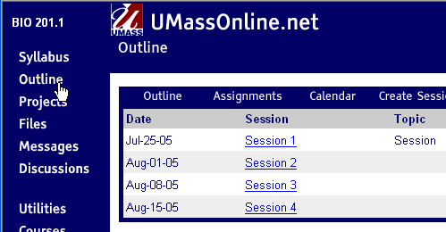
Click to select area to copy
Click to select session to copy

Select the entire text area within the content area. This will select all of the text as well as paragraph formatting, including fonts, background colors, web links, etc.

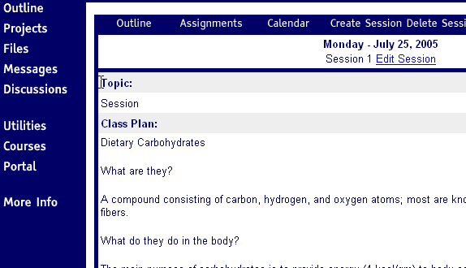
Click and drag your mouse from top of content area to bottom of page to select text.
Content area

Select Copy from the internet browser’s File menu.

Create a new document in Microsoft Word and select Paste from the File menu.

As illustrated below, Word retains most formatting from Prometheus which may not be desirable. By retaining Prometheus formatting it is difficult to recreate the same Prometheus heading styles and table formatting.
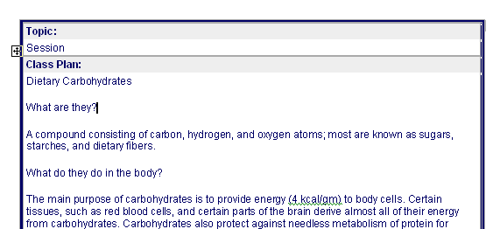
Prometheus heading style
Prometheus generated a series of tables with a background color for heading styles. This format is difficult to reproduce in Word and other web page creation applications.
Example of a Word document with content that has been copied from Prometheus

NOTE: It is most likely that your Prometheus pages link to other files in your Prometheus course. These internal links will no longer function when you move the pages over to WebCT Vista and will need to be recreated.

Saving your file in Word format – with Prometheus formatting
To save your file in Word format and maintain Prometheus formatting, select Save from the File menu. To save your file as a web page, see Saving your file as a web page below. You may want to create a folder on your hard drive that contains all of your course files. Be sure to name the folder something descriptive, that includes the department name, course number, followed by the semester and year; for example: ENG101Spring2005.

Once your file is saved in Word format, you can always save a copy of the document as a text file, which removes all formatting. This will allow you to create a different look and feel to your pages which will make pages much easier to edit.

Saving your file in text format – without Prometheus formatting
This process will remove all text and paragraph formatting, web links and images.

1. Open your document in Word
2. From File menu select Save As, select Plain Text from Save as type box.

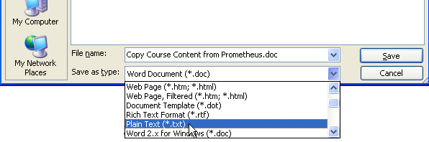

3. Click Save.
4. Click OK to the File Conversion prompt.
5. Close the file. From the File menu select Close.

Next, open the file you just saved

From the Open dialog box, select All Files from the Files of type box. This will allow you to view the file you just created, which now has a .txt extension.

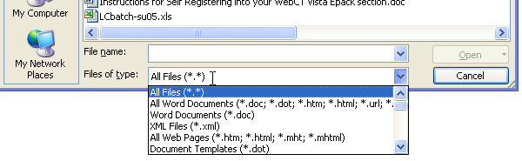

Click Open.
You will now be able to reformat the document. Be sure to save the file as a Word document again, after making changes.

Saving your file as a web page

After reformatting your pages, it is possible to save them in native Word format or web page format. If you choose to save as a web page it is recommend to save as a Filtered Web page. From the File menu in Word, select Save As, click on Save as type drop down box and select the Web Page, Filtered option, then click on the Save button.

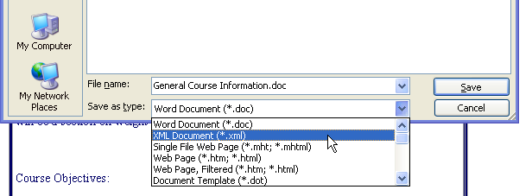

The advantage of saving as a web page, is that the page will usually appear within the same window as the link that opened it, as opposed to opening in a new window and launching MS Word.

