Creating WebDAV Folders in Windows XP
- From within your WebCT Vista course Build Tab: Basic View, Click File Manager from the Designer toolbar.
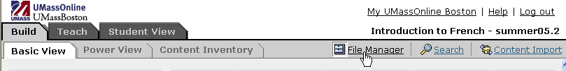
- From the File Manager screen, scroll to the bottom of the page.
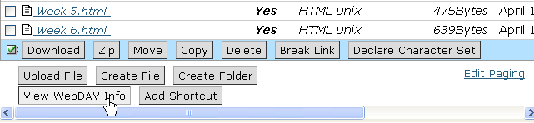
- Click View WebDAV Info. A pop-up window appears, displaying the server path to the folder in the WebDAV path to this folder is text box.
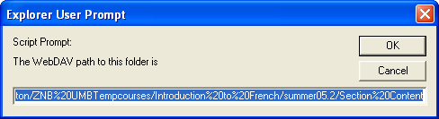
- Ensure that the text is selected in the WebDAV path to this folder is text box. The text will be highlighted as it appears in the graphic above. Press Ctrl+C on your keyboard. The text is copied to your computer's clipboard. Click OK to close the Explorer User Prompt box.
- From the Windows desktop, double-click the Network Neighbourhood or My Network Places icon. The contents of the folder appear.
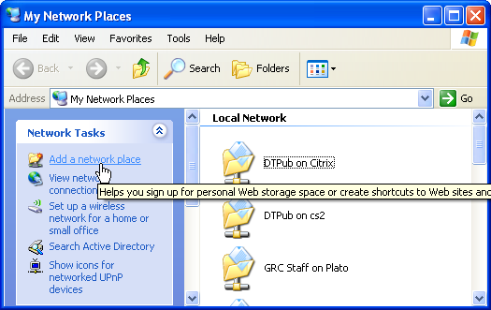
- Click Add Network Place. The Add Network Place Wizard pop-up window appears. Click Next.
- Click Choose another network location and Click Next.
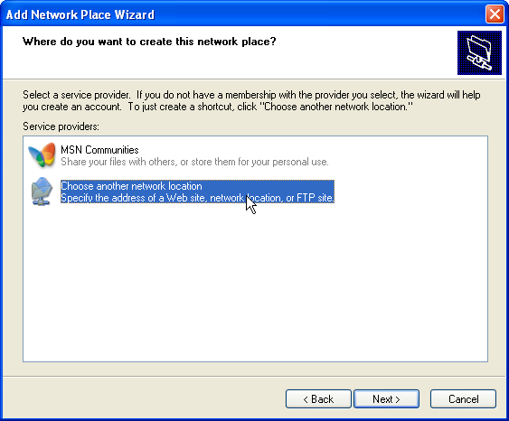
8. Ensure that your cursor is in the Type the location of the Network Place text box and press Ctrl+V on your keyboard. The clipboard's contents are copied into the Type the location of the Network Place text box
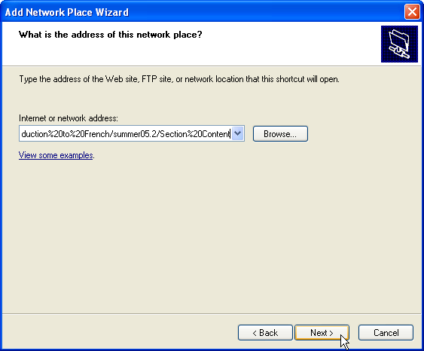

- Click Next. The Connect to vappsrv-prd.umassonline.net pop-up window appears.
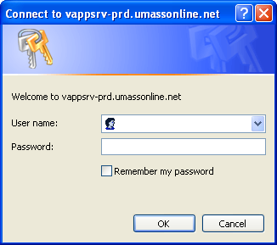
- In the User name and Password text boxes, enter your WebCT Vista user name and password and click OK. The Add Network Place Wizard pop-up window appears.
- Click Next. Windows will attempt to authenticate.
Note: | This may take a few minutes.
- Click Finish. Windows opens the web folder you created in its own window.
You can now drag or copy/move files into this folder, like any other Windows folder. Files added to the folder will be automatically uploaded to the WebCT server whenever you are connected to the Internet.

