Download Files from Prometheus Files Area

You will first want to create a folder on your hard drive that contains all of your course files. Be sure to name the folder something descriptive, that includes the department name, course number, followed by the semester and year.
For example: BIO201Spring2005.

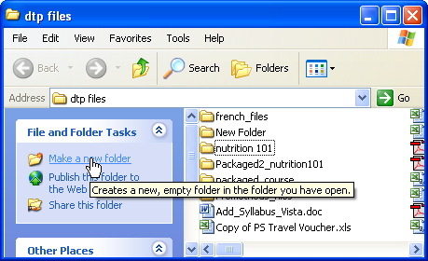
Click on the Make a new folder link OR select New Folder from the File menu.

Login to your Prometheus account using Internet Explorer or Netscape and access the course that contains the files to be copied.

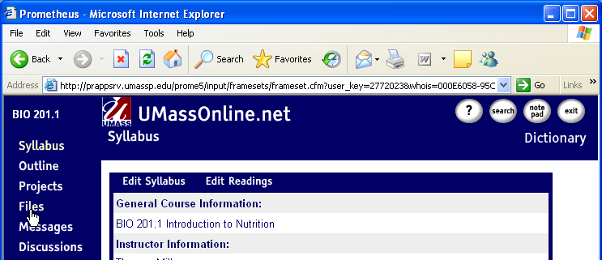

Click on Files.

The Files page appears.

Click on the plus sign beside the folder your course files reside in. This will expand the folder so that you can view the contents. Most often, files are located in the Collaborative Files folder, which appears in the Course Files section. You may have several folders contained within the Collaborative Files folder. Be sure to expand these folders as well.

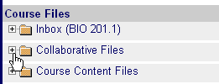

You may also have a Course Content Files Folder listed under Course Files. Be sure to expand that folder as well to check if files have been posted there as well.

The contents of the folder should display as illustrated below:

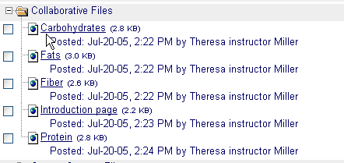

Unfortunately it is not possible to download all the files contained within the folder at once. You will need to download one file at a time. To download a file right click on the file link and select the Save Target As option.

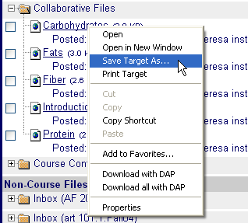

Browse to the location of the folder you created earlier. Click Save.

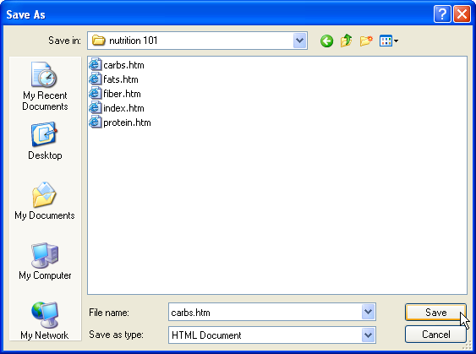

Repeat this procedure until you have downloaded all of the files needed for your course.

NOTE: You may want to re-create folders that reflect the file structure of your Prometheus course. For example, you may have a folder that contains all session 1 files. Be sure to create a folder called session 1 within the folder you created on your hard drive earlier and save the content from each folder into the appropriate sub folder.

