Linking a file to your course home page

Click on the Basic View sub tab at the top of the page. This will take you to the course home page where you can link the files you just uploaded.

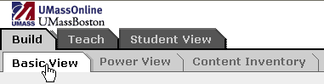

Click on the Content File link from the Add to Home Page menu to the left to add one of the files to your home page.

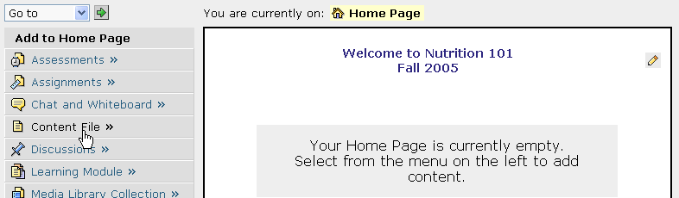

Click on Select File

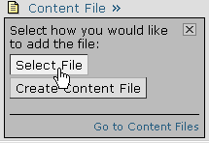

Next, click on the check box beside the name of the file you wish to include on your course home page.

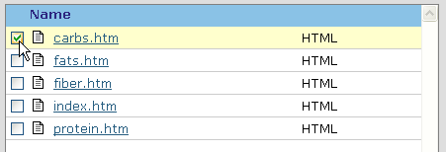

Click Add Selected.

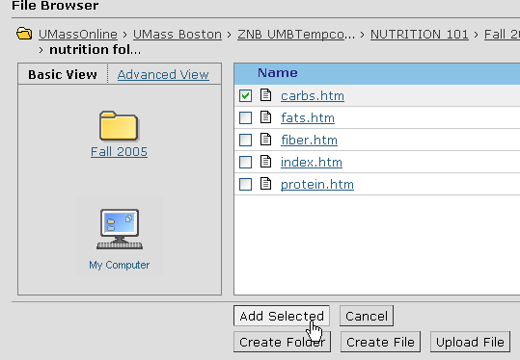

The file you just linked will now be displayed on the course home page.

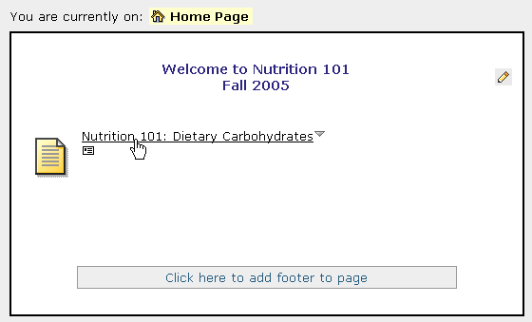

To change the file name or edit the file, click on the file link and select Edit from the menu that appears.

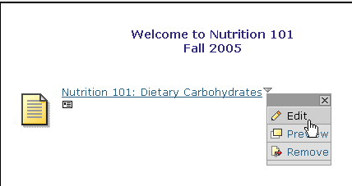

The Edit Content File page appears.

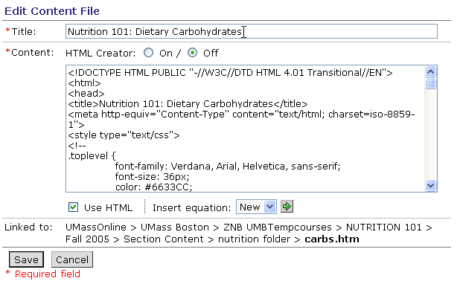
Edit the file title here.
Click the On radio button to edit web pages with WebCT Vista’s built in HTML creator tool.

After making changes to the document, click Save.

