Copy assessments from one WebCT Vista section to another

To copy an existing assessment from one WebCT Vista section to another, you must first export the assessment from the originating section, then import the assessment into the destination section. You will need designer access to the two sections in Vista in order to be able to copy the assessment from one Vista section to another.

Part I: Export the Assessment from the originating section

Log into Vista and access the originating section that contains the assessment to be copied and select Build> Basic View.

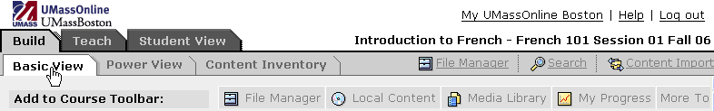
Figure 1 Home page for the section that contains the assessment to be copied.

Next, click on Assessments from Course Toolbar, and Go to Assessments tool. Alternatively you may select the Assessments link from the Content Inventory tab.

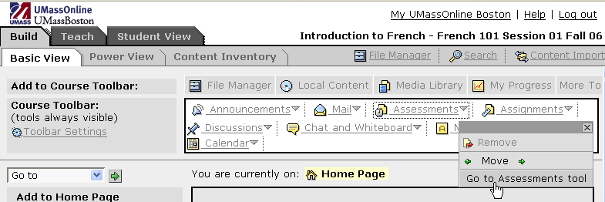
Select Go to Assessments tool from Assessments menu
Select Assessments
Figure 2 Course home page of the originating section.

The Assessments screen will appear. Within the assessments listing, select the assessment to be copied by selecting (checking) the checkbox that appears beside the assessment title. Click Export.

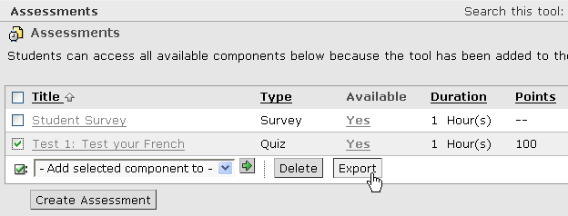
Click Export
Click checkbox to select assessment
Figure 3 Selecting “Test 1:Test your French” in the Assessments screen.

You will be prompted to enter a name for the export content package. Type a file name in the text box. Be sure to avoid including special characters and any punctuation in the file name. Click OK.

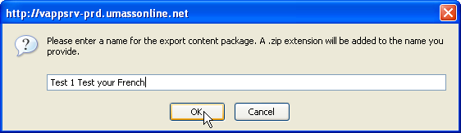
Click OK
Figure 4 The export content package prompt.

The Choose a Folder window will appear. All of the available folders will be listed in the left window pane. Use the vertical and horizontal scrollbars to view the entire listing of folders to navigate to the destination course folder.

We will be creating a subfolder within the destination section that will contain the exported assessment file.

Click on the destination section folder name beside the folder icon in the left window pane. Create a new folder by clicking Create Folder.

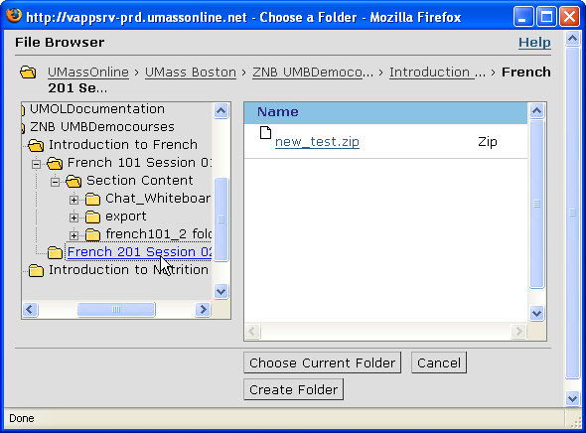
Click on destination section folder name
Click Create Folder
Figure 5 Choose a Folder window: Selecting the destination course folder and creating a new folder.

Enter a folder name and click OK.

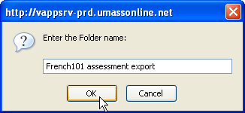
Click OK
Figure 6 Enter the Folder name prompt.

For example, create a folder called “[originating section] assessment export.”
Click on the folder you just created and click Choose Current Folder.

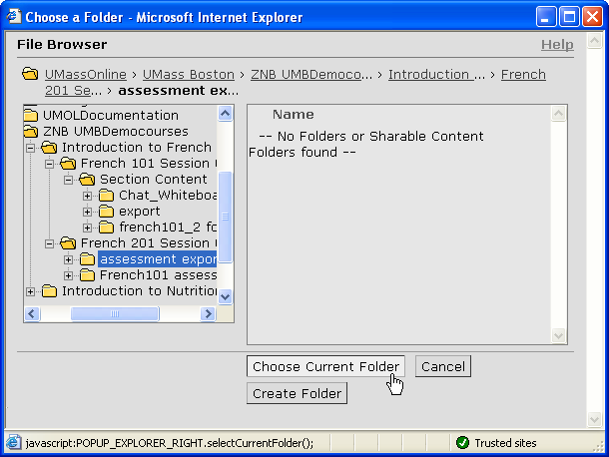
Click Choose Current Folder
Select subfolder created in destination section folder
Figure 7 Choose Current Folder window.

The export log will be displayed. The log should display “The export succeeded.” Click Return.

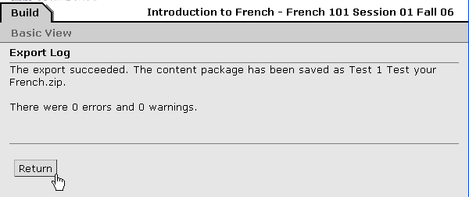
Click Return
Figure 8 Export Log window.

Part II: Import assessment into destination section

Click on the My UMassOnline Boston link and go to the My UMassOnline Boston page.
Click My UMassOnline link
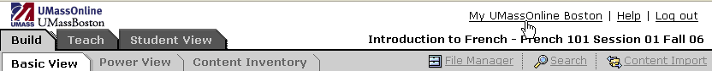
Figure 9 Selecting My UMassOnline Boston link.

Click on the link in the Course List to access the destination section.

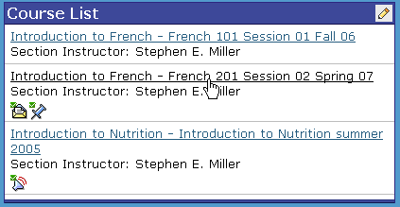
Figure 10 My UMassOnline Boston page.

Select Build> Basic View.

Figure 11 Section home page

If the Assessments tool is not available on the Course Toolbar, you will need to make it available by clicking on Assessments in the Add to Course Toolbar.

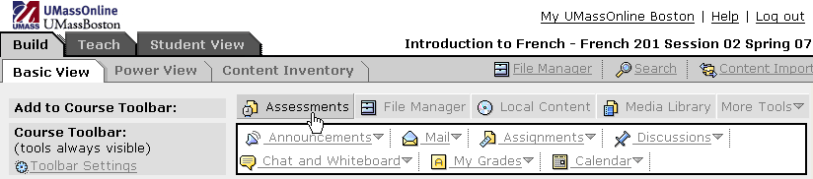
Click Assessments
Figure 12 Add Assessments tool to course home page in destination section.

Click on the Content Import link located on the designer toolbar in the top right hand corner of the screen.

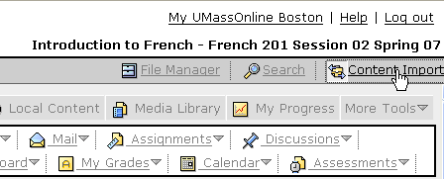
Click Content Import in Designer Toolbar
Figure 13 Selecting Content Import from course home page.

The Choose a File window will appear. Click on the Advanced View link.

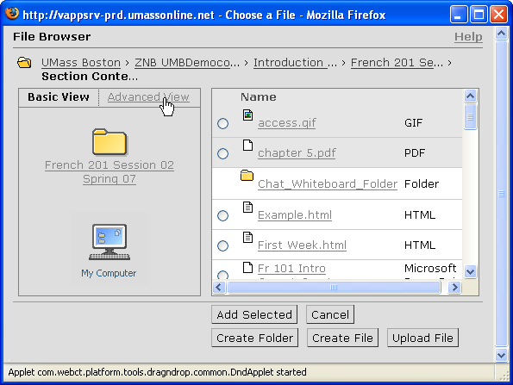
Click Advanced View
Figure 14 Choose a File window: Selecting Advanced View.

Use the vertical and horizontal scroll bars to navigate to the destination section folder in the left window pane. The folder you created will appear under the destination section folder.

Click on the folder name that contains the export content file that you created.

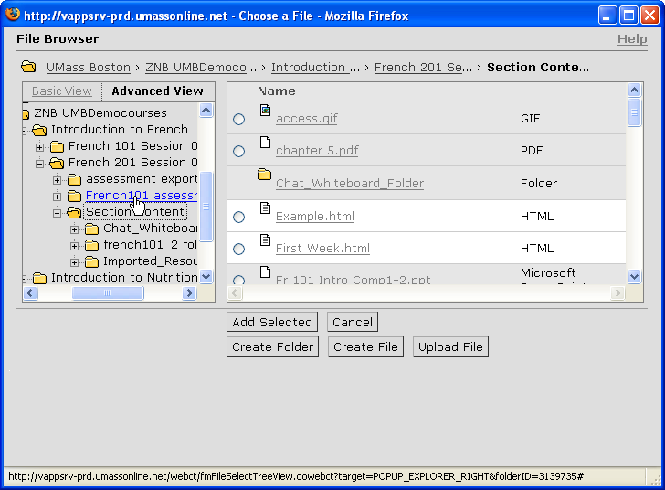
Select the folder that contains the export content file.
Figure 15 Choose a File window: Select the folder that contains the exported folder and file within the destination course folder.

Click on the radio button to choose the content package that you exported. The file will appear with a .zip extension. Click Add Selected.

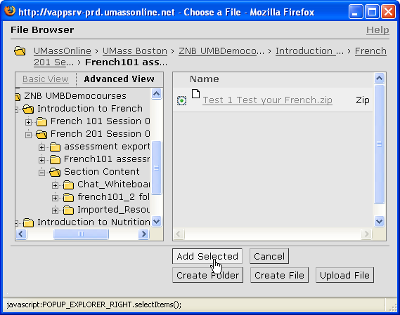
Click the radio button to select the export content file
Click Add Selected
Figure 16 Choose a File window: Selecting the export content package.

The import log screen will be displayed. If the transfer has been successful, the log will display The import succeeded. Click Return.

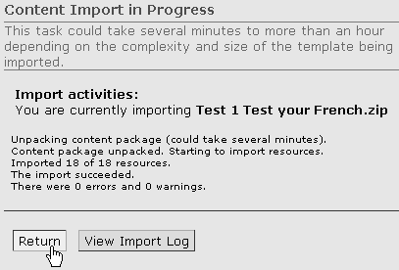
Click Return
Figure 17 The Content Import screen.

Note that if the questions already exist in the Question Database of the destination section, the log will display warnings. Click View Import Log for more detail on warnings or errors.

Within the destination course click on the Assessments, then Go to Assessments tool from the Course Toolbar.
Click Assessments
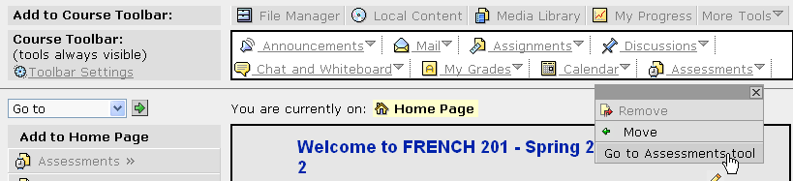
Click Go to Assessments tool
Figure 18 Course home page

The assessment that you just imported should now be listed. Click on the assessment title to view the assessment questions.

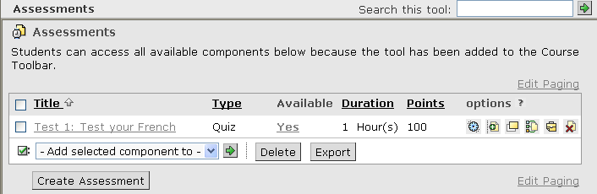
Figure 19 Assessments screen: Lists the imported assessment.

Part III: Removing temporary folder and assessment export content file.

After you have successfully imported the assessment, it is a good idea to remove the temporary folder that contains the export content file you created.

Click File Manager in the Designer Toolbar.
Click File Manager from Designer Toolbar
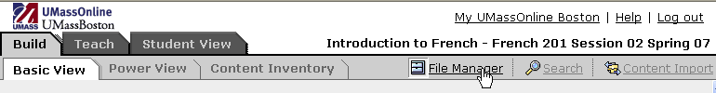
Figure 20 Selecting File Manager from the Designer Toolbar.

Next, click the section name breadcrumb. The folder you created is located one directory level above the Section Content folder, which contains all of the content files for the course.

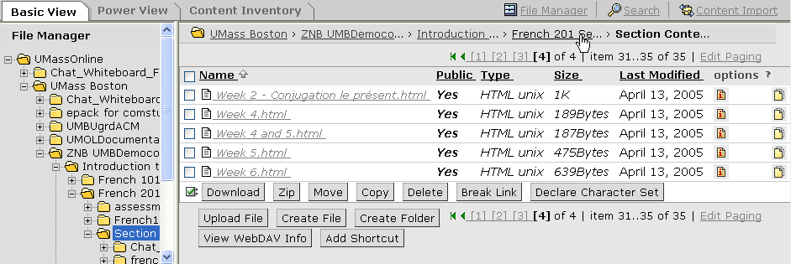
Click the section name breadcrumb
Figure 21 File Manager screen in the destination section.

Delete the temporary folder that contains the export content file by clicking on the corresponding delete icon located on the far right.

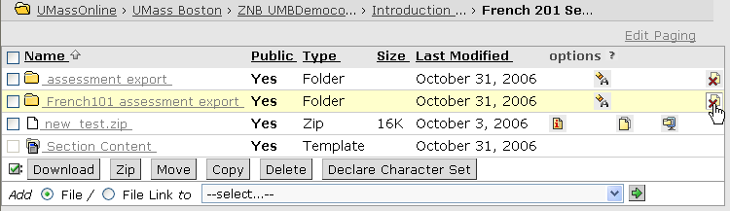
Click the delete icon beside the temporary folder
Figure 22 File Manager: Deleting the export folder.

