Using the HTML Creator in WebCT

In order to add something more to your course page other than plain text, turn on the HTML Creator by selecting the “On” radial button.

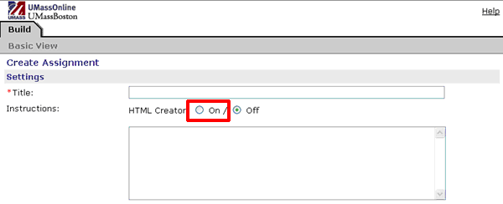

A new box will appear with the HTML Creator. The HTML Creator has a menu bar similar to word processing programs such as Microsoft Word and Corel WordPerfect.

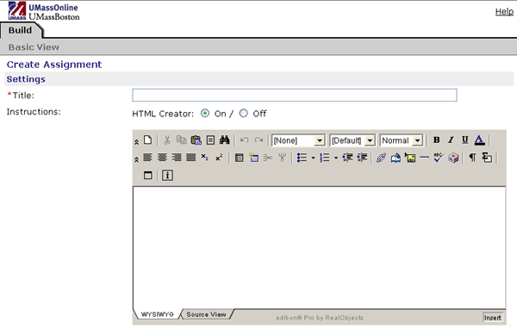

The Menu bar

The menu bar allows you to format text, add images, create bulleted lists, add tables and many other features.

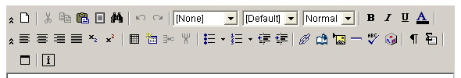

Changing font type and size

Use the drop-down menus to change the font type and/or the font size.

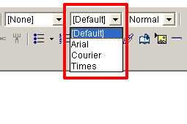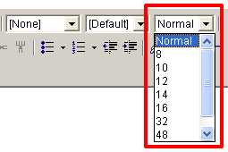

Formatting Text

Formatting text is easy. Using the menu buttons in the upper right section of the menu bar, you can bold your text, italicize and underline it, and change the color of the font.

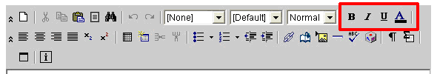

Inserting a table using the “Insert Table” button

Adding tables to organize your text and other elements is easy with the “Insert Table” button.

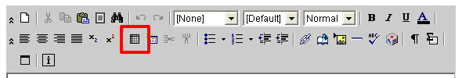

Clicking in the “Insert Table” button will open the “Tables Properties” box where you can choose how many rows or columns you want in your table. Properties of the table can also be set, such as the width of the table and the border, row and column properties, cell properties, and the color of the table’s background and border. The example below shows the “Table Properties” box with the default settings. Clicking the “Ok” button will put the new table on your page, as in the second image below.

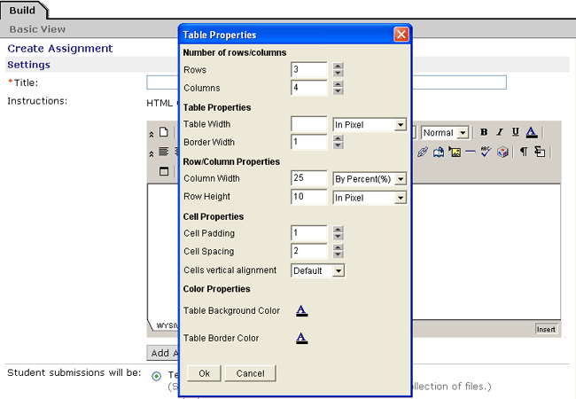

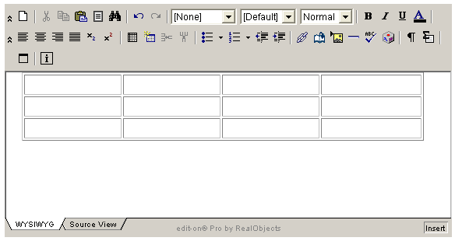

Inserting a table using the “Insert Table Wizard”

The “Insert Table Wizard” button will allow you to create a table of any number of columns and rows.

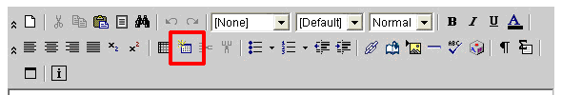

The wizard will open and by dragging with your mouse, you can select how many columns or rows will be placed on your page. In the example below, a table with 3 columns and 2 rows will be created.

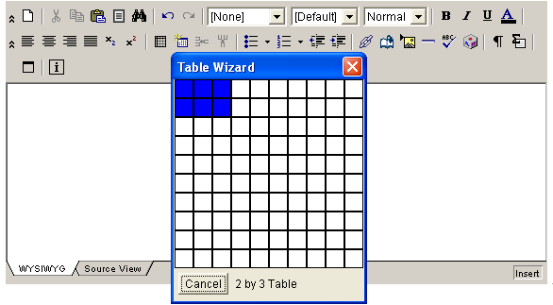

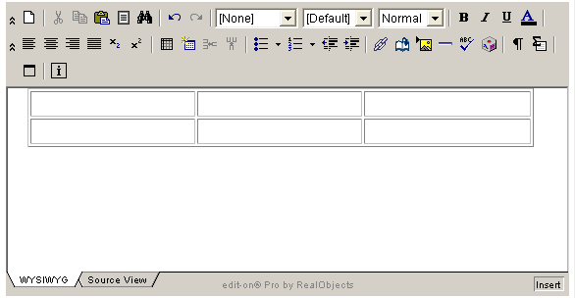

Inserting a link to your page

Inserting a link to a document, image (graphic or photo) is easily done using the “ADDLINK” button.

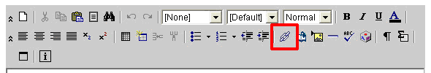

Clicking on the “ADDLINK” button will cause the Insert link pop-up window to open.

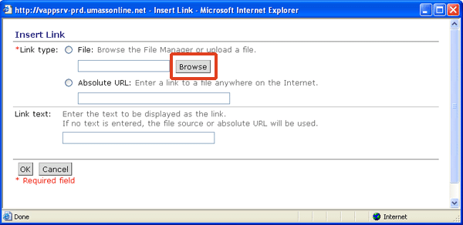

Click the “Browse” button in the Insert Link window and the File Browser window will open. The default view shows documents and images that are you already uploaded to the server. You can select one of those files, or you can choose an image on your computer. If you want to use a file on your computer, select the “My Computer” icon.

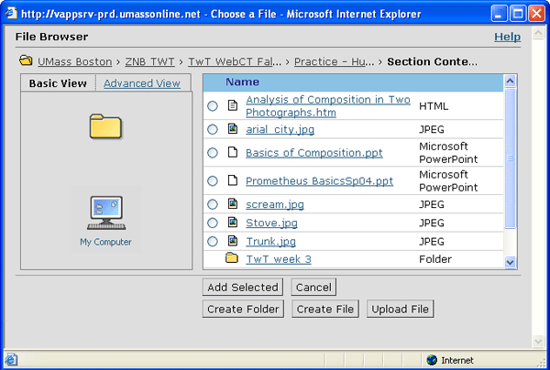

A standard search window will open where you will navigate to the file you want to set up a link to. Select the file and click “Open”. The file will then be uploaded to the server and placed in your Files folder of your course. You can then type in the text in the “Link text” field that you want to display as the link to the file. Click the “Okay” button and the link will then display on your page.

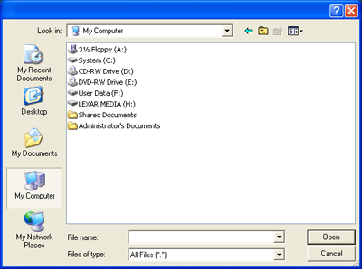

Remember to click the “Save” button at the bottom of the HTML Creator page. You may need scroll down to the bottom of the page to see the “Save” button.

Inserting an image to your page

You can add images (jpegs, gifs, picts, tiffs and other graphic file formats) to your pages by using the “Add Image” button on the tool bar.

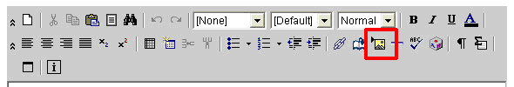

Clicking the “Add Image” button will open the “Insert Image” window.
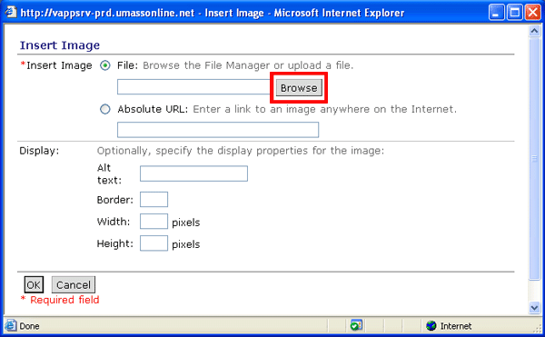

Selecting the “Browse” button will open the “File Browser” window where you can select an image from a file already uploaded to the server, or a file that is currently on your computer.

In the Display section of the “Insert Image” window, you can add alt text (text that would pop up when a mouse cursor rolls over the image), and change the dimensions of the image (in pixels). Note: while it is possible to make size adjustments in this way, it is better to make changes to images in an image editing software program. Click the “OK” button and the image will be uploaded and placed on your course page.

