
Communicating with Students: Who’s Online, Chat and Whiteboard

Copyright © 2004 by WebCT
All Rights Reserved

The content of this manual may not be reproduced or distributed without the express written consent of WebCT. Users acknowledge that the manual, and all copyright and other intellectual and proprietary rights therein, are and at all times shall remain the valuable property of WebCT and its licensors, or their respective successors or assignees. Users agree to respect and not to alter, remove or conceal any copyright, trademark, trade name or other proprietary marking that may appear in the manual.

LR LS 022204 30
Table of Contents

About this Workshop 4
Using Who’s Online 5
Setting Your Status 5
Hands-On Practice: Using Who’s Online 6
Using Chat and Whiteboard 7
The Instructor Role 7
Hands-On Practice: Using Chat as a Student 7
The Chat and Whiteboard Interface 8
Creating Chat or Whiteboard Rooms 9
Editing Room Settings 9
Viewing Chat Room Logs 10
Hands-On Practice: Using Chat as an Instructor 10
Facilitating Chat Sessions 11
Tips for Managing Chat Sessions 12
Hands-On Practice: Facilitating Chat Sessions 13
Using Whiteboard 14
Creating Slide Shows 15
Hands-On Practice: Creating Slide Shows 16

About this Workshop
Research has suggested that the amount and quality of interaction with the instructor, as well as with classmates, is a critical component in student retention, satisfaction, and success in the online environment.
WebCT Vista offers several methods for communicating with your students. For real-time communication, as in a brainstorming session, the Chat and Whiteboard and Who’s Online tools are most appropriate.
In this workshop, you’ll gain hands-on experience with these synchronous tools and learn strategies for using them effectively in your section.
Topics
- Who’s Online
- Chat and Whiteboard
 | Learning Outcomes
After completing this module, you will be able to:
- use the Who’s Online tool to initiate instant, real-time exchanges with students.
- create and edit chat and whiteboard rooms.
- view chat room logs.
- conduct an effective chat and whiteboard session.
- create a slideshow using the Whiteboard tool.

Using Who’s Online
 Who’s Online is a synchronous, instant messaging utility that lets users “see” and “talk to” whoever else is accessing a section at the same time they are. Users can determine their visibility and availability to chat with others who are also online. The feature can be disabled when an assessment is in progress.
 | The Instructor Role
As an instructor, you can:
- see who’s online.
- change your status between visible/available, visible/unavailable, and invisible.
- send chat invitations to others online.

Setting Your Status
- To make yourself invisible or unavailable for chat invitations, under My Status, select the desired option, and click Update.
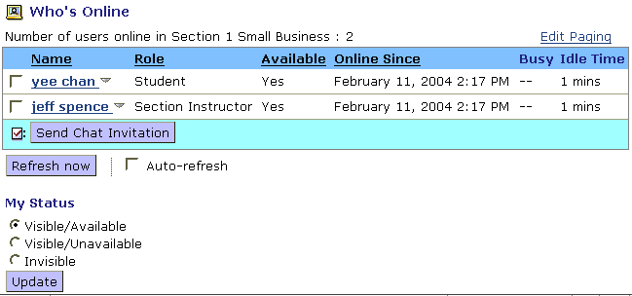
Both students and instructors can set their availability status.
- To invite users to a chat session, select the checkbox to the left of the user’s name and click Send Chat Invitation. A window appears on each user’s screen with the request and a textbox to respond. If the user accepts your invitation, a Chat window is launched.
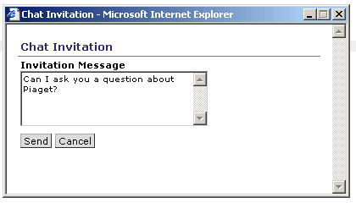

Hands-On Practice: Using Who’s Online
- From My WebCT, check Who’s Online to see who’s available.
- Invite fellow participants to chat with you individually or in a group.
- Change your status to unavailable.

Using Chat and Whiteboard
 | Chat and Whiteboard is a single tool that allows users to communicate and collaborate with each other in real time by sending text messages, creating drawings, and sharing images. Rooms can contain both chat and whiteboard functions or be limited to just one or the other.
Chat rooms are often used for online guest speakers, exam reviews, and study groups. It can be very beneficial for courses that benefit from small group collaboration, as students can meet in groups independent of the instructor for live chats.
Whiteboard rooms are particularly useful in courses where the instructor or students need to sketch out or provide information that’s difficult to convey with words alone. Diagrams, images, symbols, charts, and graphics can all be presented with the whiteboard; participants and students can also chat about the images if the combined chat/whiteboard option is selected.

The Instructor Role
As an instructor, you can:
- create and name rooms: combined Chat and Whiteboard rooms, Chat rooms, and Whiteboard rooms.
- edit room settings to allow for private messages, allow participants to use aliases, set limits on number of users in rooms.
- set availability of rooms by date using Selective Release
- moderate discussions using Handraise mode, Mute, and Deny Access to manage the flow of a session.
- enable and view logged transcripts of room activities

Hands-On Practice: Using Chat as a Student
From the Communication and Feedback student course:
- Access one of the Virtual Meeting rooms as indicated by your facilitator.
- The facilitator will model some of the techniques for managing chat sessions effectively, as you discuss how you might use WebCT’s synchronous communication tools in your course.

The Chat and Whiteboard Interface
- To access the Chat and Whiteboard tool, from the Tool View of the Teach tab, select the Chat and Whiteboard link.
If a specific chat or whiteboard room has been added to an organizer page, you can also access it from the Course View tab.
The Chat and Whiteboard homepage is referred to as the Lobby. From the lobby, you can:
- view room information such as its name and description.
- toggle the room availability
- perform actions such as editing room settings and deleting rooms.
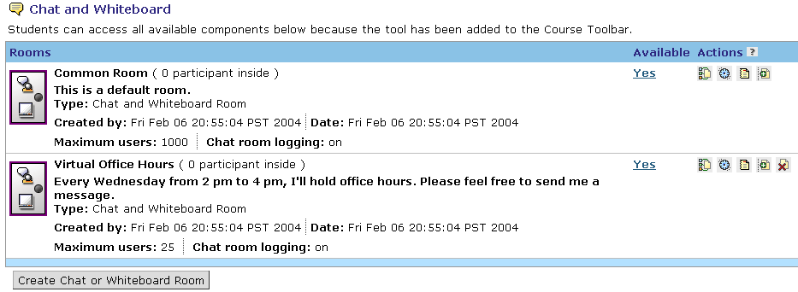
Click to enter a room.

Creating Chat or Whiteboard Rooms
- To create a chat or whiteboard room:
- From the Chat and Whiteboard screen, click Create Chat or Whiteboard Room. The Create Chat or Whiteboard Room screen appears.
- Enter the room Title and Description.
- Select whether the room is Combined, Chat only, or Whiteboard only.
- Enter the Maximum users you want to access the room at one time.
- Expand the More Options section and select the settings you want to apply.
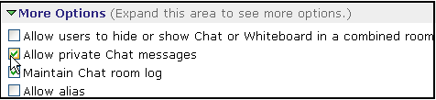
- Click Save. The Chat and Whiteboard screen appears and the room is added.

Editing Room Settings
- To edit the settings for a chat or whiteboard room:
- From the Chat and Whiteboard screen, locate the chat room you want to edit and, under Actions, click its Edit Settings icon. The Edit Room screen appears.
- Edit the room Settings and More Options as desired and click Save. The Chat and Whiteboard screen appears and the room is edited.

Viewing Chat Room Logs
- To view a chat room log, locate the chat room for which you want to view the log and, under Actions, click its View Log icon. The Chat Room Log screen appears and the log is displayed.  - To clear the log, click Clear Log. | 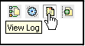

Hands-On Practice: Using Chat as an Instructor
From the WebCT Vista Experience course:
- Create a combined chat and whiteboard room.
- Edit the room settings: change the room title, the maximum number of users that can access the room, and allow users to use and alias.
- Enter the room and type in some welcoming text. Exit the room.
- View the log of your chat session.

Facilitating Chat Sessions
You can monitor chat rooms to ensure good information flow. For example, you can enable Handraise mode so that students must “raise their hand.” After you call on them, they are able to contribute to the chat conversation.
- Set an Entry Chime. The entry chime can be set to play a sound, flash the screen, or both to notify users that another participant has entered the room. This helps maintain group awareness.
- Pass the Microphone. If a student has “raised his or her hand,” pass them the microphone, allowing only that student to “speak.”
- Use Mute. Allows an instructor to prevent a user from contributing to the conversation.
- Deny Access to students, if necessary. Enables you to remove a user from a room. If a user has been removed, you can later allow them to Join.
- Enable Private Messages. Allows users in the same room to exchange messages among each other without others seeing the messages or being aware that they have been sent.
- Enable, analyze, and provide chat logs. While chats occur, a text file is generated for the room, which can then be easily searched, or made available to students.
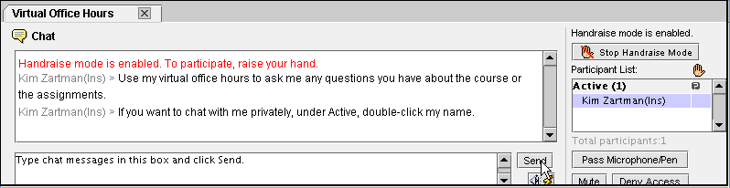
Double-click participants’ names to chat privately.
Click to set an entry chime.

Tips for Managing Chat Sessions
When you conduct face-to-face discussions in class, you and your students usually understand and adhere to the accepted protocol for such discussions. In the online chat environment, you will need to clearly articulate expectations and ground rules in order to keep the sessions focused and productive.
- Place the date, time, and room name for the chat on the Calendar and Home Page of your course. If you have distance students, keep in mind the time differences and specify the time zone.
- Make preparatory assignments available for students to study beforehand. This also helps to focus the discussion.
- Be prepared yourself – have text snippets prepared to copy and paste for the introduction, questions, and wrap-up.
- Don’t let latecomers interrupt the discussion. Have a prepared message to send privately to tardy students, orienting them briefly to the Chat.
- Keep the number of participants to a manageable number. For highly structured sessions, such as an exam review, you may be able to accommodate up to 15 participants. For free-flowing chats, 7 or 8 participants are ideal.
- Provide clear guidelines up front to facilitate communication and minimize confusion.
During Chat sessions, set up a protocol for participants to follow to keep the conversation from becoming confusing. Here is an example of “symbols” participants can use to enhance their online communication:
... You are still active or continuing a thought.
--> You are finished typing and are giving the "floor" to someone else.
? "I have a question." The speaker will then call upon you.
A “I have an answer to a question posed.”
C “I have a comment.”

Hands-On Practice: Facilitating Chat Sessions
From the Communication and Feedback student course:
- Access one of the Virtual Meeting rooms as indicated by your facilitator.
- Several workshop participants should go to the facilitator’s computer and briefly moderate the chat session.

Using Whiteboard
Whiteboard features allow class members to illustrate points with visual cues. You can moderate whiteboard sessions with many of the same features as chat rooms, including allowing private messages, Pass the Pen, Handraise Mode, Mute, and Deny Access.
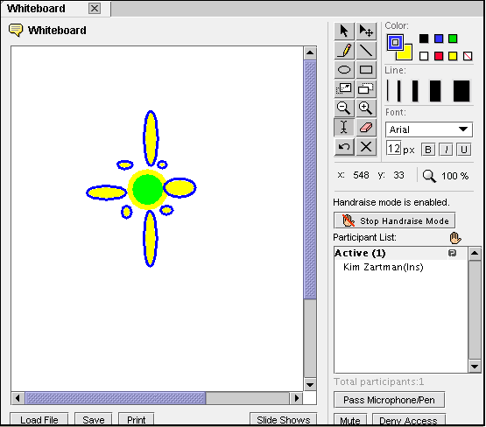
Use the controls to draw images.
Save any image on the Whiteboard in order to use it in a Slide Show.
Click to create, view, or edit slide shows
Click to load an image file stored in the File Manager.

Creating Slide Shows
Images that have been created on the Whiteboard can be saved and assembled into a slide show. Images that have been uploaded to the Chat and Whiteboard folder of the File Manager can also be assembled into slide shows.
Important: Images to be used in slide shows must have a .gif or .jpg file extension.
- To create a slide show:
- From the Whiteboard screen, click Slide Shows. The Slide Shows pop-up window appears.
- Click Create Slide Show. The pop-up window updates.
- Enter a Slide Show Title and select whether you want to enable the slide show to autoplay.
- Click Add Slides and locate and select the slides you want to add.
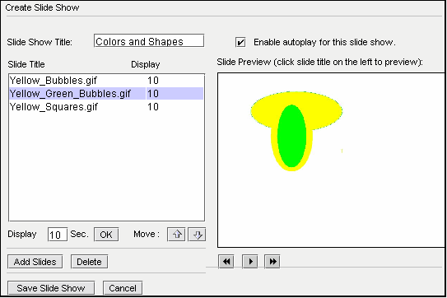
Use the controls to navigate the slide show.
Click to move slides up or down in the list.
- Click Save Slide Show. The Slide Shows pop-up window appears and the slide show is added.

- To start a slide show
- From the Whiteboard screen, click Slide Shows. The Slide Shows pop-up window appears.
- Select the title of the desired slide show and click Load Slide Show. The Whiteboard screen appears and the slide show is loaded.

Hands-On Practice: Creating Slide Shows
- Practice drawing images in the Whiteboard. Save the images to the File Manager with .gif or .jpg extensions.
- If you have other images available, upload them to My Files and add them to the Whiteboard.
- Create a slide show using the images you created with the Whiteboard. Load and view the slide show.

