
Leveraging Discussions in WebCT Vista 3.x

Copyright© 2004 by WebCT
All Rights Reserved
The content of this manual may not be reproduced or distributed without the express written consent of WebCT. Users acknowledge that the manual, and all copyright and other intellectual and proprietary rights therein, are and at all times shall remain the valuable property of WebCT and its licensors, or their respective successors or assignees. Users agree to respect and not to alter, remove or conceal any copyright, trademark, trade name or other proprietary marking that may appear in the manual.
If you have comments or suggestions for improving this manual, please email eddev@webct.com.

LR LS 022204 30
Table of Contents

About this Workshop 4
About Discussions 5
Discussions Tool Functions by Role 5
The Discussions Tool Main Screen 6
Creating Topics 7
Viewing and Posting Messages 9
Tips for Moderating Discussions 12
Managing Discussions 13
Copying and Moving Topics 13
Re-ordering Categories 14
Locking Discussions 14
Moving and Copying Messages 15
Tips for Managing Discussions 16
Grading Discussions 17

About this Workshop
Research has suggested that the amount and quality of interaction with the instructor and classmates is a critical component in student retention, satisfaction, and success in the online environment.
This workshop focuses on Discussions, a valuable tool that supports such interaction and communication. You will work through the entire process of using discussions as an essential teaching tool, from creating the initial categories and topics to grading and managing postings.

Topics
- About Discussions
- Creating Topics
- Viewing and Posting Messages
- Managing Discussions
- Grading Discussions

 | Learning Outcomes
After completing this module, you will be able to:
- create discussion categories and topics.
- create new threads and reply to existing posting.
- move, copy, and lock discussion topics and threads.
- grade student discussion postings.
- identify strategies for effectively using Discussions in the online course environment.

About Discussions
The Discussions tool provides asynchronous communication among instructors, teaching assistants, and students, allowing them to post and read messages.

Discussions Tool Functions by Role
Although we’ll be working in the section instructor role throughout this workshop, designers at all learning contexts can create discussion topics and categories. Section designers can also post and manage messages, and the Discussions interface is virtually identical for section designers and instructors.
Function | Role
Add the Discussions tool to the Course Toolbar  Add discussion topics to the Home Page or Organizer pages | Template Designers  Section Designers
Create discussion topics and categories | Template Designers  Section Designers  Section Instructors
Post and manage (copy, move, lock, delete) postings | Section Designers  Section Instructors
Grade discussion postings | Section Instructors

- Terms to Know
Categories | Categories can be used to group discussion topics. Categories are optional.
Topics | Topics are used to group messages. A topic may be a question or the introduction of a new concept.
Messages | The individual posts to a topic.
Thread | A series of replies to the same message. A message thread consists of the original message and any replies to either the original message or to a posted reply. Messages may be viewed as threaded or unthreaded – if unthreaded, messages are shown in the order they were posted, regardless of topic.

The Discussions Tool Main Screen
- To access Discussions as a section instructor, select the Tool View sub-tab. From the list of Other Tools, click Discussions. You can also access Discussions from the Course Toolbar of the Course View, if the tool has been added to the Course Toolbar.
The Discussions screen shows all discussion categories and topics.
Categories  Topics | 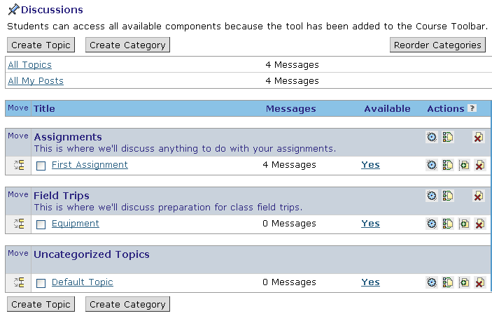
The main screen of the Discussions tool contains:
- Categories, which are optional areas in which you can group discussion topics.
- Uncategorized Topics, which lists in alphabetical order all the topics that have not been placed in categories.
- To view the messages posted to a topic, click the topic name. The Messages screen appears.
- To view only your posts, click the All My Posts hyperlink.
- To view all postings to all topics, from the Discussions screen, click the All Topics hyperlink.

Creating Topics
You can create discussion topics on their own or within discussion categories. You can also determine whether posts are gradable, and if they are anonymous.
- To create topics:
- From the Discussions screen, click Create Topic. The Create Topic screen appears.
- Enter a title and description.
- Select options as required. A topic can have none, some or all of the following options:
- Gradable - Creates a column in Grade Book, allowing you to mark students on their contributions to the topic. If you make a topic gradable, you cannot revert back to non-gradable.
- Editable – Members can edit their own posts.
- Locked - Users can read messages, but cannot post messages.
- Anonymous -Indicates whether posts to this topic do not include the author’s name.
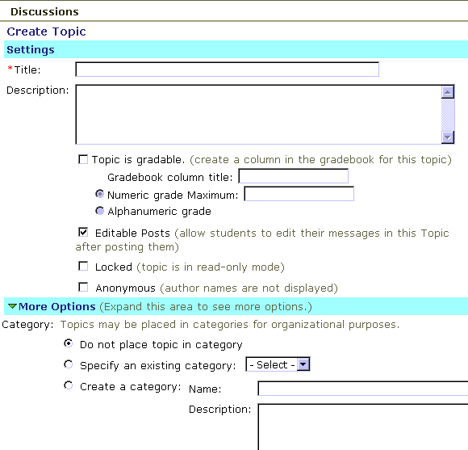
- To put the topic in a category, click More Options and specify the category.
- Click Save.
 |  | Anonymous Discussion topics enable the instructor to make "temperature checks" and gauge students’ understanding and concerns throughout the course. Feedback regarding the progress of the course can be solicited so that you can make necessary changes.
You can create private group forums with Selective Release. Select the Set Release Criteria icon for the topic. From the Group Criteria option, choose the Group you want to release the topic to.
Alternatively, from Group Manager, you can create group activities, including Discussion Topics that are only available to group members.
Anonymous Discussion topics enable the instructor to make "temperature checks" and gauge students’ understanding and concerns throughout the course. Feedback regarding the progress of the course can be solicited so that you can make necessary changes.
 | Hands-On Practice: Creating Topics
- Create a gradable discussion topic that would be appropriate for a section you teach. Create a category for the topic.
- Create a second uncategorized topic. Allow students to edit their postings.
- Create a private topic for an existing group.
Web Link |  |  | For more information on using online discussions successfully in your courses, read WebCT user Karen Peters’ three-part article.  Creative Use of Threaded Discussion Areas: Five Specific Educational Advantages of Courses with Online Discussion Tools  http://www.webct.com/OTL/ViewContent?contentID=898084  Creative Use of Threaded Discussion Areas: Key Issues in Asynchronous Learning Environments  http://www.webct.com/OTL/ViewContent?contentID=898085  Concrete Steps for Online Discussion: Strategies and Examples of Current Practice  http://www.webct.com/OTL/ViewContent?contentID=2711014

Viewing and Posting Messages
- To access the message screen, click the hyperlinked topic title from the main Discussions screen.
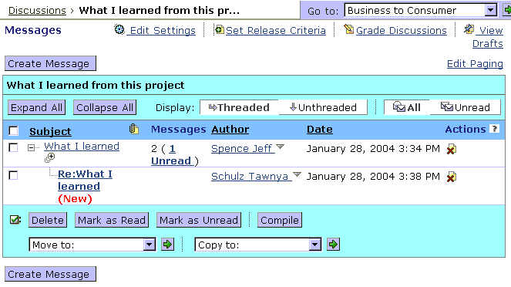
The Messages Screen
Threaded option is selected.
Click Expand icon to view titles in thread.
Compile icon
- To view all message titles in a thread, click the Expand icon.
- To read a message, click its hyperlinked subject.
- To view all messages in a thread:
- Click the hyperlinked topic. The Message screen appears.
- Click Display Complete Thread. A screen containing all messages in that thread appears.
- To print or save all messages in a thread for offline viewing, select the messages that you want to compile and click Compile.

Posting Messages
- To start a new thread:
- From the Discussions screen, select the topic by clicking the topic’s hyperlinked title.
Click the topic title to access the Message screen.
- From the Messages screen, click Create Message.
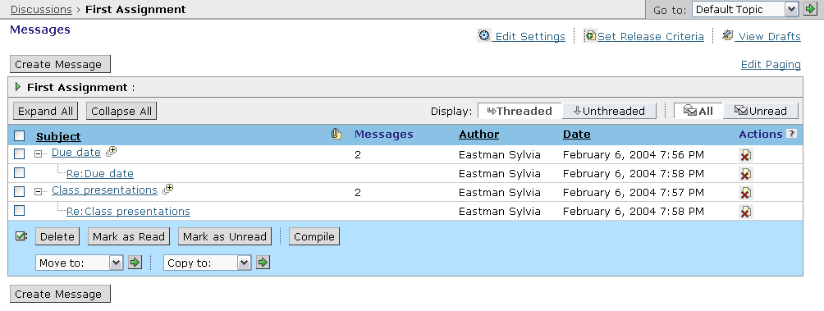
Click Create Message to start a new thread.
- In the Message window, enter a subject and message.
- Click Post.

- To reply to a posted message:
- From the Discussions screen, select the topic by clicking the topic’s hyperlinked title.
- From the Messages screen, select the post by clicking its hyperlinked title.
Click the message subject to view the post.
- In the Message window, click Reply. The Reply window appears with the Subject text box pre-filled.
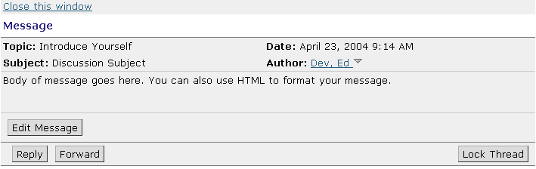
- Enter text in the Message text box, and click Post.

Hands-On Practice: Viewing and Posting Messages
- Create a new posting for one of the topics you just created.
- Reply to several other postings.
- Experiment with viewing messages: expanded, compiled, threaded vs. unthreaded, all versus unread.

Tips for Moderating Discussions
- Provide a positive role model for your students. If you post thought-provoking questions and fair comments, it will be natural for your students to follow suit. Provide honest feedback on students’ postings.
- Establish your presence and provide guidance. Let students know what to expect of you - how often you will check and respond to messages.
- Communicate your expectations in concrete terms. Provide written guidelines for online communication (message length, content, number of posts), agendas, and objectives for each discussion activity.
- Start discussions and offer structure, yet allow room for students to talk to each other rather than read an instructor-dominated “lecture.”
- Just as you do in the classroom, remember that students will have different communication styles (dominant vs. passive/shy) or special needs (poor writing skills, non-native language issues). For example, conversation dominators may need to be reeled in, while shy students may need encouragement to participate and support to elaborate on their ideas.
- Create a social area within the course. Students don’t have the opportunity to converse in the hallways, so provide a discussion topic or chat room that is strictly for fun - a virtual student lounge.

Managing Discussions
As the semester progresses, you will want to manage postings to keep Discussions current and uncluttered. For instance, you may need to:
- copy or move topics.
- re-order categories.
- copy or move postings to other topics.
- lock topics or threads.

Copying and Moving Topics
You can copy or move topics within or between categories. For example, you might want to move the most current topic so it’s at the top of the list, or you might decide to move a topic to a different category altogether.
- To move or copy an existing topic:
- Select the check box next to the discussion topic you want to move or copy.
- Click the Move icon either above or below where you want to move or copy the topic to. A list of options appears.
Note: You can move or copy the selected topic within the same category or to a different category. You can also select multiple topics to move or copy simultaneously.
- Select whether you want to move or copy the topic above or below the Move icon you selected.
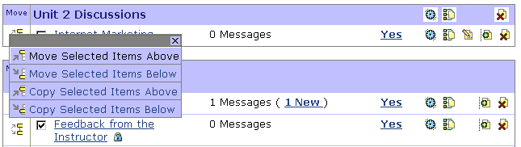
The Move and Copy icons allow you to move discussion topics to categories.

Re-ordering Categories
You may want to re-order categories so the most current and relevant are at the top of the Discussions screen.
- To reorder categories on the main discussion screen:
- Click Reorder Categories. The Reorder Discussion Categories screen appears.
- Select the check box next to the category you want to move.
- Click the Move button in the row just below where you’d like the category to appear.
- Click OK.
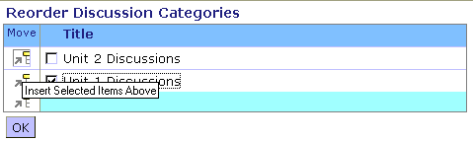

Locking Discussions
Discussions topics and threads within topics can be locked to prevent students from posting new messages. If a thread is getting too far off topic, for example, lock it and encourage students to start a new thread. Or, if discussions for a certain topic were to be completed by a certain date, lock the topic after the due date.
- To lock a topic:
- From the Messages screen, click Edit Settings. The Edit Topic screen appears.
- Select the Locked check box and click Save. The topic is now “read-only;” students can read postings already in the topic but cannot add new ones.
- To lock a thread:
- From the Messages screen, click the hyperlinked name of the thread you want to lock. The Thread Messages screen appears.
- Click Lock Thread and close the screen.

Moving and Copying Messages
Throughout the semester, students will inevitably post messages to the wrong topics. As an instructor, you can move (or copy) messages from one discussion topic to another. Moving a message also moves all replies to that message.
- To move or copy a message:
- From the Messages screen, select the message you want to move or copy.
Note: You can also select multiple messages.
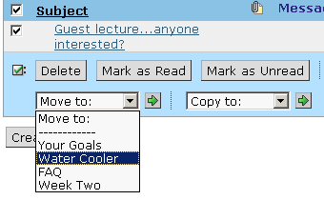
- From the Move to or Copy to drop-down list, select the topic to which you want to move the message and click the Go icon. A confirmation message appears.
- Click OK. The Messages screen appears if the new topic is empty; the messages will be moved or copied. The Specify Thread pop-up window appears if the topic contains existing messages.
- If the Specify Thread pop-up window appears, you can select the thread that you want to add the message to. Do not select a thread if you want the message to be moved or copied as a new thread.
- Click OK. The Messages screen refreshes and the moved or copied message appears as replies under the selected message in the new topic

Hands-On Practice: Managing Discussions
- Create several discussion topics appropriate for your discipline. Make at least one discussion gradable. Add one of the topics to a new category.
- Reorder the categories.
- Move and copy several topics and messages.
- Experiment with locking topics and threads. What happens to the messages screen when you lock a topic or message thread?
- Grade several of the messages posted to the Facilitating Discussions topic.

Tips for Managing Discussions
- Monitor the activity level of your Discussions topics frequently. Students will lose interest if they aren't getting responses. They need your direction and encouragement.
- To keep the Discussion area focused, it is useful to close or archive topics that are no longer active. This streamlines the Discussion area, making it easier for you and you’re your students to access active discussion topics.
- Have a back up plan. Technology is not perfect, so an alternate means of completing activities should be ready to implement if the need arises.
Web Link | Time Management Strategies for Online Teaching  http://www.tact.fse.ulaval.ca/ang/html/timesaver.html  It's About Time: Time Saving Strategies  http://www.onlinelearning.net/InstructorCommunity/  Go to Teaching Resources heading ⇒ Teaching Tips ⇒ August 2000.

Grading Discussions
You or the designer can create a gradable discussion. When you create a gradable discussion topic, you can:
- grade the student directly from the Discussions tool.
- view an activity overview that provide statistics on the average number of messages read, the average number of messages posted, and the average number of replies.
- view an individual student’s posts and save or print the posts.
- To grade a discussion topic:
- From the Discussions screen, in the row containing the Discussion to grade, under Actions click the Grade Discussion icon.
The Grade Discussion screen appears. It shows each student who has posted a message to discussion, a Discussion Activity Overview, and a Student Overview.
Grade Discussions
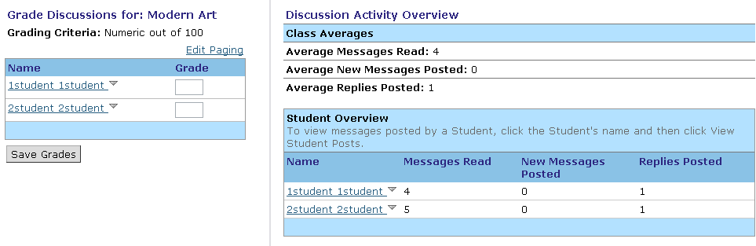
- To view a student’s posts, click the student’s name, and from the menu that appears, click View Student Posts. | 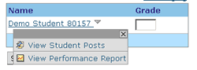

The Student Discussion Posts screen appears, displaying the student’s postings for the topic, along with summary information on the number of new messages, the number of replies posted, and the number of messages read.
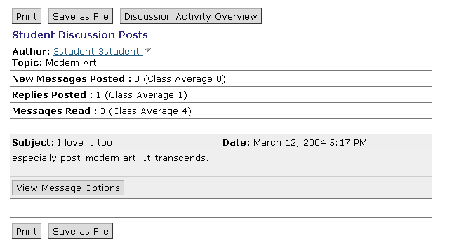
You can print or save the messages for off-line grading or record-keeping.
- After viewing the messages and summary information, enter a grade in the Grade text box and click Save Grades. The results are entered in the Grade Book tool.
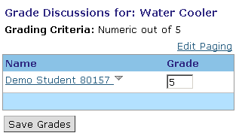
The Grading Criteria indicates the maximum number of points.

Hands-On Practice: Grading Discussions
- Select the Grade Discussions option for the Facilitating Discussions topics.
- View the Discussion Activity Overview information.
- View and grade one student’s post.
- Click the student’s name and send them an email with either positive feedback or suggestions for improving their postings.

Tips for Grading Discussions
If you decide to grade discussions, it is essential to provide clear protocols for how their contributions will be assessed: qualitatively, quantitatively, or both.
- For quality-based interaction evaluations, students will benefit from detailed examples of how a discussion posting will be evaluated. You may also want to provide a grading rubric that explains the grading criteria.
- If evaluations are based on the number of postings, then the Student Tracking tool will give you the necessary data. Some students experience anxiety during the initial 5 postings within a course. By requiring 10 or more postings, students are more likely to overcome this obstacle.

