

Exploring Vista
WebCT Vista 3.x

Copyright© 2004 by WebCT
All Rights Reserved
The content of this manual may not be reproduced or distributed without the express written consent of WebCT. Users acknowledge that the manual, and all copyright and other intellectual and proprietary rights therein, are and at all times shall remain the valuable property of WebCT and its licensors, or their respective successors or assignees. Users agree to respect and not to alter, remove or conceal any copyright, trademark, trade name or other proprietary marking that may appear in the manual.
If you have comments or suggestions for improving this manual, please email eddev@webct.com.
LR KZ 0040604 3x
Table of Contents
About this Workshop 4
My WebCT 5
The My WebCT Interface 5
Customization 6
Browser Checker 6
Hands-On Practice: My WebCT 7
Mail 8
Accessing Mail 8
The Mail Interface 9
Creating a Message 10
About HTML Creator 12
Working in WebCT Vista: Common Functions 13
Hands-On Practice: Using Mail in My WebCT 16
File Manager: My Files 17
My Files Folder Interface 17
Uploading a file 18
Creating a file 18
Deleting a file 19
Hands-On Practice: File Manager 19
The Section Interface 20
The Vista Tab Structure 20
The Student Experience 22
Navigation 23
Hands-On Practice: Exploring WebCT Vista Functionality as a Student 24
The Instructor Experience 25
Hands-On Practice: Exploring WebCT Vista Functionality as an Instructor 26
The Designer Experience 27
Hands-On Practice: Exploring WebCT Vista Functionality as a Designer 28

About this Workshop
In this Workshop, we will explore tools and features that can be accessed by students, designers, and instructors alike: My WebCT, Mail, and My Files. We will also identify and use some of the common functions that appear throughout the WebCT Vista interface. You’ll discover how the uniform look and operation across tools helps users to quickly become comfortable with WebCT Vista. Finally, we will take brief tours of the student, instructor, and designer roles as we explore a sample course.
Topics
- My WebCT
- Mail
- File Manager: My Files
- The Section Interface
- The Student Experience
- The Instructor Experience
- The Designer Experience
 | Learning Outcomes
Upon completion of this module, you will be able to:
- navigate and customize My WebCT.
- navigate through Mail, compose and organize mail messages.
- identify and perform functions that are common to many features in WebCT Vista.
- explain the purpose of the My Files folder
- manage files within the My Files folder
- navigate in WebCT Vista as a student, instructor, and designer

My WebCT
My WebCT provides you with a single point of access to your courses and sections.
In addition, from My WebCT you can:
- access tools such as Calendar, Mail, File Manager, and Who’s Online.
- create a personal to do list.
- access external courses, which are online courses that reside on other servers.
- create personal bookmarks, access campus bookmarks, and read campus announcements.

The My WebCT Interface
The My WebCT interface is similar for all roles: designers, instructors, administrators, and students.
Logo Bar
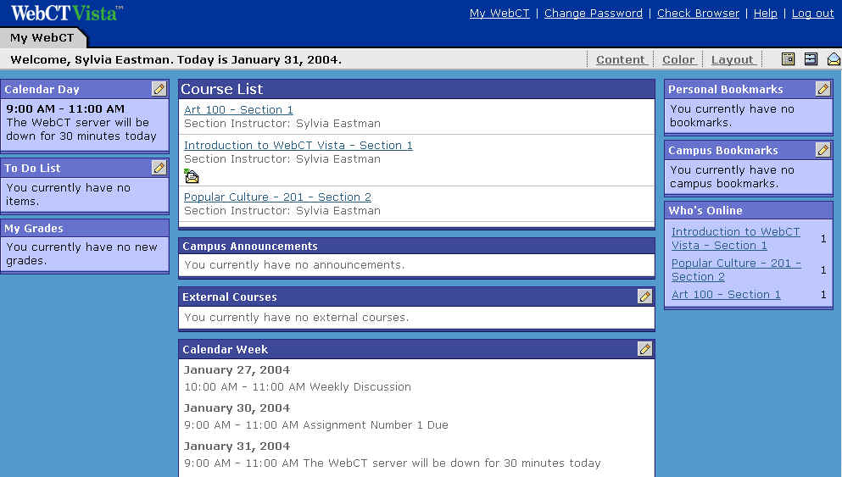
Course List channel
Content channels
Toolbar
The screen contains:
- the Logo Bar, which is the top-most frame in the WebCT browser window. It is always present and it contains links to Help and Log Out. An institution can customize this frame to reflect the school’s visual identity by setting the color scheme and replacing the WebCT logo.
- Content channels, with each channel containing a category of content, such as the To Do List, My Grades, Personal Bookmarks, and External Courses.
- the Course List channel, which provides access to the courses and sections in which the user is enrolled. Course news, including notification of new announcements, calendar entries, mail, discussions, assessments, and assignments, may also appear here.
- the Toolbar, which is below the Logo Bar. It contains icon links to tools such as Mail, Calendar, and File Manager. The tools may vary depending on administrator settings.

Customization
We’ve already noted that institutions can customize the Logo Bar to reflect their visual identity. WebCT Vista users can also customize the look and feel of their My WebCT page to suit their individual preferences.
- To hide channels, click the Content link.
Note: You can hide all of the channels except the Course List channel.
- To customize background and table colors, click the Color link.
- To change the order and location of the channels, click the Layout link.

Browser Checker
WebCT Vista provides both automatic and manual browser checking. The automatic browser check occurs only upon your first access to the Log In page and to My WebCT. It displays a warning if you are using an unsupported browser. The manual browser checker can be used at any time.
- To check your browser, click the Check Browser link.
Note: If the link does not appear, your administrator has disabled this feature.
In addition to checking your browser, WebCT Vista automatically checks to see if your browser is Java™ enabled and that the required version of Java Virtual Machine (JVM) has been installed. These checks occur whenever you access a tool that requires Java, such as the HTML Creator.
You will see a warning only if you do not have Java enabled, or if you do not have the correct version of Java Virtual Machine installed. The warning includes a link to the Browser Tune-Up page for additional information.

Hands-On Practice: My WebCT
- Add a To Do Note.
- Hide the My Grades channel.
- Rearrange the order in which the channels display.

Mail
Mail allows you to communicate privately with other WebCT users who are enrolled in the same courses or sections in which you are enrolled. Mail in WebCT Vista includes features common to most standard email programs. You can:
- send, receive, and forward messages, in plain text or HTML, and with file attachments.
- carbon copy or blind carbon copy message recipients.
- print, search, compile, and organize messages into folders.

Accessing Mail
You can access all mail for all your courses or sections from My WebCT. If you are in a section, you will only see mail for that section.
- To access Mail from My WebCT:
- From the Toolbar, click the Mail icon. The global view of mail appears, listing all the courses and sections in which you are enrolled.
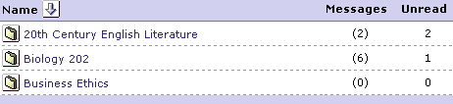
- Click the course or section name to view its mail.

The Mail Interface
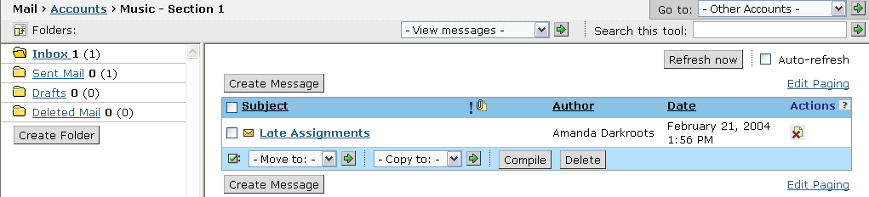
On the Mail screen:
- Folders are listed in the left frame. The number in parentheses is the total number of messages in the folder; the number outside the parentheses is the number unread.
- Messages are listed in the right frame. There are four columns:
- Subject lists the message title. Messages are displayed in reverse chronological order. Unread mail is indicated by the closed mail icon to the left of the message title.
- Author.
- Date indicates the date and time that the message was sent.
- Actions contains icons which allow you to perform actions on a mail message.
- To read a message, click the hyperlinked subject title in the right frame.

Creating a Message
You can send messages to users enrolled in your course or section. When you create a message, you can enter plain text or use the HTML Creator, which allows you to create content in HTML without entering HTML tags.
Note: You cannot use the Mail tool to send email messages to external email accounts.
- To create a mail message:
- Click Create Message.
- To complete the To field, click Browse for Recipients and select the desired recipients.
- Complete the Subject fields.
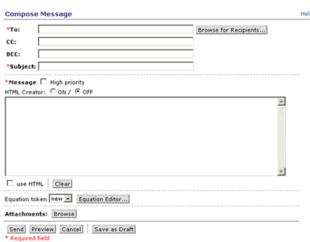
- If you want to create a message using HTML, select the HTML Creator.
Note: Depending on administrator settings, the HTML Creator may not be available or it may appear by default.
- In the Message text box or HTML Creator editing area, enter your message.

- If you want to attach files to your message:
- Click Add Attachments. The File Browser pop-up window appears.
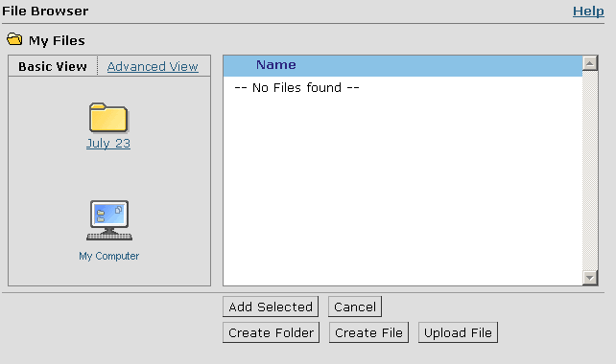
To attach files from your local computer, click My Computer.
- Navigate to the folder containing the files you want to attach.
- Next to each file you want to attach, select the check box.
- Click Add Selected. The Create Message screen appears with the selected files listed under Add Attachments.
- If you want to view the message as it will appear to the recipient, click Preview.
- Click Send. The Messages screen appears and your message is moved to the Sent Mail folder.

About HTML Creator
The HTML Creator is an HTML editing tool that allows you to create content in HTML without entering HTML tags. Similar to a word-processor, you can:
- enter text and format it using a toolbar.
- insert an image by browsing for a file.
- spell check your text.
The HTML Creator automatically generates the underlying HTML source code.
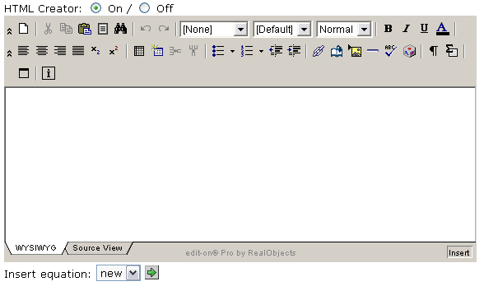
The HTML Creator is available from the following tools:
- Assessments  - Assignments  - Content  - Discussions | - File Manager  - Home Page and organizer pages  - Mail

Working in WebCT Vista: Common Functions
While working with the Mail tool, you’ll encounter several functions that are used throughout WebCT Vista.

Viewing Messages
Throughout WebCT Vista, when information is underlined it indicates that the item is clickable.
- To view a mail message, click its hyperlinked title.
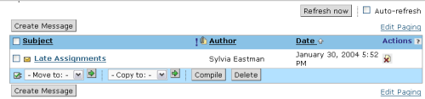

Sorting Messages
Items in a list can be sorted by clicking the underlined column names. An up or down arrow next to a column name indicates the selected sort criteria and direction.
- To sort mail messages by date, click the Date column. The default is to place the most recently received messages at the bottom of the list.
Column Names
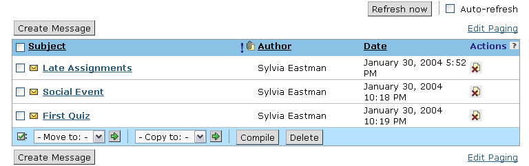

Selecting Items in a List
Individual mail items (messages) are displayed in a list. When you encounter a list of items, there are usually several actions that can be taken on selected items or on the entire list. For example, you might want to compile a list of mail messages.
- To compile messages:
- Select the messages that you want to compile.
To quickly select all the items, use the checkbox at the top of the list.
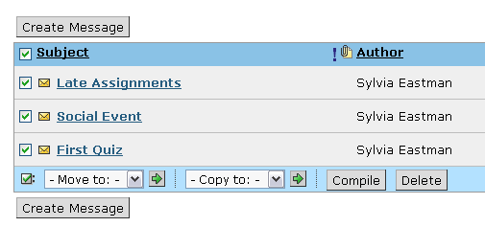
- Click Compile.

Moving or Copying Items
You can move a message by selecting the checkbox next the message, selecting the folder to move the message to, and then clicking the Go icon. This same process can be used for move and copy functions throughout WebCT Vista.
- To move a message:
- From the Messages screen, under Subject, select the check box next to each message you want to move.
- From the Move to drop-down list, select a folder to move the message to and click the Go icon.
Go icon
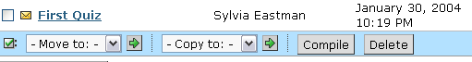

Using Action Icons
Action icons provide easy access to common functions that can be applied to individual items in a list.
To determine what an Action icon does, mouse over the icon to see a text interpretation. Alternatively, you can access the Action Icon Key by selecting the question mark next to the Actions column heading.
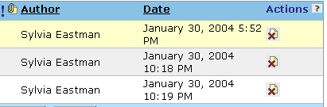 | 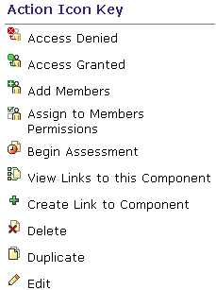

- To delete a mail message, under Actions, click its Delete icon.
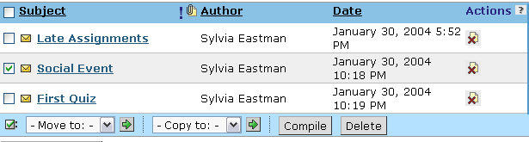

Using Drop-Down Menus
Throughout WebCT Vista, you can navigate and select actions by choosing an item from a drop-down menu and then clicking the Go icon.
- To view Mail for other sections, from the Other Accounts drop-down menu, choose a section and then click the Go icon.
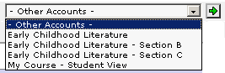

Hands-On Practice: Using Mail in My WebCT
- From My WebCT, open the mail for your student course.
- Read a message in the Inbox.
- Compose a one-word message of high priority. Address it to one person, and carbon copy five other people.
- Sort messages by author, date, or subject.
- Create a new folder and move a read email to it.
- Collapse the folder frame.

File Manager: My Files
File Manager is the area to store and access files. It is accessible from My WebCT and also from within your course or section. File Manager in WebCT Vista is similar to the file management system on your personal computer in that it contains files and folders. One of these folders is called the My Files folder and it is primarily designed for users to store their documents. All users, including students, have a My Files folder. Files placed in My Files are private and cannot be accessed by other users.
In your My Files folder, you can:
- upload existing files.
- create files, either by entering text or by using the HTML Creator.
- create sub-folders to organize your documents.
- move files.
- delete files.
Note for  CE Users | Unlike WebCT CE where there is a single My Files folder for each course, with WebCT Vista there is a single My Files folder for each user.

My Files Folder Interface
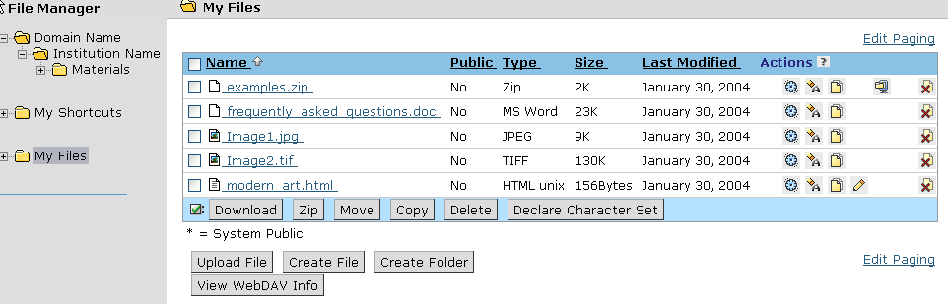
In File Manager:
- Folders appear in the left-hand frame.
- Files appear in the right-hand frame. Files are listed in alphabetical order by name.

Uploading a file
You can upload course content such as text files, images, and PowerPoint presentations.
- To upload a file:
- Click Upload File.
- Next to File, click Browse. Your computer's file browser appears.
- Locate and select the file that you want to upload. The Upload File screen appears with the File text box completed.
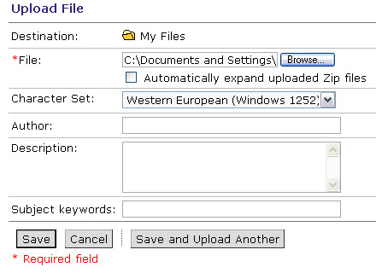
- If you want to, complete the Author, Description, and Subject Keywords text boxes.
- Click Save. The file is uploaded.

Creating a file
You can create content, either by entering text or using the HTML Creator.
- To create a file:
- From the File Manager screen, click Create File. The Create File screen appears.
- If you want to use the HTML Creator to create your file, next to HTML Creator, select On.
Note: Depending on administrator settings, the HTML Creator may not be available or it may appear by default.
- In the text box or HTML Creator editing area, enter content.
- In the File name text box, enter a name for the file.
- Click Save.

Deleting a file
We learned in the Mail section that there are some common functions that are seen throughout the WebCT Vista interface. For example, we learned that Actions icons provide easy access to common functions that can be applied to individual items in a list.
In File Manager, Action options allow you to change file settings, rename files, and delete files.
- To delete a file, locate the file and, under Actions, click its Delete icon.
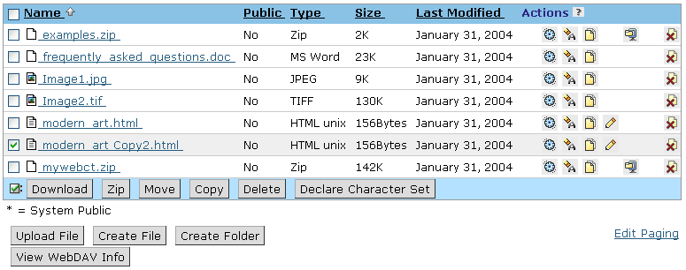
Delete icon

Hands-On Practice: File Manager
- Access File Manager from the My WebCT toolbar.
- Upload a file from your local computer to your My Files folder.
- Create a subfolder and move the file that you uploaded to it.
- Click the folder to view the file in its new location.

The Section Interface
You access your section from the Course List of My WebCT. When you mouse over the title of the section, you see a pop-up tool tip that indicates your role, which in this case is Section Designer/Instructor.
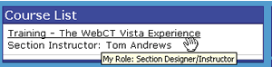

The Vista Tab Structure
Upon entering the section, you will notice that the interface is organized into three tabs: Build, Teach, and Student View.
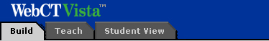
In WebCT Vista, building a course is a process distinct from teaching a course. The WebCT Vista interface reflects this distinction. All building functions are available under the Build tab; all instructional tasks are available under the Teach Tab. The third tab, the Student View tab, allows you to experience the course as a student.
Note | All three tabs are visible because you are currently enrolled in the combined role of Section Designer/Instructor. Users can also be enrolled in single roles:  - Users enrolled as Section designers see only the Build tab and the Student View tab. They build the section, adding assessments, assignments, and content.  - Users enrolled as Section instructors see only the Teach tab and the Student View tab. They teach the section, communicating with students, grading assessments and assignments, and performing a variety of instructional management tasks.

The following table summarizes the functions that you can perform from each tab.
Build tab | - create, manage, and organize course content.  - design quizzes and assignments for evaluating student progress.  - provide course members with communication methods.  - change the visual presentation of the course.
Teach tab | - access the instructor view of all the tools that have been added to the course from the Build tab.  - access instructor tools such as Grade Book, Reports and Tracking, and Settings.  - manage and grade student submissions and provide students with feedback on their performance.  - manage the statistics generated by student submissions.
Student  View tab | - allows you to experience the course as a student, for example by taking a quiz, or submitting an assignment.

The Student Experience
From the Student View tab, you can view and interact with the section exactly as students do. You can preview content, post discussions, complete quizzes and surveys, submit assignments, and perform all other student activity as a Demo Student.
Student View of Home Page
Course Toolbar
Organizer Page
Header
The screen contains:
- Course Toolbar, which appears below the Logo Bar, and contains links to tools that have been added using the design features on the Build tab.
- Home Page as it appears to students. This page contains icons that represent course content that has been added or created on the Build tab. It may include components, organizer pages, headers or footers, and descriptive text.

- Terms to Know
Organizer Page | Organizer pages are used to group and present content. The Home Page is the top-level organizer page and cannot be deleted.
Learning Module | Learning modules are like organizer pages in that they contain components. However, with learning modules, the components are organized hierarchically in a table of contents, providing a structured learning path. Depending on their scope, learning modules can be analogous to a unit or chapter in a textbook.
Action Menu | The Action Menu, available only within a learning module, contains navigation links. The Action Menu may also include links to components (e.g. discussion topics) and to Action Menu tools: Bookmark, Compile, and Notes.
Media Library | A media library collection is a collection of text entries, images, video files, or audio files.

Navigation
- To access an item on the Home Page, click its icon.
- To access tools, click the tool icon on the Course Toolbar.
- To return to the Home Page, click the Return to Home Page icon.
Return to Home Page

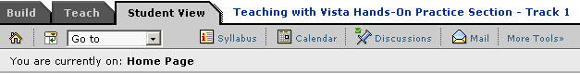

Hands-On Practice: Exploring WebCT Vista Functionality
as a Student
From the Student View tab of the WebCT Vista Experience section:
- Preview the Sample Learning Module.
- Explore the Action Menu on the first page of the Learning Module.
- Complete the Introduce Yourself assignment.
- Complete the Workshop Intro quiz.
- Compile the Learning Module.
- Preview the Virtual Office organizer page.
- Post a question to the instructor in the Ask the Prof discussion topic.
- Chat with your workshop facilitator in the Virtual Office Hours chat room.
- Explore the tools available from the Course Toolbar.
- Browse the available Media Library collections.
- Check your quiz grade from My Grades.

The Instructor Experience
From the Teach tab, you can access the Grade Book, view and grade completed assignments and assessments, communicate with students, and complete a variety of instructional tasks.
The Teach tab is divided into two sub-tabs: the Course View tab and the Tool View tab.
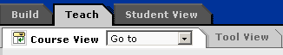
Course View | - Visually represents the structure and organization of the section.  - Allows you to access the Course Toolbar and components that have been added using the Build tab.  - Provides access to Course Management tools: Grade Book, Reports and Tracking, Selective Release Map, and Settings.
Tool View | - Provides a listing of the tools and components available to you in your instructor role.  - Provides access to Course Management tools: Grade Book, Reports and Tracking, Selective Release Map, and Settings  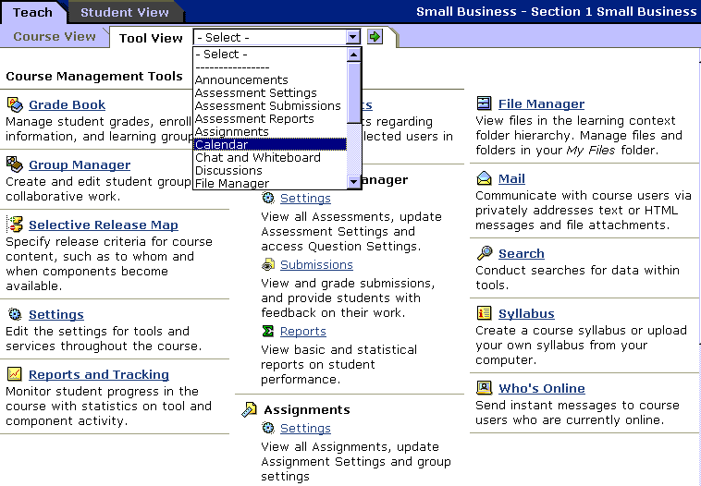

Hands-On Practice: Exploring WebCT Vista Functionality
as an Instructor
Note: This exercise is designed to orient you to the Teach tab.
From the Tool View sub-tab:
- Select the Grade Book link under Course Management tools.
- View the grade for the Workshop Intro quiz you completed as a Demo Student.
- View the other Grade Book tabs.
- From the drop-down list on the Tool view sub-tab, select Assignment Dropbox.
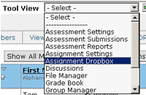
- From the Assignment Dropbox, under the Submitted sub-tab, click the title of the Introduce Yourself assignment you submitted as the Demo Student. The assignment you submitted as a Demo Student is displayed.
- Under Grader/Reviewer Comments, enter a comment about the submitted assignment.
- Under Save Options, select the option to Return graded submission to Student(s) with the following grade, and enter a numerical grade for the assignment. Click Save.
- From the Assignment Dropbox, click the Graded sub-tab. The assignment you just graded will be listed.
- From the drop-down list on the Tool view sub-tab, select Grade Book.
- From the Graded sub-tab, notice the Assignment grade has been automatically added.
Take a few minutes to explore the Course View tab as well.

The Designer Experience
From the Build tab, you construct a course by enabling tools, creating and organizing content, and dynamically releasing content with Selective Release.
The Build tab contains three sub-tabs: the Basic View tab, the Power View tab, and the Content Inventory tab. Each sub-tab offers different methods for accomplishing similar course design functions.
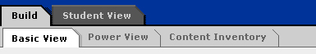
Basic View | - allows you to design the course and to immediately see how it will appear to a student (i.e., it provides a WYSIWYG interface).  - provides access to Course Customization and Selective Release.
Power View | - allows you to design the course and to see an outline view of it.  - provides access to Course Customization and Selective Release.
Content Inventory | - provides a complete listing of existing course content by tool and allows you to add or modify content.

Hands-On Practice: Exploring WebCT Vista Functionality
as a Designer
Note: This exercise is designed to orient you to the Build tab. Design tasks are covered in greater detail in the Building Advanced Components workshop.
From the Basic View sub-tab:
- From Add to Course Toolbar, click the Notes tool icon. The Notes tool is added to the Course Toolbar.
- Under Add to Home Page, click URL. Create a URL of your choice. Select Open in a new browser window.
- From the Home Page, next to the URL that you just added, click the Add/Edit Description icon. Enter some descriptive text about the web site.
Add/Edit Description icon
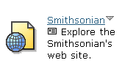

- Click the Options Menu for the URL, and choose Preview.
To view the Options Menu, click the down arrow.
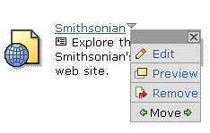

Take a few minutes to explore the Power View tab as well.

