
Managing and Evaluating Assessments in WebCT Vista 3.x

Copyright © 2004 by WebCT
All Rights Reserved

The content of this manual may not be reproduced or distributed without the express written consent of WebCT. Users acknowledge that the manual, and all copyright and other intellectual and proprietary rights therein, are and at all times shall remain the valuable property of WebCT and its licensors, or their respective successors or assignees. Users agree to respect and not to alter, remove or conceal any copyright, trademark, trade name or other proprietary marking that may appear in the manual.

LR LS 022204 30
Table of Contents
About this Workshop 4
Assessment Manager 5
The Instructor Role 5
Editing Assessment Settings 6
Hands-On Practice: Editing Quiz Settings 8
Grading Assessments 9
Grading Assessments by Student 10
Grading Assessments by Question 11
Modifying Grades 13
Resetting Attempts 14
Hands-On Practice: Grading Quiz Submissions 14
Viewing Survey Submissions 15
Hands-On Practice: Viewing Survey Results 15
Generating Assessment Reports 16
Quiz Reports 18
The Performance Report 18
The Item Statistics Report 20
The Summary Statistics Report 20
The Class Statistics Report 21
Hands-On Practice: Generating Reports 21

About this Workshop
In this workshop, you will become familiar with the Assessments tool and how it can be used:
- manage assessments and student submissions.
- generate reports on assessments.
Topics
- Assessment Manager
- Editing Assessment Settings
- Grading Assessments
- Generating Assessment Reports
 | Learning Outcomes
After completing this workshop, you will be able to:
- edit assessment settings.
- grade assessments.
- generate reports to evaluate student performance and the effectiveness of assessments.

Assessment Manager
There are three types of assessments:
Quizzes | Quizzes are online tests for which grades are assigned. Depending on the kinds of questions included in the quiz, quizzes can be graded automatically or manually.
Self Tests | Self tests are online tests that allow students to test their knowledge. Grades are not recorded.
Surveys | Surveys are anonymous online assessments for which no grades are assigned. You can see whether students have completed the survey but the submissions themselves are anonymous.

 | The Instructor Role
As an instructor, you can:
- edit assessment settings.
- view assessment submissions.
- assign or modify grades and provide feedback to students.
- generate reports to view performance and statistical data.
The Assessment Manager tool is available from the Tools sub-tab. There are three sub-categories:
- Settings allows you to edit settings for individual assessments, including their title, delivery method, date of availability, and whether the scores are released to students.
- Submissions is the main assessment interface. Similar to the Assignment Dropbox, Assessment Submissions organizes assessments under four tabs: Graded, Not Graded, Not Submitted, or All.
- Reports allows you to run statistical reports on assessments and surveys.
Note | From the Course View sub-tab, you can select a specific quiz and edit its settings, set release criteria, view/grade results, and generate assessment reports.

Editing Assessment Settings
When designers create an assessment, they specify its settings. You can edit the following settings:
Basic Settings | - assessment title.  - whether question titles are displayed.  - question delivery.  - for quizzes and surveys only, assessment duration.  - for quizzes and surveys only, the number of attempts allowed and the time students must wait between attempts.
Dates Available | - start and end date and time for the assessment.  - whether there is a corresponding public entry in Calendar tool, advising course members of the assessment date.
Security | Security settings apply to quizzes and surveys. You can:  - assign a proctor password, which students will have to enter to access the assessment.  - set an IP address mask, so that only students whose machines match the IP address mask will have access to the assessment.
Results | Results settings apply to quizzes only. You can:  - edit student score information.  - edit feedback release information.  - edit how results will be displayed to Students.

- To edit assessment settings:
- From the Tool View, under Assessment Manager, click Edit Settings. The Assessment Settings screen appears, displaying all the assessments in the course.
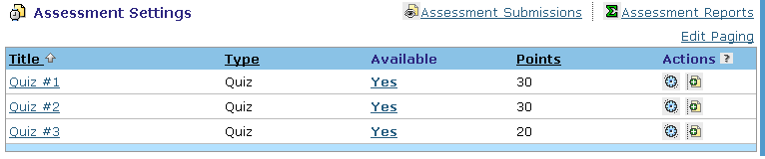
Edit Settings
- 2. Locate the assessment for which you want to edit settings, and click its Edit Settings icon. The Edit Assessment Settings screen appears.
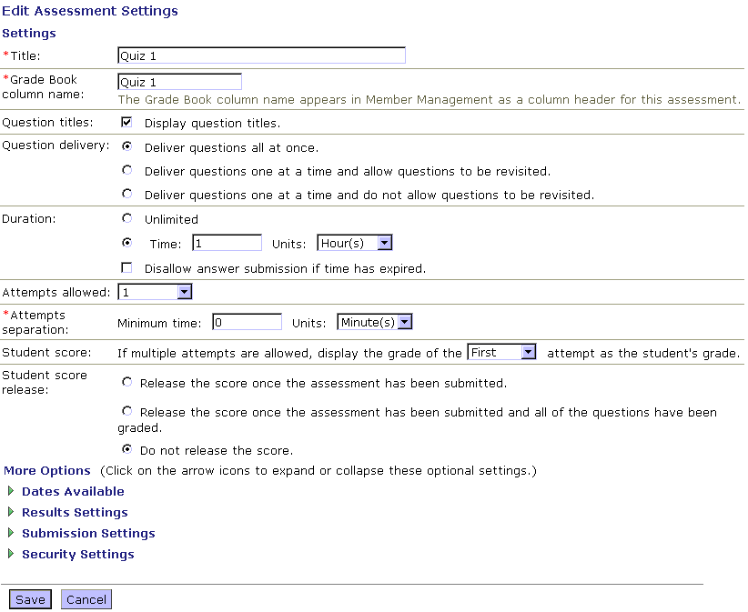
Reset Attempt
- Edit the settings as desired.
- Click Save. The Assessment Settings screen appears.

Hands-On Practice: Editing Quiz Settings
From the Tool view sub-tab, access Assessment Manager and view the settings for a quiz. Modify several settings, such as the Start time and the Results Settings.

Grading Assessments
When a student submits an assessment, responses are automatically graded by WebCT Vista, except for questions requiring a paragraph answer. The grades for an assessment are automatically added to the Grade Book to the assessment column.
From Assessment Submissions, you can:
- grade assessments by student. This option shows you the entire assessment by student, similar to traditional paper-based marking.
- grade assessments by question. This option allows you to see each student’s answer to the same question in succession. You can hide student names if you want answers to be anonymous.
- re-grade questions. For example, you can change a grade to a question if a student successfully defends the answer.
- modify quiz grades. This option allows you to change the grade of an entire quiz, rather than just individual questions.
Submissions are organized by four tabs:
- the Graded tab displays all assessments that have been graded. Grades have been recorded in Grade Book.
- the Not Graded tab displays assessments that have a mix of graded and not graded questions.
- the Not Submitted tab displays all assessments which have outstanding submissions and lists the students who have not made a submission.
- the All tab display all submissions, organized by assessment.

Grading Assessments by Student
You must manually grade paragraph questions. You may also want to manually grade an assessment if a student successfully defends an incorrect response, or if the question was originally scored incorrectly.
- To grade or re-grade by student:
- From Assessment Submissions:
- if you want to grade assessments, click the Not Graded tab. All ungraded or partially graded quizzes are displayed. Each row is one student’s submission for a specific assessment. The Attempt column indicates the attempt number.
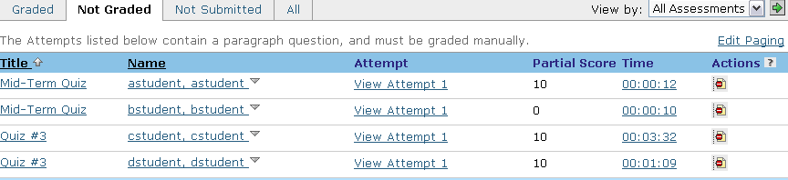
- if you want to re-grade assessments:
- Click the Graded tab. All graded assessments are displayed.
- Next to the assessment that you want to re-grade, click its Expand icon.
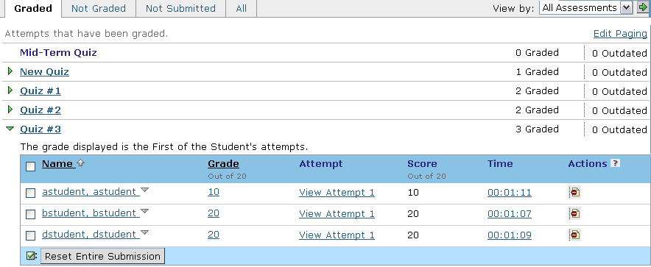
- For the student that you want to grade, click the hyperlinked View Attempt 1 (or whichever attempt is recorded). The View Attempt screen appears, displaying the assessment questions and the student’s answers. Any automatically graded questions display the grade.
- Grade or override the score and add comments for each question. You can also adjust the total quiz score and add general comments for the student.
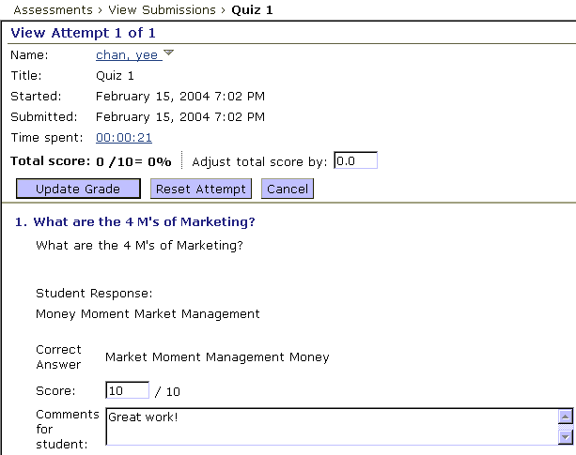
- Document any changes in the grades in the Audit Log Comments text box. These comments can be retrieved at a later point from the Grade Book, and are useful in case of grade challenges or related issues.
- Click Update Grade.

Grading Assessments by Question
You can grade assessments by question. This option allows you to see each student’s answer to the same question in succession. You can hide student names if you want answers to be anonymous.
- To grade by question:
- From Assessment Submissions, click the Not Graded tab. All partially graded or ungraded assessments appear.
- Click the title of the assessment that contains the question you want to grade.
Note: There may be multiple instances of the same quiz. You can choose any instance. The quiz questions appear.
- Locate the question that you want to grade and click its Grade all attempts icon. A list of student names appears. If you want to students names hidden, click Hide Names. The students’ names are replaced with numbers.
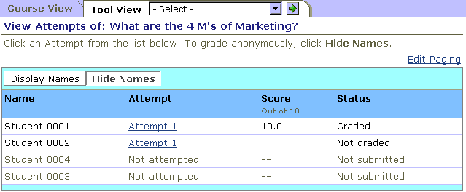
- For the first student, click Attempt 1 (or whatever attempt number it is). The View Question Attempt screen is displayed.
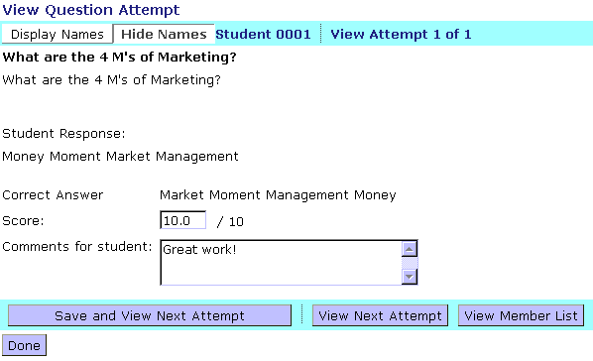
- In the Score text box, enter the grade. Enter comments if desired.
- If there are more students’ attempts to be viewed for this question, click Save and View Next Attempt. To view the next attempt without saving the current, click View Next Attempt.
- When all attempts are viewed or graded, click Done.

Modifying Grades
You can modify the grade for an entire assessment on a per student basis.
Important | Modifying the grade for an entire assessment will override the scores given to individual questions.
- To modify a grade:
- From Assessment Submissions, click the Graded tab.
- Next to the name of the assessment for which you want to modify grades, click the Expand icon. A list of students is displayed.
- Under Grade, click the grade that you want to modify. The Modify Grade pop-up window appears.
- In the Grade text box enter a new grade.
- In the Audit Log Comments text box, enter comments.
- Click Save. The Graded tab appears and the new grade is displayed. The old grade is displayed in parentheses.

Resetting Attempts
You can reset an attempt to give students an opportunity to retake the assessment. For example, if a student experiences technical problems while taking the quiz, you can reset the submission and re-release the attempt to the student.
- To reset attempts:
- From Assessment Submissions, click the tab that contains the assessment that you want to reset an attempt for.
- Next to the assessment name, click the Expand icon.
- Do one of the following:
- To reset a specific’s student’s attempt, locate the row for the student and click the Reset Attempt icon.
- To reset all attempts, click Reset Entire Submission.
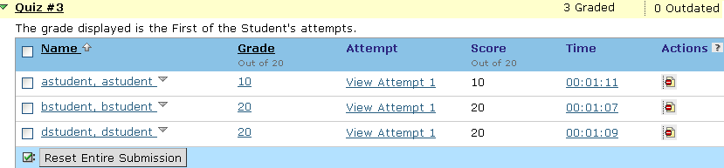

Hands-On Practice: Grading Quiz Submissions
- Grade the paragraph question in the Internet Quiz by student.
- Grade the paragraph question in the Workshop Intro Quiz by question.
- Re-set Kristie Shaw’s submission for the Browser Tune-Up.
- Add five points to Hanna’s total score for the Internet Quiz.
- Adjust Kristie’s score on question six of the Workshop Intro Quiz; give her five points for her response.

Viewing Survey Submissions
- To view survey submissions
- From Assessment Submissions, click the All tab.
- Next to the survey title, click the Expand icon. A table appears, displaying the names of the students in the section and whether they have completed the survey
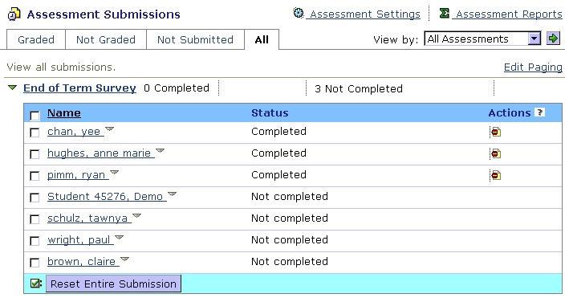
Reset
- If necessary, reset the entire section’s submissions or specific student submissions.
  - To reset a student’s submission, locate the row for the student and click Reset.
  - To reset the entire section’s submissions, click Reset Entire Submission.

Hands-On Practice: Viewing Survey Results
- From Assessment Submissions, view which students have completed the Participant Survey.
- Reset one student’s survey submission.

Generating Assessment Reports
You can generate reports to determine how well students are performing on assessments.
There are four reports for quizzes:
- Performance report provides each student’s answer to quiz questions and provides statistics on which answers students selected.
- Item Statistics displays performance statistics on an individual question by person. Or, you can choose to run statistics on an individual question for the whole class.
- Summary Statistics show the mean score either by person or by class on a particular assessment.
- Class Statistics display class performance on individual questions.
You can also run a Performance report for a survey. Because surveys are anonymous, student names are replaced with numbers. The Performance report contains each student’s answers to each survey question and statistics showing which answers students selected.

Terms to Know
Attempts | The number of responses to a question. A low number of attempts might indicate the item was not well worded or that the test was too long.
Discrimination | Indicates how well a question distinguishes between students who have a high quiz score and those who have a low score. The discrimination number is always between 1 and –1. A negative number indicates that the lower-scoring students performed better on this question than the high-scorers.  For example, a score of -.07 may suggest that the question is not reliable. You might choose to not count this item for the assessment, or reword it for the next assessment.
Frequency | The number of times an answer was chosen or given by a student. This can differ from the number of attempts if a student chooses to not answer a question or if there are multiple attempts at a question. This indicates if your multiple-choice test had good distracters, if it was too easy, or if the instructor made an error in presenting a certain piece of material (e.g., all students chose wrong answer).
Mean | Percent representing the average quiz score or the average frequency that an answer was given by students. A high mean could indicate the test was easy; a lower mean, the test too hard or material not taught well.
Standard Deviation (SD) | An average of the amount that the results deviate from the average score. The greater the standard deviation, the less reliable is the test.
Upper 25% | The group of students whose score is in the upper 25% of the class. If you’re evaluating your assessment against a normal curve, this value should be 25% of the class.
Lower 25% | The group of students whose score is in the lower 25% of the class. Similar to Upper 25%.

Quiz Reports

The Performance Report
Performance reports can be generated for individual assessments.
When you run a Performance Report, a table is generated. The table contains columns for:
- student’s first and last name and user name
- the grade received and the number of attempts
- the score
- every question in the assessment
For question columns, you can view statistics showing how students answered the question. For example, for multiple choice questions, you can see a breakdown of how frequently each of the possible answers was selected.
- To run a Performance Report:
- From the Tool View sub-tab, under Assessments, click Reports.
- Select the assessment to run the report on.
- Select Performance and click Run Report. The Performance Report appears.
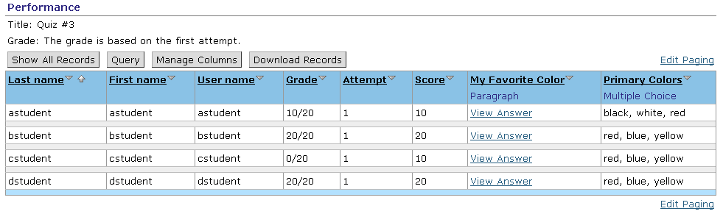
- To view a student’s response to paragraph questions, click the View Answer link.
- If you want to see statistics for a specific question, click the hyperlinked question title and, from the menu that appears, click Statistics. A screen containing the question and a table of response summary data appears which shows how many students answered the question in a particular way.
Example:
The question in the figure to the right is a multiple-choice question. From a total of five students, four students correctly chose answer C, and one incorrectly chose answer B.  Note: The Performance generated for surveys is similar to the Performance report for quizzes, except that student names are not provided. | 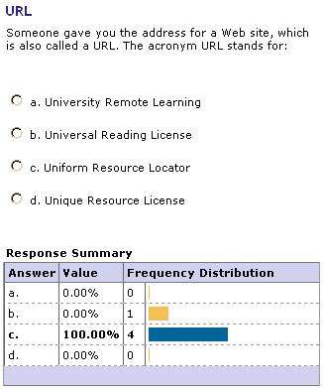

The Item Statistics Report
Item Statistics display the performance for individual questions while comparing the performance of selected students to that of the entire class. Item Statistics reports are available for quizzes and can be generated for the class as a whole, or for all individuals in a class. In addition to the columns appearing in the figure below, mean, standard deviation, and a comparison to the whole class’s performance (comparing attempts, percentiles, discrimination, mean, standard deviation).
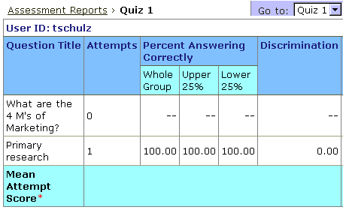

The Summary Statistics Report
Summary Statistics compare all students’ results in one table.
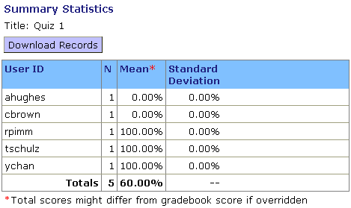

The Class Statistics Report
Class Statistics show a question-by-question analysis of the performance of an entire section on a quiz. One class value for each question is displayed for each of Attempts, Percent Answering Correctly, Discrimination, Mean, and Standard Deviation.
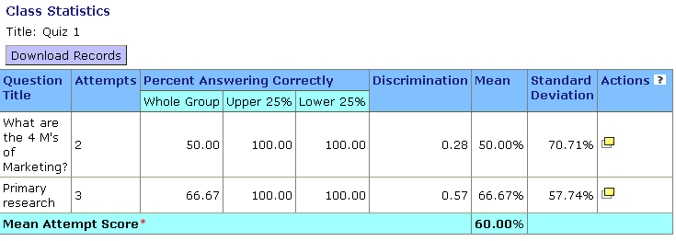

Hands-On Practice: Generating Reports
- Select different reports to view for one or two of the quizzes in your section.
- Run a Performance Report for the Workshop Intro Quiz.
  - Use the Query feature to display students who scored less than 75%.
  - Display the statistics for several questions.
- Run a Performance report for the Participant Survey. View statistics for several individual questions.

