

Managing Content
WebCT Vista 3.x

Copyright© 2004 by WebCT
All Rights Reserved
The content of this manual may not be reproduced or distributed without the express written consent of WebCT. Users acknowledge that the manual, and all copyright and other intellectual and proprietary rights therein, are and at all times shall remain the valuable property of WebCT and its licensors, or their respective successors or assignees. Users agree to respect and not to alter, remove or conceal any copyright, trademark, trade name or other proprietary marking that may appear in the manual.
If you have comments or suggestions for improving this manual, please email eddev@webct.com.
LR KZ 0040604 3x
Table of Contents
About this Workshop 1
Naming and Organizing Files 2
Rules for Naming Files 2
File Naming Conventions 3
Discussion: File Naming Conventions 4
Organizing Files 5
Case Study: Creating a Structure Locally 5
Discussion: Mirroring Course Organization and Folder Structure 6
Using File Manager 8
File Manager Interface 9
Managing Files and Folders 10
Duplicating Files 12
Editing HTML Files 13
Creating a Folder 13
Uploading Files 14
Hands-On Practice: File Manager 15
Leveraging Shared Content 16
Navigating Folders 16
Adding Public Files and Links to Public Files 17
Hands-On Practice: Shared Content 19
Using WebDAV 20
Setting up WebDAV for Windows 20
Using WebDAV Drag-and-Drop 21
Hands-On Practice: Using WebDAV 21
Exporting Content 22
Exporting Questions 22
Exporting Learning Modules 23
Exporting Assessments 23
Hands-On Practice: Exporting Content 24
Importing Content 25
Using the Content Import Tool 26
Importing SCORM Modules 27
Hands-On Practice: Importing Content 28
Appendix A: Sharing Your Files 29
Appendix B: Creating WebDav Connections in Mac OS 10 31

About this Workshop
In this Workshop, we’ll focus on the skills necessary to effectively manage content in WebCT Vista. After identifying strategies for naming and organizing content locally, you will explore options for uploading and managing files within WebCT Vista, including how to leverage content sharing features. In addition, you’ll learn how to export and import content.
Topics
- Organizing Files Locally
- Using File Manager
- Managing Files
- Uploading Files
- Using WebDAV
- Leveraging Shared Content
- Importing and Exporting Content
 | Learning Outcomes
Upon completion of this module, you will be able to:
- identify strategies for effectively naming and organizing files locally.
- identify key elements and functions of File Manager.
- manage files through File Manager.
- upload files through File Manager.
- set up and use WebDAV to upload and manage files.
- export questions and learning modules.
- import content into your course.
- import SCORM modules.

Naming and Organizing Files
Often, much of your course content is created outside of WebCT. You can save development time by doing the following tasks locally:
- ensuring that your file names conform to WebCT Vista technical requirements.
- using file naming conventions.
- organizing files into folders that map to the course structure.

Rules for Naming Files
Ensure that your file names conform to the following requirements.
- cannot begin or end with a period
- can include letters, numbers, spaces, commas, periods, and the following characters: _, &, ( ), –, and ~
- cannot include the following characters: / \ : * ? > < |

File Naming Conventions
Although not critical for technical reasons, developing a naming convention can assist you with remembering what each file contains and/or where it fits into the structure of your course.
The table below outlines some possible naming conventions.
Naming Method | Examples | Notes
By topic | art_surrealism | If you are only responsible for developing a small number of courses, consider leaving out the general subject area.
By topic and level of difficulty | art_surrealism_100  art_surrealism_300  art_surrealism_500 | Use numbers that mirror your institution’s numbering conventions for courses. In this example, 100 is for introductory level; 300 for third year undergraduates, and 500 is for graduate students.
By topic and content type | art_surrealism_quiz  art_surrealism_assignment | You could also reverse the order and start with the content type.
By course structure | chapterone_pageten.htm | Indicates the Learning Module where the file is presented, and its order in the module (the 10th page)

Discussion: File Naming Conventions
- Consider each of the naming methods above and brainstorm advantages and disadvantages of each.
- Brainstorm other methods and discuss their advantages and disadvantages.

Organizing Files
You can save development time by organizing your files into folders that mirror the structure of your course.

Case Study: Creating a Structure Locally
Dan is teaching an Education course and has organized his content to reflect the three major units within the textbook. In storyboarding his course, he determined that he would include three icons on his Home Page, each leading to a learning module. |  | Home Page
 |  | Links to Learning Modules
 |  | Chapter 1 Philosophy of Education | Chapter 2 History of Education |  | Chapter 3 Applying Theory
The learning modules are named Chapter 1, Chapter 2, and Chapter 3. Each module contains ten to twelve HTML pages with numerous images and several audio files.
In order to organize his content locally to parallel his course structure, Dan created a folder with the same name as his course, “foundations.” Inside the “foundations” folder, he created a folder for each learning module. Inside each learning module folder, he’s added a sub-folder called media for sounds and images. |  |  |  | 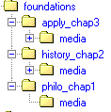
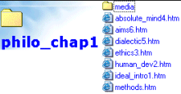 | Before he begins to build the web pages, he places all the images and sounds in the media folder of the appropriate learning module folder. Then, as he creates the web pages for his content, he saves them to the appropriate folder.

Discussion: Mirroring Course Organization and Folder Structure
Sketch out a logical folder structure and naming convention for the scenario below.
Scenario: The course includes four icons on the Home Page titled Unit 1, Unit 2, Unit 3, and Unit 4 that each link to separate learning modules. Each of the four learning modules consists of about twenty pages, with ten to twelve photos in each learning module. In addition, each module contains several identical graphics that are used repeatedly throughout the course.

Now consider your own course and how the folder structure should be organized. Sketch it in the space below.

Using File Manager
File Manager is the area to store, access, and manage files. You can use File Manager to:
- move, copy, duplicate, and delete files.
- edit HTML files.
- create folders.
- upload single files or a zip archive.
- Terms to Know
Learning Context | - A learning context is an organizational unit such as a faculty, a course, or a section.  - There is a hierarchy of learning contexts. The server learning context is at the top of the hierarchy, followed by domain, institution, group, course, and section.  - There can be only one server learning context and one domain learning context but there can be multiples of all other learning contexts. For example, their might be a group learning context called Science, with three course learning contexts: Biology, Chemistry, and Physics. In this scenario, the Science learning context is called the parent learning context and Biology, Chemistry, and Physics are child learning contexts.
Learning Context Folder | - For every learning context, there is a learning context folder with the same name.  - A learning context folder is called a Shareable Content folder because it can contain public files that designers can link to or add to their sections/templates.
Section Content Folder/  Template  Folder | - A sub-folder of the learning context folder.  - When content is created within a section it’s automatically saved to the Section Content folder; similarly when content is created within a template it is automatically saved in the template folder.

File Manager Interface
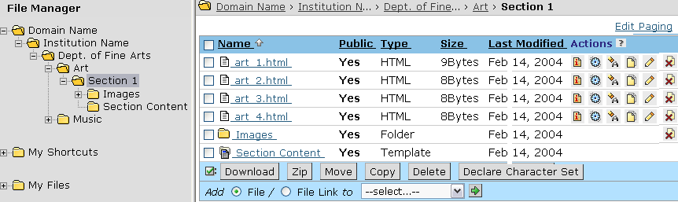
In File Manager:
- Folders appear in the left-frame. The folder structure within File Manager mirrors the learning context hierarchy that your institution has created; child folders are nested within parent folders. A designer’s view of File Manager shows all the learning context folders for learning contexts in which the designer is enrolled. It also shows the parent learning context folders.
- Sub-folders and files appear in the right-hand frame which contains 6 columns:
- Name lists the files and folders in alphabetical order by name.
- Public indicates the file or folder’s status.
  - Public files/folders can be accessed, viewed, and copied by users with appropriate roles.
  - Private files/folders cannot be accessed by anyone but their owner (the user who created or uploaded the file/folder), an editor (as designated by the owner), and administrators.
- Type indicates the type of file: HTML, MS Word, JPEG, etc, or the type of folder: template (section content folder), sharable content (learning context folder), or folder (user created folder).
- Size indicates the size of the file.
- Last Modified indicates the last time that the file was modified.
- Actions contains icons which allow you to perform actions on a file.
The location where you access File Manager determines which folder is opened.
Entry Point | Initial Folder | Folder Content
From a section | Section Content folder | All the files that make up your section, including:  - the files that you have added to your section, either by creating them or uploading them.  - the files in the template upon which your section has been created.
From a template | Template folder | All the files that make up your template, including:  - the files that you have added to your template, either by creating them or uploading them.  If the template was based on another template, it also contains the files from the source template.
Linked Files
If your section or template was based on a template, the files that you see are not the files themselves but links to the files in the template. The names of linked files are italicized. Linked files have a Break Link icon under Actions.
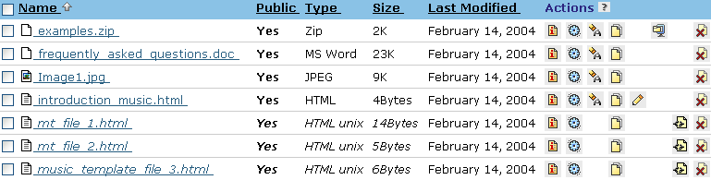
Break Link icon
Linked Files

Managing Files and Folders
You can:
- create folders
- copy and move files
- make duplicates of files
Copying Files
You can copy files from your learning context, all parent learning contexts, and your My Files folder and paste them to your learning context and your My Files folder. You can copy multiple files simultaneously.
Note | To make a copy of a file within the same folder, use the duplicate feature.
- To copy files:
- From File Manager, select the file(s) that you want to copy.
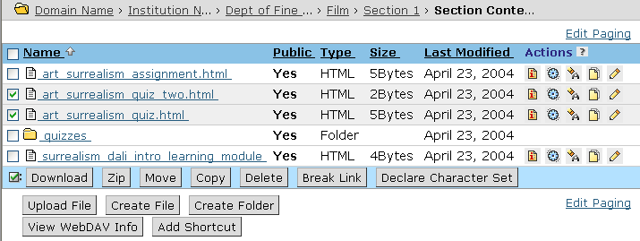
- Click Copy. The Select Destination pop-up window appears.
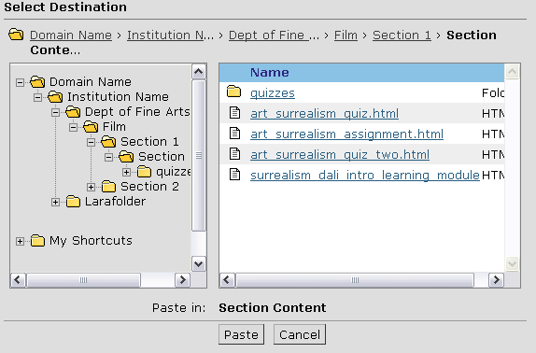

- Navigate to the folder where you want to paste the file and click Paste. A confirmation window appears.
- Click OK. The file is copied.

Duplicating Files
You can duplicate files in all folders in your learning context and in your My Files folders.
- To duplicate a file, locate the file that you want to duplicate, and under Actions, click its Duplicate icon. The file is duplicated. The duplicate is named filenameCopy2.xxx.
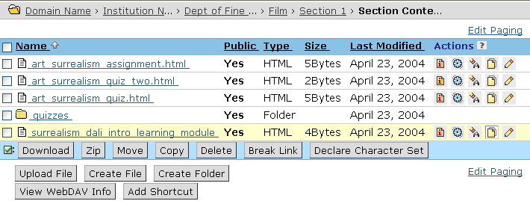
Duplicate icon

Editing HTML Files
You can use File Manager as the central location to edit HTML files in your section or template. If the file is a linked file, you must break its link before you can edit it.
Warning | If you break the link, changes made to the source file are not reflected in the unlinked file.
- To break a file link, click its Break Link icon. The following occurs:
- the link to the file is broken.
- the file name appears in Normal font.
- an Edit icon for the file appears under the Actions column.
- To edit an HTML file:
- Locate the file and click its Edit icon. The Edit File screen appears.
- If you want to use the HTML Creator, select On.
- Make the desired edits and click Save.

Creating a Folder
You can create folders within your learning context and within your My Files.
- To create a folder:
- From File Manager, navigate to the location where you want to create a folder.
- Click Create Folder. A pop-window appears.
- Enter a name for the folder.
Note: The folder name can include multiple words and spaces but cannot start with a period.
- Click OK. The File Manager screen appears and the folder is created.

Uploading Files
You can upload single files or a zip archive. If you upload a zip archive, you can choose to have it automatically unzipped.
Note | You cannot upload any files containing the following characters in the file name: /\:*?><|. If you are uploading a compressed file that contains files named with these characters, the file names will automatically be corrected during upload. If you upload a file with commas in the filename, the commas are replaced with spaces automatically.
To upload a file:
- Click Upload File.
- Next to File, click Browse. Your computer's file browser appears.
- Locate and select the file that you want to upload. The Upload File screen appears with the File text box completed.
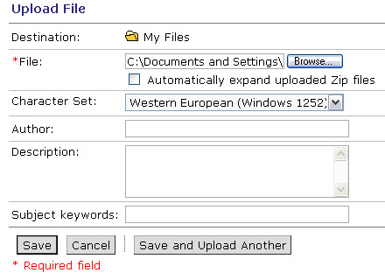
- If you are uploading a zip archive and want the zip file decompressed, select Automatically expand uploaded Zip files. If you select this option, WebCT Vista creates a sub-folder with the same name as the zip archive and decompresses the files into the sub-folder. The zip archive itself is uploaded to the current folder.
- If you want to, complete the Author, Description, and Subject Keywords text boxes.
- Click Save. The file is uploaded.

Hands-On Practice: File Manager
- Within your section content folder, create a folder named Media.
- Copy the build_module.swf and build_module.htm files into the Media folder.
- Upload the zipped file provided by your facilitator. Select the Automatically expand uploaded Zip files option.
- Make a duplicate of one of the .html files. Make a minor edit to the file.

Leveraging Shared Content
One of the key benefits of WebCT Vista is that content can be shared at the domain, institution, group, or course level.
Example | An institution-wide distance learning policy is placed in the institution learning context folder as a public file. Designers add links to the file from their template or section. As long as the links to the files aren’t broken, updates to the policy are automatically reflected in the sections or templates, promoting consistency among sections.
Designers can view, add, and link to public files in any learning context in which they are enrolled and their parent learning contexts. They cannot access files from lower learning contexts. For example, course designers can view, add, and link to files in their parent group, institution, and domain but they cannot access section files.

Navigating Folders
To view public files at the course, group, institution, or domain level, you can navigate the learning context folders using the tree view in the left-hand frame or by using the breadcrumbs in the right-hand frame. The left-hand frame displays folders only. Files are displayed in the right-hand frame.
Navigating from the left-hand frame:
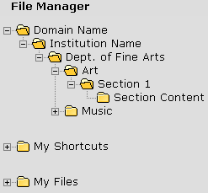
Expand Icon
Collapse Icon
- To expand a folder, click its Expand icon. The folder’s contents are displayed.
- To collapse a folder, click its Collapse icon. The folder’s contents are hidden.
- To view the contents of a folder, click its name. The left-hand frame displays the sub-folders. The right-hand frame displays the sub-folders and files.
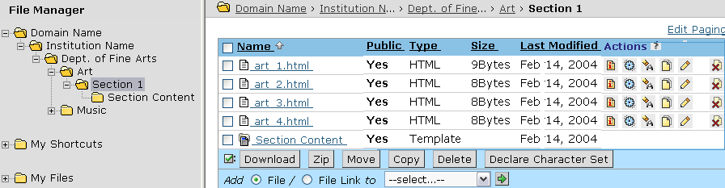
Navigating from the right-hand frame:
- To navigate up the folder hierarchy, from the breadcrumbs, click the name of the folder. The contents of the folder appear.
Breadcrumbs
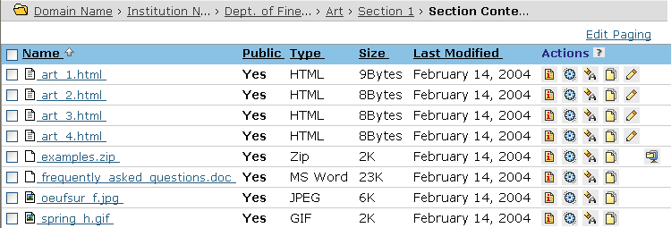
- To navigate down the folder hierarchy, under Name, click the name of the folder. The contents of the folder appear.

Adding Public Files and Links to Public Files
Once you locate a public file that you want to include in your section or template, you can either add it or add a link to it. If you link to the file, any changes made to the source file are reflected in your section or template.
- To add a link to a public file:
When you add a link to a public file, the link is placed in your section content folder or template folder. Any changes to the source file are reflected in your section or template.
- Navigate to the folder that contains the public file that you want to link to.
- Next to the file that you want to link to, select the check box.
- Select Add File link to and from the drop-down menu, select the section or template that you want to add the link to and click the Go icon. The Add File or Link window appears.
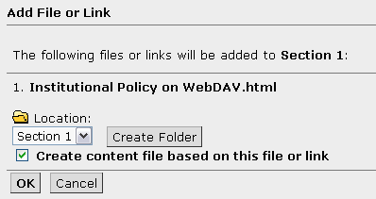
- Select Create content file based on this file or link. This adds the file to the inventory in the Content File tool.
- Click OK. A confirmation screen appears.
- Click OK. The file link is added.
- If you want to see the file link, navigate to the section content or template folder.

Hands-On Practice: Shared Content
The course and group learning contexts for The WebCT Vista Experience contain several public files.
- Navigate to the course learning context folder, and add a link to the prepcomputer.htm public file to your section content folder.
- Navigate to the group learning context folder, and add the policies.htm file to your section content folder.

Using WebDAV
Web-based Distributed Authoring and Versioning (WebDAV) allows you to set up a folder for your WebCT server on your local computer. If you add or delete files or folders in the web folder on the local computer, or on the WebCT server using File Manager, both systems will update to maintain the same content and structure.
Note | Since Distributed Authoring Versioning is a set of extensions to the HTTP protocol that allows users to collaboratively edit and manage files on remote web servers, your institution may have explicit policies surrounding its use. We recommend that you contact your system administrator for information specific to your institution. For more information about WebDAV, see the Frequently Asked Questions at http://www.webdav.org/other/faq.html.

Setting up WebDAV for Windows
You can set up web folders for Windows 98, ME, 2000, XP Home, and XP Professional.
- To create web folders in Windows:
- From the File Manager screen, navigate to the folder for which you want to create a web folder.
- Click View WebDAV Info. A pop-up window appears, displaying the server path to the folder in the WebDAV path to this folder is text box.
- Ensure that the text is selected in the WebDAV path to this folder is text box and press CTRL+C on your keyboard. The text is copied to your computer's clipboard.
- From the Windows desktop, double-click the Network Neighbourhood or My Network Places icon. The contents of the folder appear.
- Double-click Add Network Place. The Add Network Place Wizard pop-up window appears.
- Ensure that your cursor is in the Type the location of the Network Place text box and press CTRL +V on your keyboard. The clipboard's contents are copied into the Type the location of the Network Place text box.
- Click Next. The Enter Network Password pop-up window appears.
- In the User name and Password text boxes, enter your user name and password and click OK. The Add Network Place Wizard pop-up window appears.
- Click Next. Windows will attempt to authenticate.
Note: This may take a few minutes.
- Click Finish. Windows opens the web folder in its own window.
You can now drag and drop or copy/move files into this folder, like any other Windows folder. Files added to the folder will be automatically uploaded to the WebCT server whenever you are connected to the Internet.

Using WebDAV Drag-and-Drop
- On your local computer, open the folder that contains the files you want to copy to WebCT Vista File Manager.
- Open My Network Places and then the web folder for your course.
- Drag the files from your local computer folder to the web folder.
- To view the uploaded files, log in to WebCT Vista and go to File Manager.

Hands-On Practice: Using WebDAV
- Set up a WebDAV folder for the Media folder that you created earlier.
- From your local computer, drag and drop several files into the Media folder.

Exporting Content
You can export learning modules, questions from the Question Database, and assessments. The exported content is automatically added to a .zip file and saved to the File Manager tool.
You can import the .zip file to other WebCT Vista courses you’re designing, or share your content with others for inclusion in their templates or sections.

Exporting Questions
- To export questions:
- Navigate to the Content Inventory tab and click Question Database. The Question Database screen appears.
- Expand the categories containing the question(s) that you want to export and do one of the following:
- To export an individual question, locate the question and, under Actions, click its Export icon.
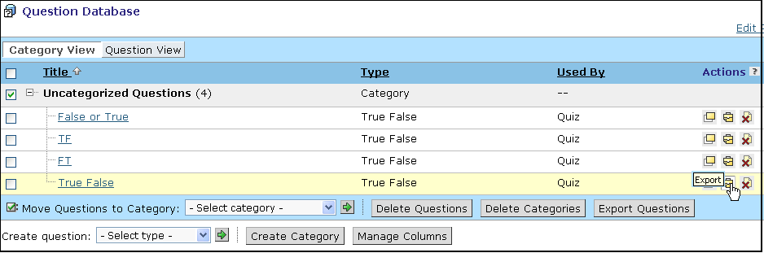
- To export multiple questions, next to each question you want to export, select the check box and click Export Questions. The Script Prompt dialog box appears.
Note: To quickly select all the questions, select the check box in the table row header.
- In the text box, enter the file name and click OK. The File Browser pop-up window appears.
Note: A .zip extension will automatically be added to the file name.
- Select the folder to which you want to export the content and click Choose Current Folder. The Export Log screen appears and lists any errors or warnings.
- Click Return. The Question Database screen appears.

Exporting Learning Modules
When you export learning modules, all assessments and content files in the module’s table of contents or in the Action Menu are included in the export. Components other than assessments and questions in the Question Database are not exported with the learning module. The learning module’s settings and any linked files are also included with the content package.
You can export multiple learning modules to one content package.
- To export learning modules:
- Navigate to the Content Inventory tab and click Learning Module.
- Select the learning module(s) that you want to export and click Export. A prompt appears.
- Enter a name for the export file. It is automatically given a .zip extension. Click OK. The File Browser appears.
- Choose a folder in which to place the export file. The learning module is exported.

Exporting Assessments
When you export assessments, its questions and the categories to which they belong are also exported from the Question Database. The assessment’s settings, along with any linked files are also included with the content package.
- To export assessments:
- Navigate to the Content Inventory tab and click Assessments.
- Select the assessment(s) that you want to export and click Export. A prompt appears.
- Enter a name for the export file. It is automatically given a .zip extension. Click OK. The File Browser appears.
- Choose a folder in which to place the export file. The assessment(s) is exported.

Hands-On Practice: Exporting Content
- Export all of the questions in the Question Database.
- Export a learning module.

Importing Content
In WebCT Vista, you can import IMS-compliant content using the Content Import tool, and SCORM packages using the SCORM Module tool.
The Content Import tool is available from the Designer Toolbar, and allows you to import both WebCT content, as well as content created in other IMS-compliant applications.
From the Content Import tool, you can import the following content:
- WebCT CE content modules. These are imported into WebCT Vista as learning modules.
- WebCT CE quizzes and surveys. These are imported into WebCT Vista as quizzes and surveys; the associated questions are added to the Question Database.
- WebCT CE questions.
- Assessments exported from another WebCT Vista course.
- Questions exported from another WebCT Vista course.
- Learning modules exported from another WebCT Vista course.
- Assessments created using Respondus™ 2.0.
- Microsoft PowerPoint presentations created using the LRN toolkit and saved in IMS compliant format. These are imported into WebCT Vista as learning modules.
- Microsoft Front Page web sites or HTML files created using the LRN toolkit and saved in IMS-compliant format. These are imported into WebCT Vista as learning modules.
Sharable Content Object Reference Model (SCORM)-compliant content packages are created outside of WebCT and imported using the SCORM Module tool.

Using the Content Import Tool
The Content Import tool is used to import WebCT content packages created in either CE or Vista, as well as IMS-compliant packaged created in other applications.
WebCT stores the files created during the import process in a sub-folder of the Section Content folder called Imported Resources. You can view the contents of this file in the File Manager tool.
Before you begin, ensure that the zip file containing the exported content is on your local drive/network.
- From the section, from the Designer Toolbar, click Content Import. The File Browser pop-up window appears, with the contents of the Section Content folder displayed.
- Make your selections to upload, select, and add the file. WebCT begins the import process.
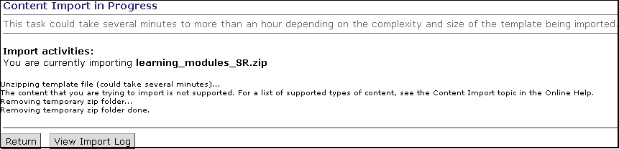
- Once the import process is complete, navigate to the Content Inventory tab and click the tool name that contains the components you just uploaded.
Note: The content is not automatically added to the Home Page or another organizer page.

Importing SCORM Modules
Sharable Content Object Reference Model (SCORM)-compliant content packages are created outside of WebCT and imported into your course as a .zip file. SCORM content packages are created using third-party tools.
Once imported into WebCT, the SCORM content package is referred to as a SCORM module. SCORM modules have a user interface very similar to that of a learning module, including a table of contents and navigation icons. SCORM modules can be added to learning modules and organizer pages.
Example: When a quiz is imported into WebCT as a SCORM module, the SCORM module containing the quiz displays within the WebCT interface with the optional table of contents and navigation icons. The content, grading scheme, and appearance of the quiz itself is determined by the creator of the quiz. If the module is gradable, data generated by the quiz will appear in the SCORM tab of the Grade Book tool.
- To import a SCORM module:
- Navigate to the Content Inventory tab and click SCORM Module.
- Click Import SCORM Module.
- Enter the SCORM Module Title.
- Select the numbering style you want to use for the SCORM table of contents.
- If you want, enter an Author and Keywords.
- Select whether the SCORM module is Gradable.
Note: Only SCORM modules that contain gradable content for which students are assigned a grade and for which you select Gradable will produce grades that appear in the Grade Book tool.
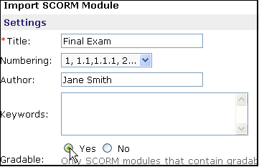
- Under Navigation Controls, select how you want students to navigate the SCORM module.
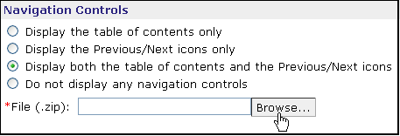
- Click Browse and locate and select the file.
- Click Save. The SCORM Modules screen appears and the imported SCORM module is listed.

Hands-On Practice: Importing Content
- Import a content module, quiz, or survey from WebCT CE.
- Import a learning module from another WebCT Vista course.
- Import a SCORM module. Ensure that both the table of contents and Previous and Next icons are displayed.

Appendix A: Sharing Your Files
Note: Only template designers can allow other designers to use their content.
You can allow other designers to use your content. To share content you must:  - Place the file in a learning context folder.  - Make the file public. Public files can be viewed by any designer in that learning context or its child learning contexts.
  Tip
  The higher a file is placed in the learning context hierarchy, the greater the number of designers who have access to it. For example, a public file in an institution learning context folder can be seen and copied by any designer in any of the institution’s child learning contexts.
- To share a file:
You can move or copy a file in your template to the learning context folder. Other designers who have permission to view the learning context folder can then add it as a file, or link to it from their template.
Note: You cannot move or copy a file to another learning context.
- Go to the template that contains the file that you want to share.
- From File Manager, locate the file, select it and click Copy. The Select Destination window appears.
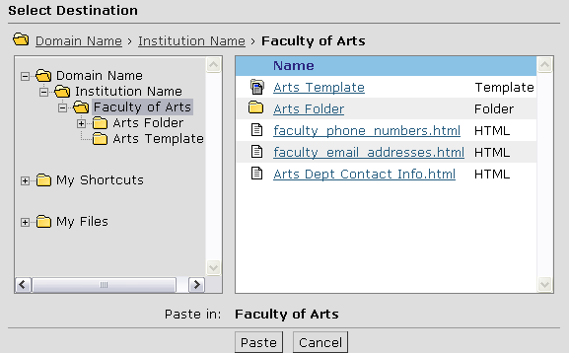
- Navigate to the learning context folder and click Paste.
- Click OK. The File Manager appears and the file has been copied.
- Navigate to the learning context folder where you copied the file.
- Locate the file that you copied and under Actions, click its Settings icon. The Edit File Information screen appears.
- Under Status, select Public.
- Click Save. Designers who have permission to view files in your learning context can now add the file or a link to the file to their template or section.

Appendix B: Creating WebDav Connections in Mac OS 10
Web-based Distributed Authoring and Versioning (WebDAV) allows you to set up a folder for your WebCT server on your local computer. If you add or delete files or folders on either the local computer, or on the WebCT server using File Manager, both systems will update to maintain the same content and structure.
- To create WebDAV Connections in Mac OS 10:
- From the File Manager screen, navigate to the folder for which you want to create a web folder.
- Click View WebDAV Info. A pop-up window appears, displaying the server path to the folder in the WebDAV path to this folder is text box.
- Ensure that the text is selected in the WebDAV path to this folder is text box and press Command+C on your keyboard. The text is copied to your computer's clipboard.
- From the Mac desktop, from the Finder, click Go.
- Click Connect to Server.
- Ensure that your cursor is in the Address text box and press Command+V on your keyboard. The clipboard's contents are copied into the Address text box.
- From your keyboard, press Option +V. The clipboard's text is copied into the text box.
- Click OK.
- In the User Name and Password text boxes, enter your user name and password and click OK. The system will authenticate the folder and, if successful, will add it to the Mac Finder.
You can now drag and drop files into this folder, like any other Mac folder. Files added to the folder will be automatically uploaded to the WebCT server whenever you are connected to the Internet.

