

Mastering the Grade Book
WebCT Vista 3.x

Copyright© 2004 by WebCT
All Rights Reserved
The content of this manual may not be reproduced or distributed without the express written consent of WebCT. Users acknowledge that the manual, and all copyright and other intellectual and proprietary rights therein, are and at all times shall remain the valuable property of WebCT and its licensors, or their respective successors or assignees. Users agree to respect and not to alter, remove or conceal any copyright, trademark, trade name or other proprietary marking that may appear in the manual.
If you have comments or suggestions for improving this manual, please email eddev@webct.com.
LR KZ 032404 3x

Table of Contents
Mastering the Grade Book 4
About This Workshop 4
The Grade Book Interface 5
Setting Up the Grade Book 7
The Instructor Role 7
Creating Columns 7
Editing Columns 9
Editing Selection List Terms 9
Editing Calculated Column Formulas 10
Editing Letter Grade Schemes 11
Hands-On Practice: Creating and Editing Columns 12
Modifying Column Settings 13
Changing the Grade Book Interface 14
Setting the Number of Members per Page 14
Freezing and Unfreezing Columns 14
Reordering Columns 14
Hiding and Showing Columns 15
Hands-On Practice: Modifying Column Settings and Changing the Grade Book Interface 16
Managing Members 17
The Instructor Role 17
Managing Individual Members 17
Adding Members 18
Managing Multiple Members 19
Find Members 20
Hands-On Practice: Managing Members 21
Managing Grades 22
Entering Grades 22
Releasing Grades to Students 23
Viewing Column Statistics 24
Viewing Audit History 25
Hands-On Practice: Managing Grades 25
Working with Student Records Outside of WebCT Vista 26
Exporting Student Records 26
Opening an Exported File 27
Importing Student Records 27
Exporting Midterm and Final Grades to SIS-Compliant Files 28
Hands-On Practice: Downloading Student Records 29

Mastering the Grade Book

About This Workshop
In this workshop, you will become comfortable working in the Grade Book as you learn to navigate the Grade Book interface and tailor it to your needs. You will create and edit additional columns and manage section members, their personal information, and their grades. You will also learn to work with student records in applications outside of WebCT Vista.
Topics
- The Grade Book Interface
- Setting Up the Grade Book
- Managing Members
- Managing Grades
- Working with Student Records Outside WebCT Vista
 | Learning Outcomes
After completing this workshop, you will be able to:
- explain the available views in the Grade Book.
- create columns for storing or calculating data.
- modify column settings.
- change the Grade Book interface to suit your preferences.
- add, remove, deny, and grant access to students and auditors to your section.
- use the PeopleLinks feature to work with an individual member.
- make grades available to students.
- enter or override grades and view audit history.
- download student records and import them into a spreadsheet or database program.
- import student records into WebCT Vista Grade Book.
- export Midterm and Final grades to a student information system (SIS).

The Grade Book Interface
The Grade Book tool is similar in appearance and function to a spreadsheet. It contains five tabs:
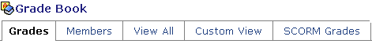
Each tab presents different groups of data columns and provides a different view of information about members, including designers, instructors, teaching assistants, students, and auditors.
- the Grades tab displays the default columns (Last Name, First Name, and User ID) and any grade-related columns. This tab is used to view, enter, or override grade-related information.
- the Members tab displays all default columns (except quiz and assignment columns) and any non grade-related columns. This view is meant to hold any descriptive information that you want to store about students and auditors.
- the View All tab displays all columns, grade-related or not.
- the Custom View tab is similar to the View All tab in that it also displays all columns but you can use it to create your own "custom view" of member information.
- the SCORM Grades tab displays columns that are automatically added for gradable SCORM modules.
Within each tab, data is presented in a grid of rows and columns:
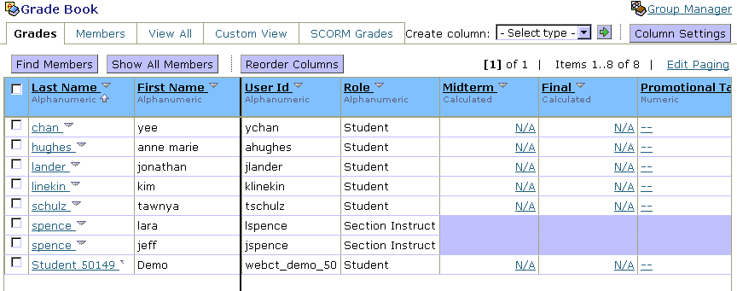
Rows
Columns
Each row is a section member. By default, members are listed in alphabetical order by Last Name. You may sort by other columns as well.
Each column contains a type of data. Some columns, such as Last Name and First Name, appear by default and cannot be deleted. Other columns are added by you or are created automatically when you create a grade-related component, such as a quiz or an assignment.
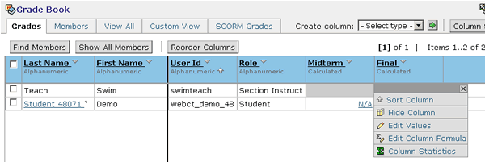
To access column options click the View Options icon next to the column name.
The following columns appear in the Grade Book tool by default:
- Last Name, First Name, User Name, and Role. These columns contain section members’ information taken from their enrollment record.
- Midterm and Final. These columns are used to generate students’ midterm and final grades. Only values from these columns can be exported to Student Information Systems (SIS). By default, these columns have a column type of Calculated, but you can edit the column type.
- Quizzes. When an assessment is created, a corresponding column is automatically created. When the assessment is graded, the grade is automatically added to the column.
- Discussion. When a gradable discussion topic is created, a corresponding column is automatically created. When the discussion is graded, the grade is automatically added to the column.
- SCORM. When a SCORM module is imported, a corresponding column is automatically created. SCORM columns are only available from the SCORM sub-tab.

Setting Up the Grade Book
You will most likely want to customize the Grade Book to suit your requirements.
 | The Instructor Role
As an instructor, you can:
- create columns to calculate or average grades, generate a letter grade based on a numeric score, keep notes, and record any other data.
- edit columns, including creating or changing formulas for calculated columns; creating or editing selection options for selection list columns; and editing numeric ranges for letter grade columns.
- modify column settings to control column attributes such as alignment, number of decimals, and whether the column is released to students.
- modify how some elements of the Grade Book are displayed, including the number of members you see displayed per page, and the order and visibility of columns.

Creating Columns
You can create the following types of columns:
- Alphanumeric, which allows you to enter a short string of text or numbers.
Example: You could create an alphanumeric column titled, “E-mail Address,” in which to enter section members’ external e-mail addresses.
- Calculated, which displays the numeric result of a formula that you create for that column. The formula can reference any other columns that contain numeric information: numeric columns, other calculated columns, quiz or assignment columns.
Example: You could create a calculated column that uses a formula that averages students’ grades for the assignments, quizzes, and midterm for the first half of the semester to generate students’ interim grades.
- Letter grade, which generates a letter grade based on the values of a numeric or calculated column. You can edit the numeric ranges that determine which letter grade is assigned.
Example: You could create letter grade columns that would convert the numeric grades for the midterm and final to letter grades.
- Numeric, which allows you to enter numeric values only.
Example: You could create numeric columns for recording grades for participation for offline assignments or assessments.
- Selection list, which allows you to select from a drop-down (selection) list of one or more values to describe or grade students. You can create the values and determine the order in which they appear in the list
Example: You could create a selection list column titled, “Class,” and specify the words, “Freshman,” “Sophomore,” “Junior,” and “Senior.”
- Text, which allows you to enter an extended amount of words, phrases, or paragraphs.
During column creation, if you specify that the column is grade-related, it is automatically added to the Grades tab. It will also appear on the View all and Custom View tab.
- To create a column:
- From the Create column drop-down list, select the column type you want to create and click the Go icon. The column screen appears.
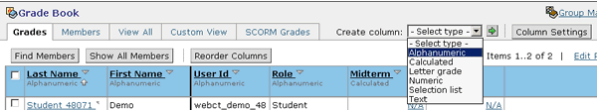
- Enter the Column label and, from the drop-down list, select the column Alignment.
- If you are creating a calculated or numeric column:
  - From the Decimals drop-down list, select the number of decimal places to which you want the column values to be calculated.
  - Enter the Maximum value to which values can be calculated.
- If you are creating a letter grade column, from the Based on numeric/calculated drop-down list, select the column on which you want to base the letter grade.
- Select whether the column is Grade-related and whether you want the column to be released to students in their My Grades tool. Grade-related columns will be displayed in the Grades tab, as well as the View all and Custom View tabs.
- Click Save. The Grade Book screen appears and the column is added.

Editing Columns
While numeric, alphanumeric, and text columns can be added to the Grade Book and used without further set up, you must edit the following column types before they can be used:
- Selection List columns
- Calculated columns
- Letter Grade columns
Note: Editing is only required if you want to change the numeric range associated with each letter grade.

Editing Selection List Terms
For selection list columns, you must specify the words or phrases to appear in the selection list.
- To edit selection list terms:
View Options icon
- From the Grade Book screen, locate the selection list column and click the View Options icon. From the pop-up menu, select Edit Column Select List icon. The Edit Column Selection list screen appears.  - In the text box, enter the first term you want to appear in the drop-down list and click Add Item. The screen updates and an additional text box appears.  - Enter the remaining terms and click Save. The Grade Book screen appears. | 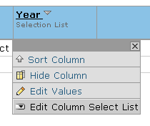  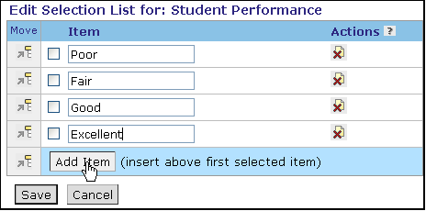

Editing Calculated Column Formulas
Once you have created a calculated column, you must edit its formula.
- To edit calculated column formulas:
- From the Grade Book screen, locate the calculated column and click the View Options icon. From the pop-up menu, select Edit Column Formula icon. The Edit Column Formula screen appears.
- Enter the formula using a combination of onscreen functions by using the numeric keypad, list of columns, and function buttons. You cannot edit the Formula text box by typing in it.
Example: AVG{[Midterm] + [Project]}
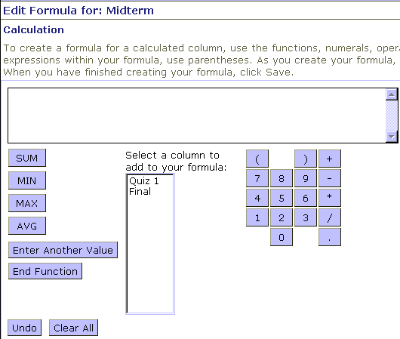
All numeric columns can be added to the formula
Function List
Formula Box
Some guidelines:
- To enter numbers and arithmetic operators in the formula box, use the mouse to select numbers and symbols and operators on the numeric keypad.
- To clear the last value entered in the Formula text box, click Undo on the Edit Formula screen.
- To clear all values from the Formula text box, click Clear All.
- MAX (maximum), MIN (minimum), AVG (average), and SUM refer to a function performed on a list. For example, if you wanted to take the highest score from three quizzes to be used in the calculation of a final grade, you would pick a function, in this case MAX, enter values, and then end the function.

Editing Letter Grade Schemes
For letter grade columns, you can change the range of numeric grades that each letter grade represents.
- To edit letter grade schemes:
- From the Grade Book screen, locate the letter grade column and click the View Options icon. From the pop-up menu, select Edit Column Letter Grade Scheme. The Edit Letter Grade Scheme screen appears. | 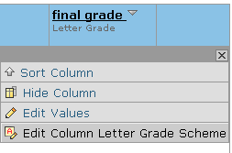
- In the Grade and Range text boxes, enter the letter grade and the range it represents.
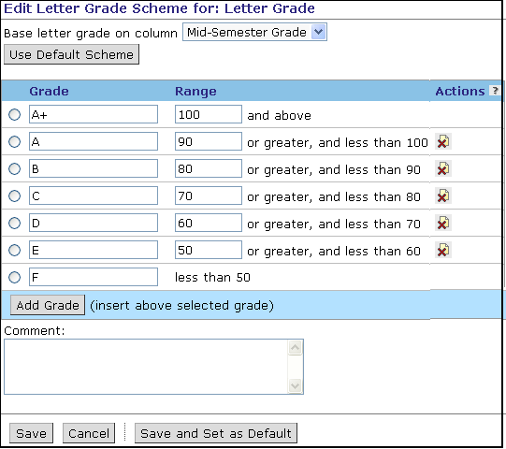
Delete unnecessary grade rows
- Click Save or Save and Set as Default. If you select Save as default, new letter grade columns will automatically use the same grade scheme.

Hands-On Practice: Creating and Editing Columns
- Create a numeric column titled Project to enter grades for a final project. The column should be grade-related and released to students. The maximum score is 30.
- Edit the existing Mid-Term column. The formula should average the scores on the Bio, Internet Acronyms, and Web Portfolio assignments.
- Create a new column titled Quiz Total that will add student scores on the Browser Tune - Up, Workshop Intro, and Internet quizzes.
- Create a letter grade column titled Final Grade based on the Final column. Specify the following letter grade scheme:
- 92 or above is an A
- 84 – 91 is an B
- 76 - 83 is a C
- 68 -75 is a D
- 67 or less is an F
After entering the values, save them and view the Edit Letter Grade Scheme screen again to see your changes. Be sure to delete unnecessary letters from the default scheme, such as “E.”
- Create a selection list column to record whether students are on-campus or distance students. The column should not be grade-related, and will therefore appear on the Members, View All, and Custom View tabs rather than the Grades tab.
- Create a text column to record phone numbers. The column should not be grade-related.

Modifying Column Settings
Column Settings control the display of information in the columns. Column Settings allow you to adjust column attributes such as the column label, alignment, number of decimals, and whether the column is released for students to view.
From Column Settings, you can:
- change the column label unless it is a default column or automatically created by a tool.
- indicate the alignment of the column – left, centered, or right.
- change the column type.
- release grades to students.
- indicate whether the column is a graded column.
- specify the number of decimals that should be displayed in the column.
- edit the maximum value of the column.
Note: Depending on the column type, you may not be able to change specific settings.
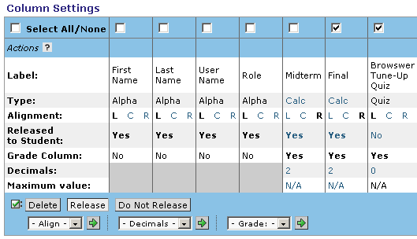
- To change the Type, Alignment, Decimals, or Maximum Value, click the current hyperlinked value. A pop-up window appears, allowing you to enter a new value.
- To change a column label, click the current hyperlinked label.
- To change the Grade Column and Released to Students settings, click the Yes/No toggle.
- To edit multiple columns simultaneously, select the columns and then choose desired alignment, decimal, or grade option from the drop-down boxes at the bottom of the screen.

Changing the Grade Book Interface
You can adjust the appearance of the information to suit your preferences. You can:
- set how many members appear per page.
- reorder all of the columns, except Last Name and First Name.
- hide or show columns, except Last Name and First Name.
- modify column settings.

Setting the Number of Members per Page
By default, 10 members per page are displayed.
- To change the number of members to display per page, click Edit Paging and enter a number. If the number of records in the Grade Book exceeds your page limit, links to the remaining pages appear.
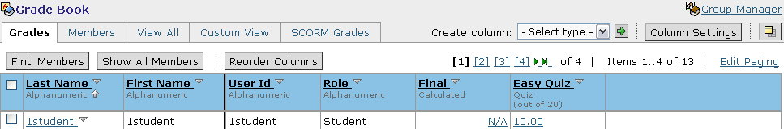
Page links

Freezing and Unfreezing Columns
By default, the columns for Last Name and First Name are “frozen” on the screen, meaning they will always appear, regardless of how far you scroll across the Grade Book screen.
- To unfreeze columns, click Unfreeze Columns. .

Reordering Columns
You can determine the left-to-right order in which columns display. The order of columns is set per Grade Book tab. By default, within each tab the Last Name, First Name, User ID, and Role columns appear first. Created columns appear from left to right in the order in which they were created.
Note: The Last Name and First Name columns cannot be reordered. However, the data within these columns can be sorted (e.g., alphabetically).
- To reorder columns:
- Navigate to the tab that contains the columns which you want to reorder and click Reorder Columns.
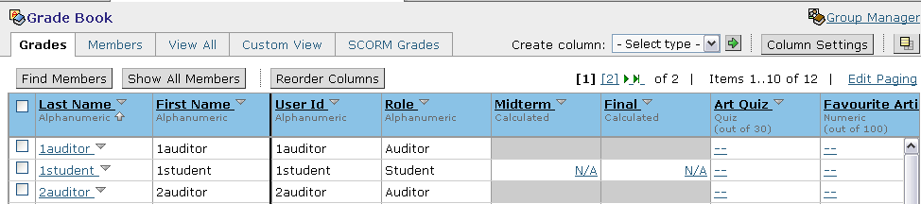
The Reorder Columns screen appears, with a list of columns. The top column in the list is the farthest left column in the tab view.
- Next to each column you want to move, select the check box.
- Do one of the following:
- Move the selected columns by clicking the appropriate Insert Selected Columns Above icon.
- Insert selected items at the bottom of the list by clicking the last icon in the Move column. These items will appear farthest to the right in the Grade Book tab view.
- Click Save. You are returned to the tab from which you initiated the column order action.

Hiding and Showing Columns
You can determine which data columns display in each tab. You cannot hide the Last Name and First Name columns.
- To hide one column at a time, click Hide Column in the pop-up menu that appears.
- To hide multiple columns:
- Navigate to the tab that contains the columns that you want to hide.
- Click Reorder Columns and do one of the following:
- To hide selected columns, select the columns and click Hide.
- To hide all columns, in the table heading row, select the check box and click Hide.
- To hide individual columns, use the Yes/No toggle in the Visible column.
- Click Save. You are returned to the tab that you started on and the columns are hidden.
- To show columns:
- Navigate to the tab whose data columns you want to show.
- Click Reorder Columns.
- Do one of the following:
- To show selected columns, select the columns and click Show.
- To show all columns, in the table heading row, select the check box and click Show.
- To show individual columns, use the Yes/No toggle in the Visible column.
- Click Save. You are returned to the tab that you started on and the columns are displayed.

Hands-On Practice: Modifying Column Settings
and Changing the Grade Book Interface
- Re-name the Final Grade column. The new label should be Final Letter Grade.
- Modify the Midterm and Final columns to display one decimal point.
- Re-order the columns so that the Final and Final Letter Grade columns are last.
- Hide the User ID column.
- Set the number of members to display per page to twenty.

Managing Members
Throughout the semester, you will use the Grade Book to manage students and other section members.

The Instructor Role
As an instructor, you can:
- grant or deny access to members.
- send e-mail messages to members.
- view performance reports for student and auditors.
- search for members that meet certain criteria.
- add a member, if the member exists in the institution user database and you know the member’s User Name.
- remove members to delete them from the section completely. They cannot access the section unless you add them back.
Note: Some options, such as adding and removing members, may be disabled by your administrator.

Managing Individual Members
You can use PeopleLinks to quickly work with individual members. With PeopleLinks, you can:
- edit member information and grades.
- view audit history.
- send a mail message to the member.
- view the member’s Performance Report.
- deny access.
- remove the member.
- To manage an individual member:
- From any of the Grade Book tabs, click the member’s hyperlinked name. The PeopleLinks menu is displayed.
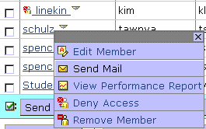
- Select the option from the pop-up menu:
- To edit column values (e.g., grades and other data), click Edit Member.
- To send mail, click Send Mail. The Create Message window appears, with the To text box pre-populated with the member’s name.
- To display a summary of the student’s participation and activity in the section, click View Performance Report.
- To deny a member access, click Deny Access.
- To delete a member, click Remove Member.

Adding Members
The Grade Book tool allows you to add students and auditors to your section. You must know their User Name and they must already exist in the institution’s database of users. If they do not exist in the institution database, contact your administrator.
- To add a member:
- From the Grade Book screen, click Add Members. The Add Members to Section screen appears.
- Enter the user name and select whether to add them as a Student or Auditor.
- Click Add. The screen updates, showing the Member that you are adding.
- Click Save.

Managing Multiple Members
You can streamline management tasks by selecting multiple members from any Grade Book tab, and then selecting actions to perform, such as:
- send Mail
- deny access
- grant access
- remove
- To manage multiple members:
- Select the members you want to manage. You can select all displayed members by selecting the check box in the table heading row.
- Select the action to perform:
- To grant selected members access, click Grant Access.
- To deny selected members access, click Deny Access. When the member clicks the section name from My WebCT, they will see a message that they are denied access.
- To remove selected members from the Grade Book, click Remove. Removing a student deletes all grade information; contact your administrator before removing students from your section.
- To send selected members a mail message, click Send Mail. The Create Message window appears, with the mail addresses pre-populated.
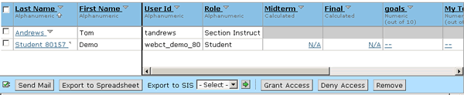

Find Members
You can search for subsets of members using the Find Members feature. The criteria that you use for your search can include:
- one or more of the columns in the Grade Book
- role type (e.g., students, auditors)
- group membership
- a combination of the above criteria
Example: You can search for all members whose role is student or auditor and who scored below 75% on a quiz and then send them an e-mail message with suggestions for improving their performance. Once you have found members, you can perform actions on the retrieved set.
- To find members:
- From the Grade Book tab that contains the column you want to search by, click Find Members. The Find Members screen appears.
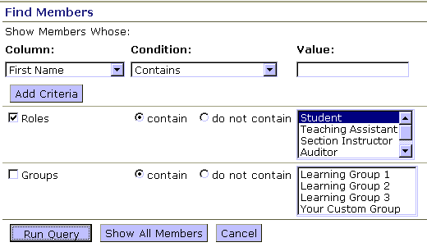
- From the Column drop-down list, select the column that you want to search.
- From the Condition drop-down list, select a comparison function.
- Under Value, in the text box, enter a text value that will be compared to members' values for the selected data column.
Note: The values are case-sensitive.
- If you want to limit by role, select the Role check box and your criteria.
- If you want to limit by group, select the Groups check box and your criteria.
- Click Run Query. You are brought to the tab where you initiated your query, and only those members who satisfy the Find criteria are displayed.
- To return to displaying all members, from any of the Grade Book tabs or from the Find Members screen, click Show All Members.

Hands-On Practice: Managing Members
- Use the PeopleLinks menu to:
- add a phone number for Abe Stewart.
- indicate that Hannah Kennedy is an on-campus student.
- record a score of 25 on the final project (Project) for Bob Zeigler.
- Select several students simultaneously and deny them access to the section.
- Find all students who scored at least an 80% on the Internet quiz and send them an e-mail message congratulating them on their good grade.

Managing Grades
You can perform many grade management tasks from the Grades tab, including:
- entering or overriding grades.
- viewing column statistics.
- viewing audit history.

Entering Grades
You can enter grades directly into their column in the Grade Book if the grades are not automatically populated by the tool. For example, you might create columns to record overall participation grades or for off-line projects.
You can also override grades for columns that have been automatically populated (e.g., quiz, assignment, or gradable discussion) or calculated (e.g., letter grades, calculated grades). For example, you might want to override data for a quiz if you’ve determined that the quiz was too difficult. When you override a grade, a caret symbol (^) is added to the cell to indicated that the data has been overridden.
Reminder: You can edit grades for individual students by selecting Edit Member from the PeopleLinks menu.
- To enter or override a grade for a single student:
- From the Grades tab, in the row for the student, click the cell that you want to add a grade to. The Edit Value screen appears.
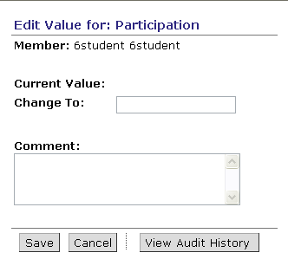
- In the Change To: text box, enter or edit the value.
- If desired, enter a comment. The comment will be added to the Audit History.
- Click Save.
- To enter grades for multiple students:
- From the Grades tab, click the column name and from the menu, click Edit Values. The Edit Column screen appears; each member appears as a row.
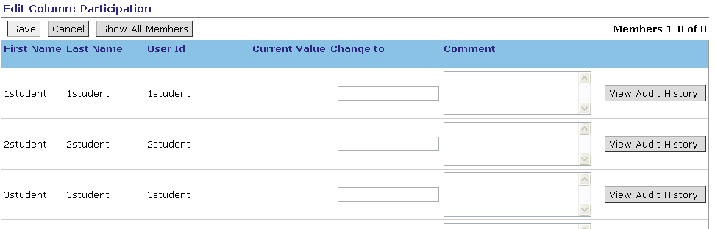
- For each member, enter the grade and if desired, enter a comment. The comment will be added to the Audit History.
- Click Save.

Releasing Grades to Students
If the designer has added the My Grades tool to the Course Toolbar, students can access their grades. You determine which grades the students can see by releasing the associated columns in the Grade Book. You can release only grade-related columns.
- To release grades:
- Click Column Settings.
- If you want to release a single column, toggle the Released to Students setting to Yes.
- If you want to release several columns, select the columns and click Release.

Viewing Column Statistics
You can view the following statistics for calculated, numeric, and alphanumeric columns from the Grades, Members, View All, or Custom View tabs:
- count – the total number of values in the column
- average – the average value of all values in the column
- median – the middle value in a distribution of column values
- maximum – the maximum column value
- minimum – the minimum column value
- standard deviation – the measure of the variation in a distribution of column values

- To view column statistics:
- Select the Grade Book tab that contains the column for which you want to view statistics.
- Click the column title and, from the menu that appears, click Column Statistics. The Column Statistics window appears displaying all available column statistics.
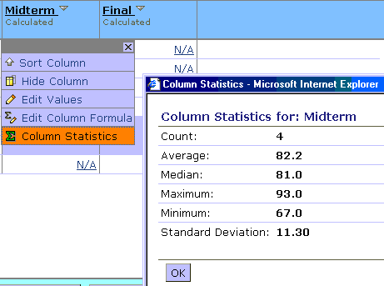
- When you are done viewing statistics for the column, click OK.

Viewing Audit History
You can view a history of all changes to grades. The Audit History displays the date and time of change and indicates which user made the change.
- To view the audit history for a single student:
- From the Grades tab, from the PeopleLinks menu for the student whose audit history you want to view, click Edit Member. The Edit Member screen appears
- Next to the student’s name, click Audit History. The Grade Audit History pop-up window appears, displaying all changes made to all columns for this student.
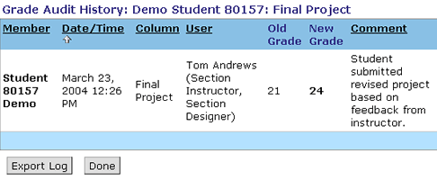
- To view the audit history for multiple members, from the main Grade Book screen, select the members you want to view the audit history for. Click View Audit History.

Hands-On Practice: Managing Grades
- Enter a Participation grade for Abe Stewart.
- Enter grades for all students in the Project column.
- Change Kristie Shaw’s grade on the Internet Quiz. In the Comments text box, enter a reason for the change of grade.
- Release the Participation grades to students.
- View the grade changes for Jill Ellis.
- View all of the grade changes for all of the members.

Working with Student Records Outside of WebCT Vista
You can export student records and store them locally for use as a backup. You can also work with them in a spreadsheet program such as Microsoft Excel ™, and then import them back into Grade Book.

Exporting Student Records
Important: If you want to work with the records outside of WebCT Vista and then re-import them, you must export the User ID column, as it is used for matching column data.
- To export student records:
- From Grade Book, click Export to Spreadsheet. The Export to Spreadsheet screen appears.
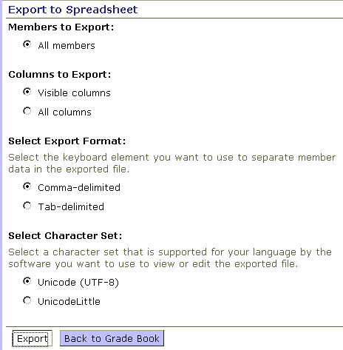
- Select columns and format for exporting.
Note: Choosing the comma-delimited format will save the file with a .csv extension; the tab-delimited format will save the file as text (.txt ).
- Click Export. A file download screen appears.
- Enter a filename and click Save.

Opening an Exported File
These instructions are for Microsoft Excel® but the steps that instruct you to choose delimiters (a.k.a. separators) will work in all spreadsheet software and in some database software programs.
- Open Microsoft Excel.  - Open the file that you exported. The Text Import Wizard appears.  - Specify that you want to open the file as a “delimited” file. Click Next.  - Specify the delimiters. Choose “Tab” and “Comma.” Click Next. Your new file will preview with the information in appropriate columns.  - If this appears to be the proper layout, click Finish. | 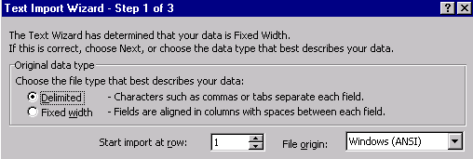  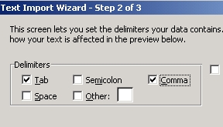
Note: Depending on the version and software you’re using, you may not need to complete the steps outlined above.

Importing Student Records
Once you’ve edited the student data, you can then re-import it back into the Grade Book. You can also create student data in a worksheet and import it. One of your columns must be labeled User ID and contain the User Names for the students in your course.
Note: All new columns created during import are created as text columns. If you want imported columns to be alphanumeric, calculated, letter grade, numeric, or selection list, you must create them first in the Grade Book.
- To import student records:
- From the Grade Book screen, click Import from Spreadsheet. The Import File screen appears.
- Click Browse and select the file to import. Specify whether the file you’re importing is Comma or Tab separated.
- Click Upload. The Import File appears, displaying the Import Column, whether it matches with an existing column, and the current Grade Book columns.
- From the Grade Book column, choose the name of the column in WebCT’s Grade Book to match the column in the import file:
- If there is no match, select either Do not import or Add as New Column.
- To ignore a column, select Do not import.
- Click Import. The Import Errors screen appears, explaining possible errors
- Click OK.

Exporting Midterm and Final Grades to SIS-Compliant Files
If required by your institution, you can export Midterm and Final grades for use in a Student Information System (SIS). You can only export a midterm or final grade once; be sure that the grades are correct before your export.
- To export your midterm or final grades to an SIS compliant file:
- From the Export to SIS drop-down list, select Midterm or Final and click Go. The Export Grade screen appears.
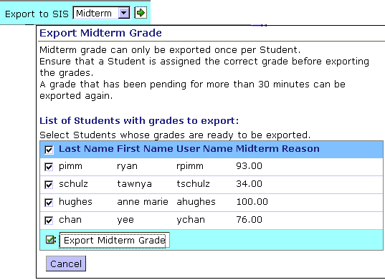
- Select the students whose grades you want to export.
- Click Export Grade.

Hands-On Practice: Downloading Student Records
- Download the student records and note the folder on your local computer where you saved them. Be sure to download ALL columns (not just visible columns) because the user id column was previously hidden in an exercise and is needed for importing.
- Open the student record file in a spreadsheet program to view the data.
- Modify one column’s data in the spreadsheet application.
- Import the file into your course.

