

Orienting Students to Your Section
WebCT Vista 3.x

Copyright© 2004 by WebCT
All Rights Reserved
The content of this manual may not be reproduced or distributed without the express written consent of WebCT. Users acknowledge that the manual, and all copyright and other intellectual and proprietary rights therein, are and at all times shall remain the valuable property of WebCT and its licensors, or their respective successors or assignees. Users agree to respect and not to alter, remove or conceal any copyright, trademark, trade name or other proprietary marking that may appear in the manual.
If you have comments or suggestions for improving this manual, please email eddev@webct.com.
LR KZ 032404 3x

Table of Contents

About This Workshop 4
Preparing Students for WebCT 5
Browser Configuration 5
Plug-Ins and Software 5
Optional Activity: Browser Tune-Up 6
Orienting Students to Your Course 7
Discussion: Using WebCT Tool to Orient Students 7
Tips for a Successful Start 8
Using Syllabus 9
The Instructor Role 9
The Syllabus Interface 10
Hands-On Practice: Using Syllabus 10
Using Calendar 11
The Instructor Role 11
Types of Entries 12
The Calendar Interface 12
Common Calendar Tasks 13
Choosing the Type of Entries to View 13
Viewing entries 13
Adding entries 14
Deleting entries 15
Advanced Calendar Tasks 16
Editing Section Settings 16
Creating Recurring Entries 17
Creating Linked Entries 18
Compiling Entries 18
Hands-On Practice: Using Calendar 19
Using Announcements 20
The Instructor Role 20
Creating Announcements 20
Hands-On Practice: Using Announcements 21
Using the Reports and Tracking Tool 22
Types of Reports 23
Generating Reports 24

About This Workshop
Learning online may present some new challenges for students. In this workshop, we’ll discuss several proactive strategies to prepare students for participation in a WebCT course. We’ll then turn your attention to specific WebCT Vista tools you can use to orient students to your course, providing them with critical information on getting started, course expectations, important dates, and time-sensitive announcements.
Topics
- Preparing Students for WebCT
- Orienting Your Students
- Creating a Syllabus
- Using Calendar
- Using Announcements
- Using Tracking and Reporting
 | Learning Outcomes
After completing this workshop, you will be able to:
- make recommendations to your students for browser and plug-in performance.
- develop a syllabus.
- use the Calendar tool to post a schedule of class-related dates.
- add announcements to provide students with time-sensitive information and tips.
- use the Tracking and Reporting tool to identify students who may need additional assistance and encouragement.

Preparing Students for WebCT
You can help maximize student success by providing students with information on:
- browser configuration.
- any plug-ins or other software required to use your section.
- the online learning environment.

Browser Configuration
In order to use WebCT Vista 3.0, you and your students must use a supported browser. You can ensure that your browser is supported by checking the Browser Tune Up page at http://www.webct.com/tuneup.
In addition, upon a user’s first access to WebCT Vista, automatic browser checking is performed. It displays a warning if you are using an unsupported browser, along with a link to the Browser Tune-up page.
A manual browser checker is also available from My WebCT. It can be used at anytime.
- To manually check your browser, from My WebCT, click the Check Browser link.
Note: If the link does not appear, your administrator has disabled this feature.
In addition to checking your browser, WebCT Vista automatically checks to see if your browser is Java™ enabled and that the required version of Java Virtual Machine (JVM) has been installed. These checks occur whenever you access a tool that requires Java, such as the HTML Creator.

Plug-Ins and Software
If your course includes multimedia or non-HTML files such as PowerPoint presentations or PDF documents, your students may require additional plug-ins and players to view these files.
You might want to provide students with:
- information on which types of files will be used.
- instructions on how to acquire and install any necessary plug-ins, viewers, or readers.
- instructions on how to test their hardware and software to make sure everything is in order before the class begins.

 | Optional Activity: Browser Tune-Up
- Using the Check Browser link, make certain your browser version is one recommended for use with WebCT Vista. If the installed browser is not one that is recommended, follow the online instructions to install a recommended browser.
- Access the WebCT Browser Tune-up at http://www.webct.com/tuneup.
- Use the checklist below to make sure your browser settings are properly prepared (Java, Cache, Anonymous Logon, Cookies and Auto Configuration).
Computer Identification (e.g. home, office, lab #):
 |  | Microsoft Internet Explorer |  | Netscape Communicator
Version Installed
Java Enabled |  | □ Yes | □ No | □ Yes | □ No
Cache Set |  | □ Yes | □ No | □ Yes | □ No
Anonymous Logon turned off (IE only) |  | □ Yes | □ No
Cookies enabled |  | □ Yes | □ No | □ Yes | □ No
Auto config disabled (see appendix) |  | □ Yes | □ No | □ Yes | □ No

Orienting Students to Your Course
Research undertaken by the State University of New York identified eight pieces of information that were crucial to the success of an online course:
- Welcome message | - How to begin the course
- Contact information | - Expectations for participation
- Course schedule | - Course overview and objectives
- Description of activities | - How assignments are evaluated
Source: Student Satisfaction and Perceived Learning with On-line Courses: Principles and Examples from the SUNY Learning Network http://www.sloan-c.org/publications/jaln/v4n2/v4n2_fredericksen.asp

Discussion: Using WebCT Tool to Orient Students
How could you use the following WebCT Vista tools to provide students with the eight pieces of information identified above?
Syllabus
Calendar
Announcements
Mail/Discussions

Tips for a Successful Start
The start of a new course can be both exciting and a little scary – especially the first day. Because the first day of class is so important for setting the tone of the course, it is crucial to think carefully about how you introduce yourself. The lasting nature of initial impressions holds as true for online courses as it does for conventional ones.
Actually, first impressions may be even more important in online courses. Since students may not have an opportunity to “see” you or meet with you personally, they will place great emphasis on their initial interactions with you. We suggest using the first week of your online course to establish a rapport with your students, clarify expectations about the course, gather useful information concerning the students, and generate excitement about the learning experience.
Here are some other suggestions to get your students off to a strong start:
- provide warm-up activities to break the ice and get participants comfortable in the online environment.
- log on to the course especially frequently at the beginning of the course and set a schedule to ensure a high rate of responsiveness for your students.
- respond to all private correspondence immediately.
- encourage students to post non-private messages and questions in a “public” area, such as Discussions.
- grade and return assignments as quickly as possible.
- contact students who have not logged into the course in the first week of class.

Using Syllabus
The Syllabus tool provides a framework in which you can either build a syllabus for your course or upload an existing syllabus.
A syllabus built within WebCT Vista consists of items such as course information, instructor information, course goals, policies, textbooks, course requirements, and lessons. You can also create customized items and timed events with the Calendar tool.
Example: Optimizing Your Syllabus for Online Students
“Online course syllabi serve as platforms upon which to stage, manage, or enhance your course and function as a kind of contract between you and your students. Students will most likely download, print-out, and follow your syllabus like a map, using it to chart their progress in your course.
In an online course, students need to know how to proceed and where everything is located in the online classroom, so your syllabus should include information about course layout, online procedures and preferred methods for submitting assignments.
Information on course expectations, including how the students will be evaluated, will also help orient students to your course.”
Source : Optimizing Your Syllabus for Online Students http://www.onlinelearning.net/InstructorCommunity/
 | The Instructor Role
If your section contains the Syllabus tool, you can:
- add, edit, and reorganize items using the built-in syllabus.
- import an existing syllabus.
- preview the syllabus as it will appear to students.
You cannot, however, delete or edit the Section Information or Section Instructor items.

The Syllabus Interface
When using the built-in syllabus, each section is called an item. As an instructor, you can:
- add multiple items for each item type.
- rename item types. For example, Resources could be re-titled Textbooks.
- automatically add calendar events based on the lessons item type.
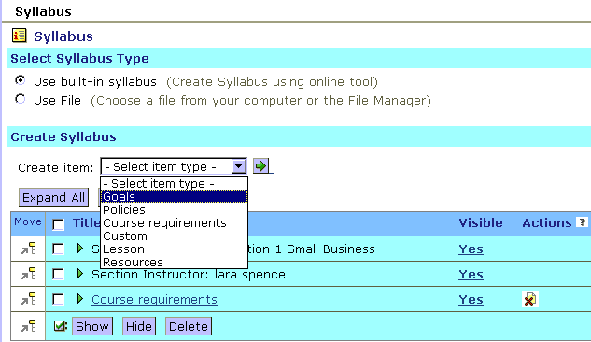

Hands-On Practice: Using Syllabus
- Create a new resource item.
- Create a new lesson item. Indicate the date and add an event to the Calendar tool.
- Re-order the sequence of items in the syllabus.
- Hide one of the syllabus items from students by setting its Visibility to No.
- Preview the printable version of the syllabus.
- Preview the student view of the syllabus.

Using Calendar
 | The Calendar tool allows students, teaching assistants, and instructors to exchange scheduling information quickly and effectively.
The Calendar tool allows you to view and create entries for campus or personal events. You can create private entries that only you can view or public entries. You can determine whether students and teaching assistants are permitted to create public entries too.
Calendar entries can be used to provide students with information about:
- assignment due dates and tests.
- changes to instructor office hours.
- links to course content and external websites.
Some instructors use the Calendar tool as the “hub” for their course, outlining each week the activities a student should be completing and directing students to course resources and external URLs.

The Instructor Role
As an instructor, you can:
- add, edit, and delete Calendar entries.
- add links from Calendar items to other items in the section or an Internet link.
- allow students to post public entries.
- compile entries to view and print.

Types of Entries
The Calendar tool can display three types of entries:
- course-related: for each of your sections, you can create entries that are public (viewable by all section members) or private (viewable only in your calendar).
- personal: you can create entries that are not related to the course but are for personal reminders. These are private.
- institution: your administrator can create entries to communicate campus events that are viewable by all institution members.

The Calendar Interface
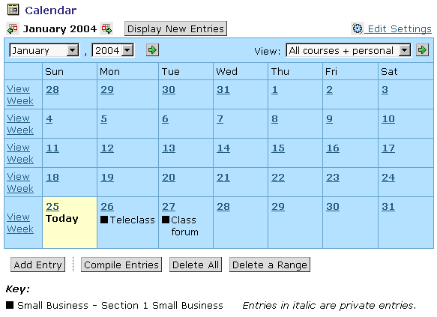
Course and section key
By default, the Calendar tool shows:
- the month view, with the week beginning on Sunday.
- entries for all courses and personal entries. Personal entries are italicized.
You can change the default appearance by using Edit Settings.

Common Calendar Tasks
Common Calendar tasks include viewing entries, adding entries, and deleting entries.

Choosing the Type of Entries to View
You can use the View drop-down menu to select the type of entries that you want to see. If you choose to display entries for multiple courses and sections, icons indicate which course or section the entry is for. An icon key is displayed in the bottom left-hand corner of the screen.
- To choose the type of entries to view, from the View drop-down menu, select your preferred view and then click the Go icon.
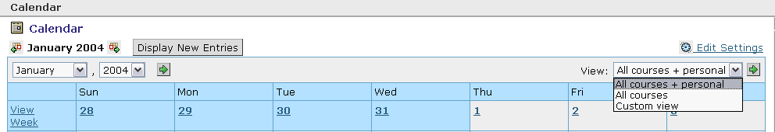

Viewing entries
The month view entries display only the summary of the entry. Date and week views show both the detail and the summary.
- To view an entry for a specific day, click its hyperlinked date.
- To view an entry for a specific week, click its hyperlinked View Week.
- To select a different month and/or year, select from the month and or/year drop-down menus and then click the Go icon.
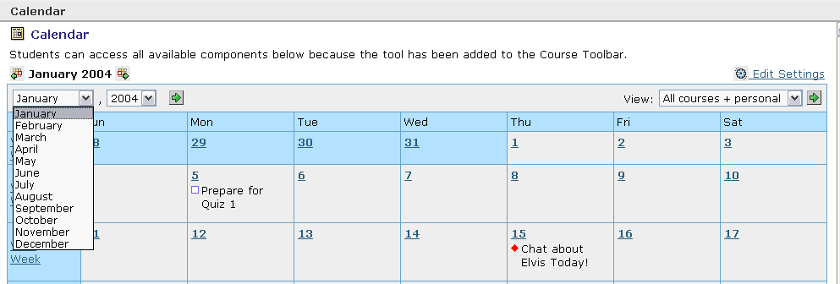

Adding entries
You can create personal or course-related entries. If you add a course-related entry, the entry will show you as the creator in the entry detail.
- To add an entry:
- From the Month, Week, or Day screen, click Add Entry.
- In the Summary text box, enter a brief description of your entry. When viewing entries on the Month screen, the summary is the only information that you see.
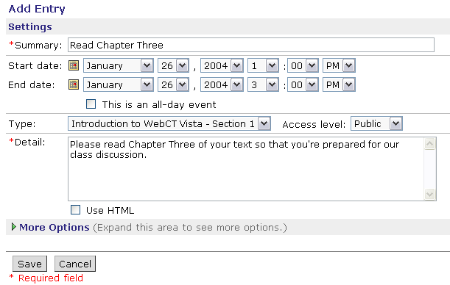
- Use the drop-down menus to select start and end dates, and the duration.
- Next to Type, from the drop-down lists, select the course or section that can view the entry, and the access level.
- To make this an entry that only you can view, select Private.
Note: You may choose to keep entries private temporarily and then release them later by editing the entry.
- To make this an entry that all members of the course or section can view, select Public.
- To include more information about the entry, enter text in the Detail text box. If you select Use HTML, you can include HTML tags to format the text.
- Click Save. The entry is added to the calendar.

Deleting entries
- To delete one entry:
- From the Week or Day screen, locate the entry and click its Delete link. A confirmation message appears:
- Click OK.
- To delete all entries for a day, navigate to the Day screen and click Delete All.
- To delete all entries, from the Month or Week screen, click Delete All.
- To delete a range of entries:
- From the Month, Week, or Day screen, click Delete a Range.
- Under Date Range, use the drop-down lists to select the date range for which entries will be deleted.
- Click Delete.
- Click OK.

Advanced Calendar Tasks
Advanced Calendar tasks include editing Section Settings, creating recurrent entries, creating linked entries, and compiling entries.

Editing Section Settings
Section Settings allow you to specify whether students can make public entries and to set the default entry type (Public or Private) for your own entries. Students and designers cannot edit Section Settings.
- To edit section settings:
- From the Month, Week, or Day screen, click Edit Settings.
- Under Section Settings, select the check box to allow students to make public entries. Deselecting the checkbox will limit students to creating private calendar entries only.
- Select the default entry type for the instructor as Public or Private. New calendar entries will automatically be set to the default entry type when created. You can select the alternate type manually.
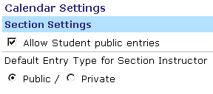
An efficient way to populate the Calendar in advance is to have all of your postings initially set to “private.” As the term proceeds and deadlines approach, change their status to public. This will prevent students from feeling overwhelmed by a large number of dates and announcements in the Calendar and lets you easily release the entries as they are needed.

Creating Recurring Entries
You may want to add entries that repeat at the specified time either on several consecutive days or on selected days of the week. For instance, if you have weekly virtual office hours, you could add a single recurring entry for the entire semester, rather than creating multiple, individual entries.
- To create a recurring entry:
- From the Add Entry screen, enter the summary, type, and details for the entry.
- Select the same dates for the start and end dates.
- Enter the time duration.
- Under More Options, under Recurrence, select This entry repeats, and choose the frequency of recurrence.
- Next to Until, select the last date that the recurring entry should appear.
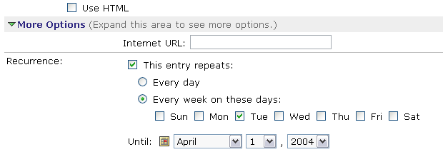

Creating Linked Entries
You can add entries that are hyperlinked either to external URL addresses or to section components, such as a Discussion topics or categories, assessments, or assignments. For example, if a quiz must be completed by the 15th of the month, you could add an entry that links directly to the quiz.
- To create a link to a Web address when creating a Calendar entry, under More Options, in the Internet URL text box, enter the address.
To create a link to a component:
- Select the tool that contains the component (e.g., chat room, survey) that you want to link to and click the Go icon. The Select Component pop-up window appears with a list of available components.
- Select the component to which you want to link and click OK.
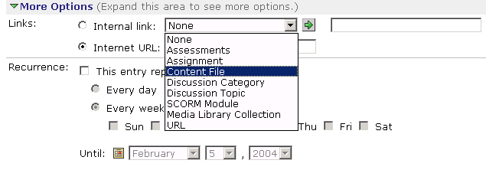

Compiling Entries
Calendar entries can be compiled according to criteria you set. Filters allow entries to be screened according to date, time, keyword, and access level. Multiple filters can be applied. Compiling entries for a week, for example, produces a list of items in a schedule.
- To compile entries:
- From the Calendar screen, click Compile Entries.
- Select a range of dates and times.
- Click Compile. A compiled report appears.

Hands-On Practice: Using Calendar
- Edit section settings to indicate whether your students should be able to make public entries in your section.
- Add a Calendar entry that is a reminder of a typical course maintenance activity, such as releasing grades to students. Make sure you specify the entry as Private.
- Add a recurring entry for virtual office hours.
- Add an entry linked to a section quiz.
- Compile a range of calendar entries. How could you or your students use the filtering options?

Using Announcements
You can use the Announcements tool to create announcements or tips for students and other section members. Section members can always view announcements from the Course Toolbar. You can also deliver announcements as pop-up messages, ensuring members see them when they log in to the section.
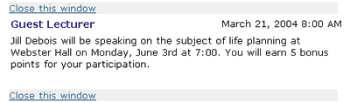

The Instructor Role
You can use the Announcement tool to:
- create and send announcements.
- edit and delete announcements.
Note: You can only edit announcements that haven’t been sent.

Creating Announcements
When you create an announcement, you select which roles should receive the announcement and the delivery dates.
- To create an announcement:
- From the Announcements screen, click Create Announcement.
- Enter a title that identifies and summarizes the announcement to course members.
- In the Message text box, enter the body of the announcement.
- Under Select Roles, select the check box next to each role you want to receive the announcement.
- Select a start and end date and time.
- If you want the announcement to appear as a pop-up message, next to Also deliver as, select the Pop-up check box.
- Click Send.
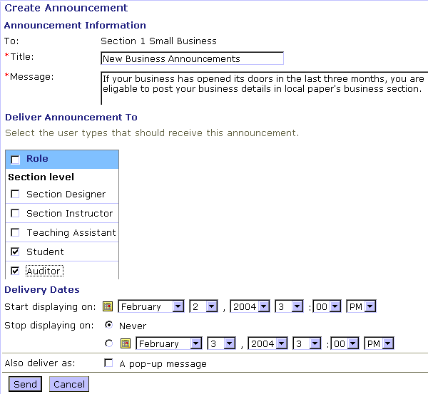
Select “Also deliver as pop-up” to ensure students receive the message as soon as they log in to the section.

Hands-On Practice: Using Announcements
- Create an announcement that you would normally make to students during the first week of the term.
- Create an announcement for later in the term to remind teaching assistants about a required meeting. Deliver the message as a pop-up.

Using the Reports and Tracking Tool
The Reports and Tracking tool generates reports on various student activities in the course during a specified date range. You can use the statistics provided by the reports to:
- identify which students have initially logged in to the course and follow different students’ levels of participation in various course activities and identify students that may need additional assistance and encouragement.
- determine which components, tools, or pages are most interesting or effective for students.
Example: Using the Tracking and Reporting Tool to Keep in Touch with Students
“During the first two weeks of classes I examine the Student Tracking Report to see who hasn't accessed the course yet. Those are the students I need to get in touch with - and I do - via e-mail. It has helped in a number of occasions.
Later in the term I view the same report, but focus on the Last Access column. This allows me to see who is keeping current in the course. If someone has not been on for a week or more, I know there is trouble brewing and I contact them. I also sort by sessions, so I can see who hasn't routinely been "coming to class."
When I contact these students, I sometimes find they're having trouble with the course and have reacted by avoiding it. Sometimes I simply find a busy student. I always find a student surprised that I care enough to take the time to ask. It is a positive experience for both of us in every case. It takes next to no time for me."
For most report types, you can graph the report statistics. For all the report types, you can export the statistics to your local computer as a comma-separated file (.csv).
 | Note: | Depending on administrator settings, it may take between one hour to one day before statistics are available.
- Terms to Know
Session |  |  | In general, one session is one logon to the course..
Page View |  |  | One page view is equivalent to one student viewing a component once.

Types of Reports
You can generate the following types of reports:
Type | Content | Suggested Use
Summary of Activity | - provides an overview of how often users access your course and when. | - use to help you determine the best time to schedule course related activities.
Tool Usage | - lists the tools which students have used and provides the total number of sessions, average time per session, and the total time the tool has been used. | - use to determine which tools are used more frequently, which may be indicative of their benefit or interest to students.
Component Usage | - lists the components which students have used, the number of visits, the average time per visit, and the total time the component has been viewed. | - can be used as a starting place to determine which components are working well. For example, components with short average viewing times may be confusing or of little benefit to students.
Entry Points | - provides an overview of the number of times students used each of the possible entry points in to the course. | - can be used to determine which entry point is the most accessible or useful to students.
Exit Points | - provides an overview of which pages and tools students were using when they exited the course. | - If you find that the numbers are the same for both entry and exit points, it could indicate that students are not getting below the entry pages into the content level of your course.
Content File Usage | - provides an overview of how often content files are accessed. | - can be helpful in determining how the students are progressing through content files (either in learning modules or that have been added to organizer pages).  - can also indicate if the organization of the course is effective.
Student Tracking. | - provides a single report that lists data about each student in the course, including the first and last access and the total time spent.  - also provides a count of the student’s activity in a each tool, such as number of mail messages read and sent, and the number of assignments read and submitted.  - you can also link to a student’s individual report | - can identify students who are falling behind or not participating regularly and gives you the opportunity to determine whether you need to communicate with them. This feature allows you to see where students are spending the most and least amount of time, which often correlates with the student’s achievement in the class.

Generating Reports
The Reports and Tracking tool is available from either the Course View or Tool View sub-tabs
After you have generated a report, you can:
- export the data.
- generate a graph of the data (for Tool Usage, Component Usage, Entry Page or Tool, and Exit Page or Tool reports).
- To generate a report:
- From Reports and Tracking tool, select the title of the report to generate.
- Select the desired date range.
- Click Run Report. The report appears in a new screen.
- If you want to export the data as a comma-separated file (.csv), click Export.
- If you want to view a graph of the results, click Graph.
- If you are viewing the Student Tracking report, and want to see data for an individual student, click the student’s hyperlinked name.

Hands-On Practice: Monitoring Student Performance
- The facilitator will demonstrate how to use the Reports and Tracking tool to:
- generate a Student Tracking report to determine which students have never logged in to the course and which students have accessed the course less than three times.
- generate a Component Usage report for the past year.
- As a group, discuss how you might use reports to offer insight into a student’s participation and performance.

