

Presenting Content in
WebCT Vista 3.x

Copyright© 2004 by WebCT
All Rights Reserved
The content of this manual may not be reproduced or distributed without the express written consent of WebCT. Users acknowledge that the manual, and all copyright and other intellectual and proprietary rights therein, are and at all times shall remain the valuable property of WebCT and its licensors, or their respective successors or assignees. Users agree to respect and not to alter, remove or conceal any copyright, trademark, trade name or other proprietary marking that may appear in the manual.
If you have comments or suggestions for improving this manual, please email eddev@webct.com.
LR KZ 0040604 3x
Table of Contents

Options for Presenting Content 2
Adding Content Files 4
Hands-On Practice: Content Files 6
Creating Organizer Pages 7
Organizer Page Options Menu 8
Organizer Page Descriptions 9
Hands-On Practice: Organizer Pages 9
Building Learning Modules 10
The Learning Module Interface 10
Terminology Refresher 11
Naming the Learning Module and Selecting Settings 12
Adding Components 12
Ordering Components 13
Adjusting Heading Levels 14
Hands-On Practice: Building Learning Modules 15
Customizing the Action Menu 16
Learning Module versus Component Action Menus 16
Learning Module Action Menus 16
Component Action Menus 17
Editing Learning Module and Component Action Menus 18
Creating Links to Components 18
Adding Action Menu Tools 19
Adding Action Menu Tools 19
Hands-On Practice: Editing Action Menus 19
Creating Goals and Resources 20
Creating Resources 21
Hands-On Practice: Adding Goals and Resources 21
Creating Media Library Collections 22
Creating Collections 23
Creating Entries 24
Manually Linking Entries to Content Files 26
Hands-On Practice: Working with the Media Library Tool 27

About This Workshop
In this Workshop, we will explore several options for presenting content and components to students. After reviewing options for sharing individual content files with students, we will examine the key differences between Organizer Pages and Learning Modules. Through hands-on activities, we will build Learning Modules and customize the Action Menu to create rich, structured learning paths for students. We will also use the Media Library tool to build collections of media files to share with students.
Topics
Topics include:
- Options for Presenting Content
- Adding Content files
- Creating Organizer Pages
- Building Learning Modules
- Customizing the Action Menu
- Creating Media Library Collections
 | Learning Outcomes
After completing this workshop, participants will be able to:
- explain the key differences between content files, organizer pages, and learning modules.
- share individual content files with students.
- use organizer pages to present content and components.
- build learning modules to organize and present course content and components.
- customize the Action Menu to enhance the learning experience.
- create Media Library collections and entries.
- manually or automatically link entries.

Options for Presenting Content
In WebCT Vista, the term content encompasses any of the components that you create using various tools, such as discussion topics that you create with the Discussions tool and quizzes that you create with the Assessments tool. It also includes content in the form of content files, which are single files that you can either create in WebCT Vista or upload from your local system.
WebCT Vista provides two frameworks for organizing your content: learning modules and organizer pages.
Organizer pages are empty pages to which you can add components. The Home Page is an example of an organizer page.
Learning modules are like organizer pages in that you can add components to them. With learning modules, however, you can structure content hierarchically in a table of contents to determine the order in which content is delivered to students. Depending on their scope, learning modules can be analogous to a unit or chapter in a textbook.
Briefly review the following features of organizer pages and learning modules and decide which best suits your content and teaching style.
Learning Module | Organizer Page
Sequential: content is presented in a set order | Exploratory: content is presented in a list or table
Navigation provided via the Action Menu | No navigation
Component use is tracked | Component use is tracked
Does not contain Headers or Footers | Contains Headers and Footers
Provides Headings for refining the sequence of content | Headings are not provided
Components are integrated with content in the Table of Contents and Action Menu | Components are presented cafeteria-style, with no relationship to content
Additional tools - Goals and Resources - are available | Additional tools - Goals and Resources - are not available
Can apply Selective Release | Can apply Selective Release

List the titles of learning modules and organizer pages you plan to add to your course.
Learning Modules | Organizer Pages

Adding Content Files
You can add content to your course in the form of single files. This type of content is called a content file. You can add content files to organizer pages and learning modules. You can create content files by:
- using the HMTL Creator
- using files from File Manager or your local computer, such as Word documents (.doc), Power Point presentations (.ppt), or .pdf files.
- To create a content file:
- From the Content File tool screen, click Create Content File. The Create File screen appears.
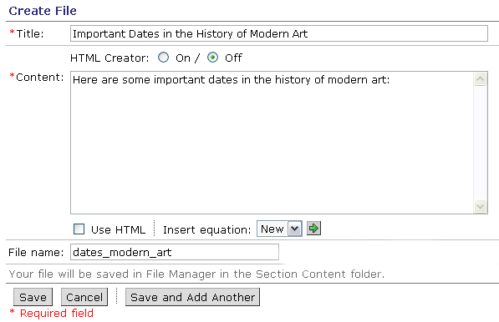
- If you want to use the HTML Creator, select On.
- Complete the Title, Content, and File Name text boxes.
- Click Save.
- To use an existing file as a content file:
- From the Content File tool screen, click Browse for File. The File Browser appears allowing you to select a file in File Manager or from your local computer.
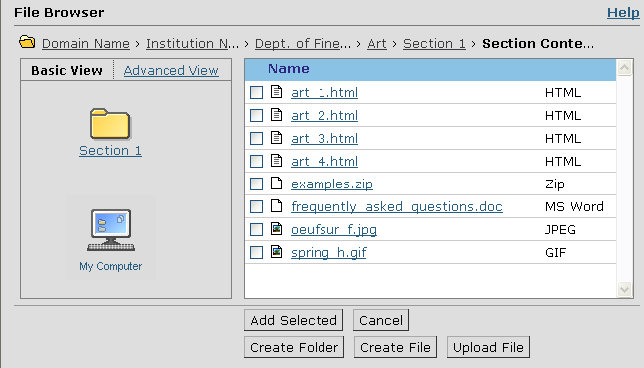

- Do one of the following:
- If you want to select a file from File Manager, locate the file, select it, and then click Add Selected. The files are added to the Content File inventory.
Note: You may select multiple files.
- If you want to select a file from your local computer, click My Computer. Your computer’s file browser appears. Select the file or files that you want to add. The files are uploaded and added to the Content File inventory.
After you have added a content file to the inventory, you can link it to the Home Page or an organizer page.
- To add a content file to the Home Page:
- From the Content File screen, next to each content file you want to create a link to, select the check box.
- From the Add selected component to drop-down list, select the Home Page and click the Go icon. A confirmation message appears.
- Click OK. The Content Files screen appears.

Hands-On Practice: Content Files
- Create a content file. Use the HTML Creator to generate it.
- Add a link to the content file to the Home Page.
- Go to the Home Page and view the content file that you added.

Creating Organizer Pages
Organizer pages are empty pages to which you can add components. The Home Page is an example of an organizer page.
- To add an organizer page:
- From either Basic View or Power View, under Add to Home Page, click Organizer Page. The Organizer Page section expands.
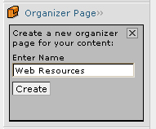
- Complete the Name text box.
- Click Create. The organizer page is added.
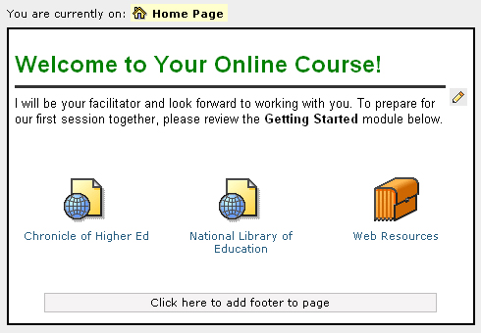

Organizer Page Options Menu
You can click an organizer page to access its options menu. From the options menu, you can go to the organizer page, edit its settings, remove the organizer, move the organizer, or move the organizer to another organizer page.
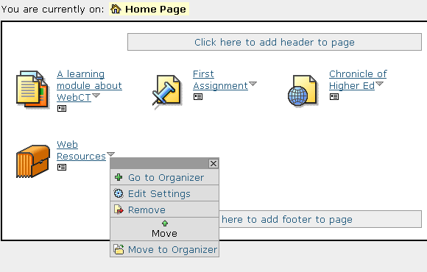
- To go to an organizer, click the organizer and from the menu, click Go to Organizer. The organizer page appears.
- To edit settings, click the organizer and from the menu, click Edit Settings. You can edit the name of the organizer and add or edit its description.
- To remove an organizer page, click it and from the menu, select Remove. The organizer page is deleted.
- To move an organizer page, click it and from the menu, click the left or right Move arrow to select the direction of the move.
- To move an organizer page to another organizer page:
- Click the organizer page and from the menu, click Move to organizer page. The Select an Organizer Page window appears, listing all the organizer pages.
- Select the organizer page. The organizer page is moved to the selected organizer page and that organizer page appears. You can return to the Home Page by clicking the breadcrumbs.

Organizer Page Descriptions
You can add descriptive information about an organizer page.
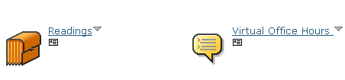
Add/Edit description icon
- To add a description:
- Click the organizer page’s Add/Edit description icon. A text box appears.
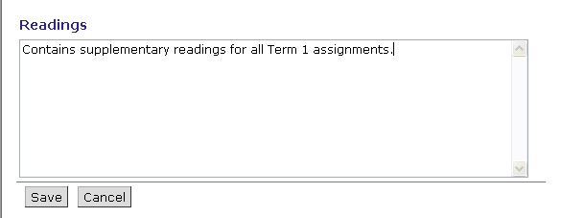
- Enter text and click Save. The description is added.
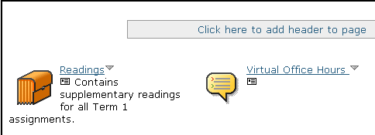

Hands-On Practice: Organizer Pages
- Create an organizer page named Getting Started.
- Add a description about the organizer page.

Building Learning Modules
A learning module is a collection of components, arranged sequentially and organized by a Table of Contents. It includes built-in navigation links and optional interactive tools. Because of their linear nature, learning modules are sometimes compared to a book or a chapter in a book, depending on how much information is presented. It’s important, however, to remember that learning modules can bring together many different types of components and present them as a cohesive unit.
You can include the following types of components in a learning module:
- assessments, including quizzes, surveys, and self-tests
- assignments
- chat and whiteboard rooms
- content files (typically HTML pages, but other file types, such as Word docs, .pdf files, .jpg or .gif images, can also be added as content files to the Table of Contents.)
- discussion categories and topics
- media library collections
- URLs
Note for  CE Users | WebCT Vista learning modules are functionally comparable to content modules in WebCT Campus Edition.

The Learning Module Interface
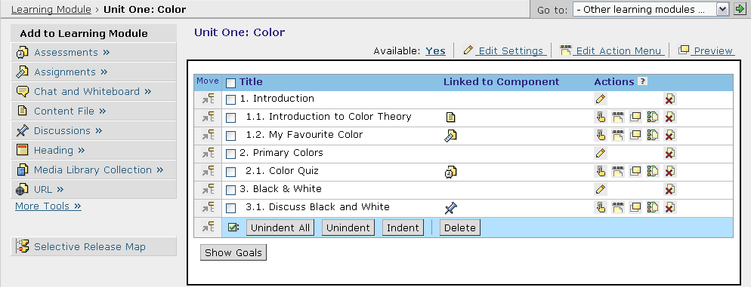
The learning module interface is divided into two sections:
- Add to Learning Module, which is similar to the Add to Home Page menu that you see in the Basic and Power view and which allows you to add components and headings.
- The learning module content frame, which displays the current content of the learning module and the order in which the content will appear to students and instructors. This frame contains three columns:
- Title is the title of the component or heading.
- Linked to Component provides a link to the component itself.
- Actions contains icons which allow you to perform actions on a component or heading.
 | Terminology Refresher
Tool |  | A tool is something that is used to design and organize content. For example, the Discussions tool allows you to create discussion topics and categories; the Assignments tool allows you to create quizzes and surveys. In general, tools can only be added to the Course Toolbar.
Component |  | A component is the individual item (e.g. a discussion topic, a quiz) that you create with a tool. You can add individual components to learning modules.

Naming the Learning Module and Selecting Settings
- To create the name and select settings:
- From Basic or Power View, under Add to Home Page, select Learning Module and click Create Learning Module. The Create Learning Module screen appears.
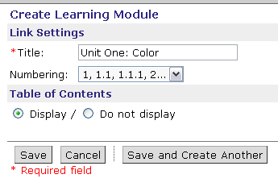
- In the Title text box, enter a name for the learning module.
- From the Numbering drop-down list, select a numbering style for the table of contents of the learning module.
- Under Table of Contents, select Display.
- Click Save. The Learning Module screen appears and the learning module is added.

Adding Components
- To add components:
- From the Home Page, click the learning module and from the component options menu, select Edit. The empty learning module appears.
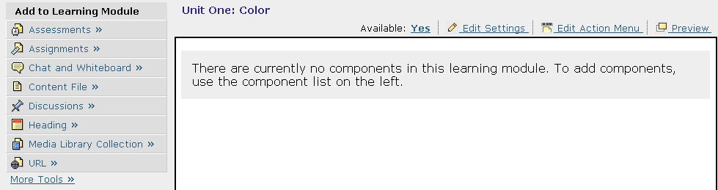

- Use Add to Learning Module to add existing components or create new ones. Add to Learning Module works like the Add to Home Page feature, except that as you add the items they are listed in sequence and assigned a number. You can add components in the desired order or re-order them later.
Tip | You can add multiple components of the same type simultaneously. In the Inventory box, hold the Ctrl key (Windows users) or the Command key (Mac users) while selecting the components.
- If you want to add a text heading to introduce or organize components, under Add to Learning Module, click Heading and enter a title for the heading. The heading is added to the learning module.
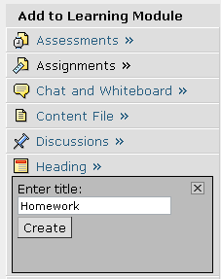 | 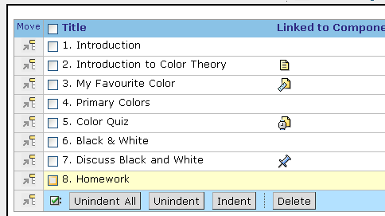

Ordering Components
- To move a heading or component, select its checkbox.
- To move it anywhere except the end of the learning module, locate the item above which you want to insert the heading or component and click its Insert Above icon.
- To move it to the end of the learning module, click the Insert Selected Item at Bottom of List icon.
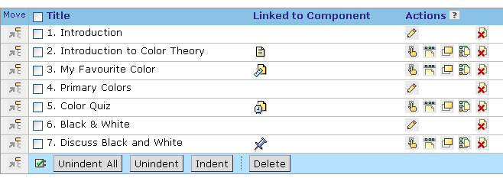
Insert Above
Insert Selected Item at Bottom

Adjusting Heading Levels
- To adjust heading levels:
When you add an item it is added as a top-level heading. You can indent items to create a hierarchy of content.
- Select the items for which you want to adjust the heading level:
Note: To adjust all headings, in the table heading row, select the check box.
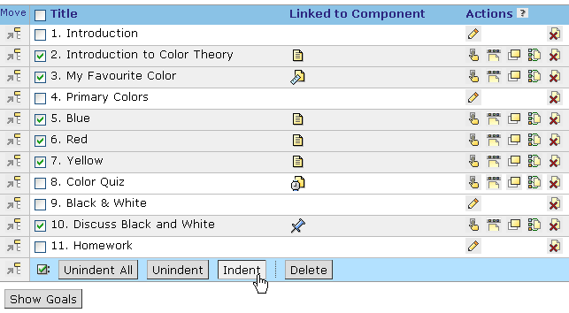
- Click the Indent icon. The selected headings are indented and renumbered accordingly.
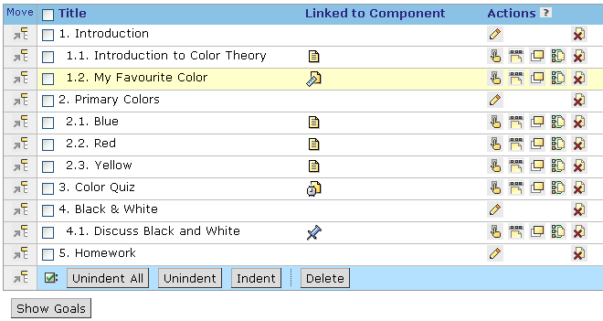
- To make a learning module unavailable, next to Availability, click Yes. The availability is changed to NO and students cannot access it.
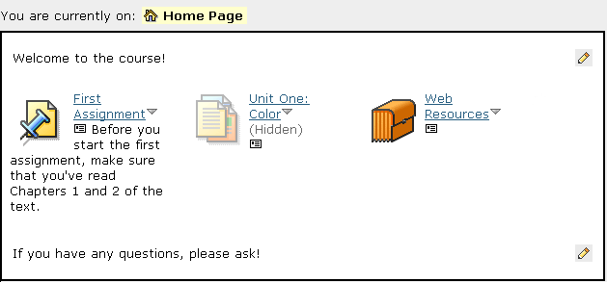
Unavailable components appear to designers and instructors but the component is labeled hidden and its icon is greyed out.

Hands-On Practice: Building Learning Modules
- Create a learning module and add several components.
- Organize and indent the components under headings.

Customizing the Action Menu
In addition to the components added to the table of contents, further components and tools can be added to the Action Menu. The Action Menu also contains navigational icons. Action Menus can be added to the entire learning module or to the individual components and pages of the learning module.
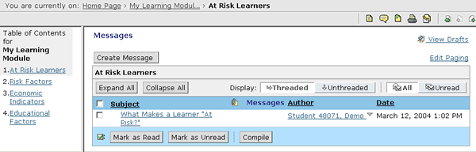
Action Menu

Learning Module versus Component Action Menus
You can add tools and components to the Action Menu for the entire learning module or for particular components.

Learning Module Action Menus
You’ll often want to have Action Menu items that are available throughout the learning module. Unless you turn them off at the component level, items added to the learning module Action Menu will be available on each component page.
Example: A discussion topic called Unit Questions could be added to the learning module Action Menu. This topic would be readily available to students from the Action Menu as they progress through each page and component of the learning module.
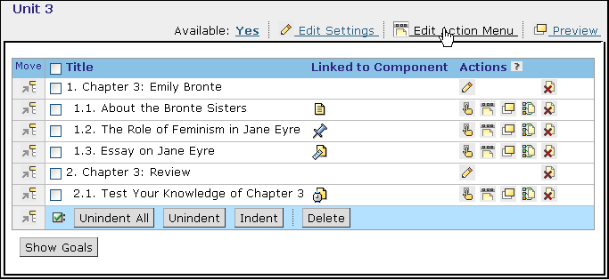
Edit Learning Module Action Menu
Edit Component Action Menu

Component Action Menus
At times, however, you may want to add an item to the Action Menu just for a particular component in the Table of Contents. Items added to the component Action Menu only appear on the Action Menu for that particular component.
You can also override the learning module-wide Action Menu settings for an individual component by editing its component Action Menu.
Example: A self test could be added to the Action Menu of a content file within a learning module. Students could only access the self test from that particular page.

Editing Learning Module and Component Action Menus
You can determine whether the Action Menu will be available to students in the learning module and which components will appear on each page of the learning module. As well, you can add or remove items specific to component Action Menus.
Note: The navigation controls that appear in the Action Menu cannot be turned off.

Creating Links to Components
Components are added to learning module and component Action Menus the same way.
- To add a component to the Action Menu:
- From the Learning Module screen, click either the Edit Action Menu link for the learning module or the Edit Component Action Menu icon for a particular component. The Action Menu Settings screen appears.
- Locate the component type you want to add and click its Create Link to Component icon. The Create Link to Component screen appears.
Create Link to Component
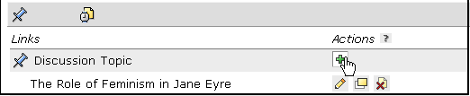
- Locate and select the component you want to add and click Add Selected. The Action Menu Settings screen appears and the component is added.
- To remove a component from the Action Menu, from the Action Menu Settings Screen, locate the component you want to remove and click its Remove icon.
Remove
Note: If you are editing the component Action Menu, the item will be removed from the Action Menu for that particular component only; the item will remain in the learning-module wide Action Menu.

Adding Action Menu Tools
The following tools are only available from the Action Menu.
- Bookmarks: Allows students to create links to important pages within learning modules.
- Compile: Allows students to compile and download the content of the learning module.
- Notes: Allows students to enter notes pertaining to content files within the learning module.
Unlike components, Action Menu tools require no set-up or configuration; you simply turn them on or off.
- To add Action Menu tools:
- From the Action Menu screen, under Action Menu Tools, select whether the tool is On or Off.  - Click Done. The Learning Module screen appears. | 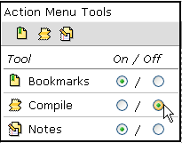

Hands-On Practice: Editing Action Menus
- Add several components to the learning module Action Menu. Turn off Notes and Bookmarks, but make sure the Compile tool is on.
- For one of the components in the learning module, add a new component to the Action Menu, and turn off the Compile tool.

Creating Goals and Resources
Unlike other components in WebCT Vista, goals and resources must be created from within a learning module and are only accessible to students from the Action Menu.
Creating Goals
Use goals to help students understand the learning objectives they are expected to achieve within a particular learning module or component. You can create goals for the entire learning module and for particular components within the learning module.
- To create goals:
- From the Learning Module screen, click either the Edit Action Menu link for the learning module or the Edit Component Action Menu icon for a particular component. The Edit Action Menu Settings screen appears.
- Click the Create Links to Component icon for Goals. The Goals for Learning Module screen appears.
- In the text box, enter the goals for the learning module and click Save. The Action Menu Settings screen appears and the goals are added.  - Click Done. | 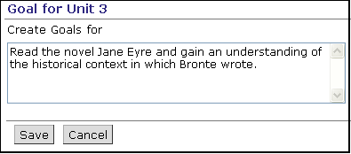

Reviewing and Editing Goals
From the main screen of a learning module, you can view and edit learning module and component goals. It’s useful to review these goals to ensure that the content and components in the module support the desired learning outcomes.
- To view goals for the learning module and all components, from the Learning Module screen, click Show Goals.
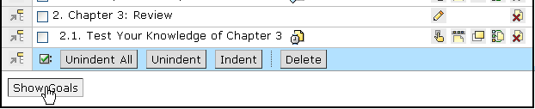
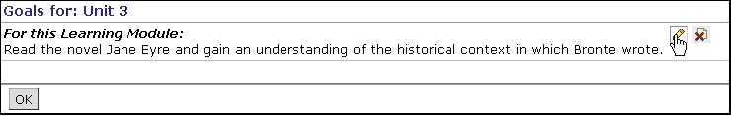

Creating Resources
With the References tool, you can create items called resources. Resource types include articles, books, and URLs. Resources can be added to the Action Menu of a learning module or to its component Action Menus.
- To create and add resources to the Action Menu:
- From the Learning Module screen, click either the Edit Action Menu link for the Learning Module or the Edit Component Action Menu icon for a particular component. The Edit Action Menu Settings screen appears.
- Click the Create Links to Components icon for References. The Create Links to Resources screen appears.
- Click Create Resource. The screen updates.
- From the Create resource drop-down list, select the type of resource you want to create. The Create Resource screen appears.
- Enter the resource Title and if desired, complete the optional text boxes. Click Save.
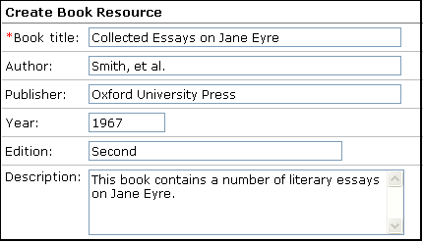
- Next to the resources you want to add, select the check box and click Add Selected.
- Click Done. The Learning Module screen appears.

Hands-On Practice: Adding Goals and Resources
- Edit the Learning Module Action Menu - add a module-wide goal.
- Edit the Component Action Menu - add a goal, and book and URL resources.
- View the goals from the main learning module screen. Edit one of the goals.

Creating Media Library Collections
With the Media Library tool, you can create a database of media files, including text, image, video, and audio files. Each media file added to the Media Library is called an entry. Related entries are grouped into collections.
Example: For a music appreciation class, you could create collections titled The Baroque Period, The Classical Period, and The Romantic Period. For each collection, you could create entries that include audio files which provide examples of the music of the period, image files that contain pictures of important composers, and text entries that define important terms.
You can also create links to entries from content files. Instances of the entry title within a content file are hyperlinked; clicking the link opens the entry in a pop-up window.
Example: An entry titled Paris, which contains an image file of the city of Paris as seen from the Eiffel Tower, can be automatically linked to each occurrence of the word Paris in content files.
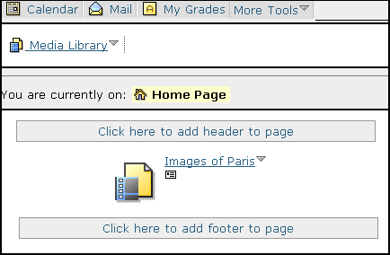
Collections can be added to organizer pages and learning modules.
The Media Library tool can be added to the Course Toolbar.

- Terms to Know
Entry | A media or text file that has been added to the Media Library tool. An entry might be an image, a movie, or a definition. A single entry can be added to multiple collections.
Collection | A grouping of related entries. Collections can be added to learning modules and to organizer pages.
Glossary | A default collection that is automatically added. The Glossary collection is often used to create an alphabetical list of terms that pertain to course content.

Creating Collections
Collections are used to group related entries. It’s easier to create collections first, then create individual entries and add the entries to the appropriate collection.
- To create a collection:  - Navigate to the Content Inventory tab and click Media Library. The Media Library Collections screen appears.  - Click Create Collection. The Create Collection screen appears.  - In the text boxes, enter the Title, Description, and Keywords for your collection.  - Click Save. The Media Library Collections screen appears and the collection is added. | 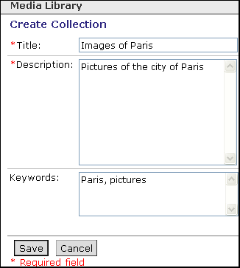  Keywords must be separated by commas.

Creating Entries
Once you have created your collections, you can create and add entries to them. When you create an entry, you can also create links to instances of the entry title in content files.
- To create an entry:
- From the Media Library Collections screen, click the View All Entries button. The Media Library Entries screen appears.
- Click Create Entry. The Create Entry screen appears.
- In the text boxes, enter the Title, Description and Keywords. Note: Links are identified by the entry title.
- If you want to include a multimedia file in the entry, click Browse. The File Browser pop-up window appears. Locate and select the file you want to use.
- Under Include in collections, select the collections in which you want to include the entry.
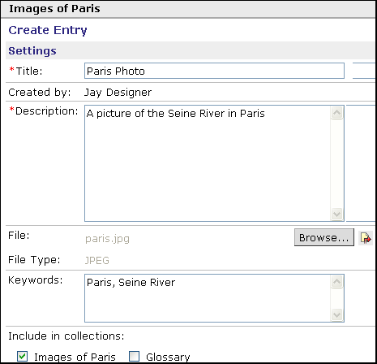
- If you want to automatically link the entry to instances of the entry title in content files, expand the More Options section and select whether you want to automatically link the first instance or all instances of the entry title.
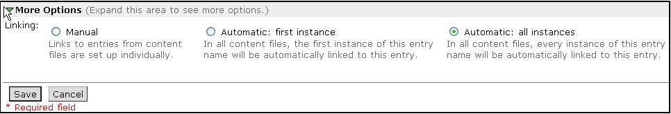
- Click Save. The Media Library Entries screen appears and the entry is added.
- If you chose to create automatic links to the entry, click Update Links. Links to the entry are updated. Note: This process may take several minutes.
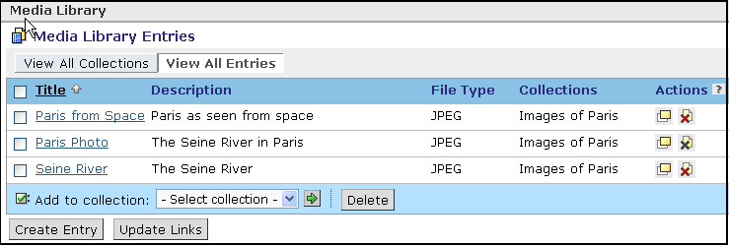
If you chose to create automatic links to the entry, you must click Update Links.
What’s the difference?  Manual  versus  Automatic  Linking | Automatic Linking: When you create an entry, you have the option to automatically create links to the entry from all instances of the entry title within any content file. For example, if Paris was the entry title, the word Paris would be linked to the entry from all content files within the section or template.  Manual Linking: The default option is to manually create links to the entry. Manual linking allows you to select which instances of the term should be linked. For example, you might decide to link to the Paris entry only the first time the word is used in a content file.

Manually Linking Entries to Content Files
Manual linking is the default setting for all Media Library entries. Unless you specify that you want links to be created automatically, you will have to create any links manually.
- To manually link entries:
- Navigate to the Content Inventory tab and click Content File. The Content File screen appears.
- Locate the content file in which you want to create manual links and, under Actions, click its Manage Media Library Links icon. The Manage Media Library Links screen appears and a list of linked and unlinked terms is displayed.
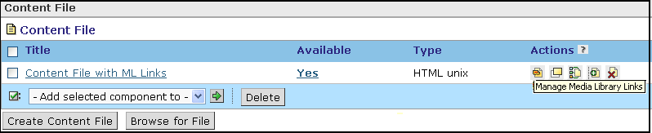
Manage Media Library Links icon.
- If you want to link or unlink a term, under Actions, click its Edit icon. Each instance of the entry on the selected content file is displayed.
- Do one of the following:
- To link or unlink a single instance of an entry, under Linked, click YES or NO. The link is toggled on or off.
- To link or unlink several instances of an entry, select the check box next to the entries and click Link or Unlink. The selected links are toggled on or off.
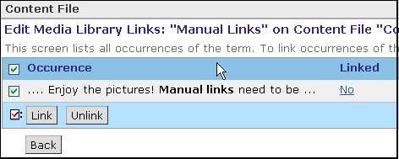
To link or unlink a SINGLE instance of an entry, click Yes or No to toggle the status.
To link or unlink ALL instances of an entry, select the check box in the table heading row and click Link or Unlink.
- Click Back. The Content File screen appears.
- If you want to test the links, locate the content file and, under Actions, click its Preview icon. The content file appears in a pop-up window.

Hands-On Practice: Working with the Media Library Tool
- Create a Media Library collection and create and add several entries. If you’ve uploaded content files ensure that your entries include terms contained in the files.
- Practice linking entries manually and automatically.

