
Customizing Content Delivery
with Selective Release

Copyright © 2004 by WebCT
All Rights Reserved

The content of this manual may not be reproduced or distributed without the express written consent of WebCT. Users acknowledge that the manual, and all copyright and other intellectual and proprietary rights therein, are and at all times shall remain the valuable property of WebCT and its licensors, or their respective successors or assignees. Users agree to respect and not to alter, remove or conceal any copyright, trademark, trade name or other proprietary marking that may appear in the manual.

LR LS 022204 30
Table of Contents

About this Workshop 1
Topics 1
Learning Outcomes 1
About Selective Release 3
Setting Availability and Release Criteria 4
Accessing a Tool’s Component List 4
Via the Build Tab 4
Via the Teach Tab 5
Setting Availability from a Component List 6
Setting Release Criteria from the Component List 7
Combining Release Criteria 9
Hands-on Practice: Setting Availability and Release Criteria 10
Using the Selective Release Map 11
The Organizer Pages Tab 11
Setting Component Availability 12
Setting Link Visibility 13
Hands-on Practice: Setting Release Criteria 13
How Availability, Release Criteria, and Link Visibility Work Together 14
Using The Members Tab 15
Hands-on Practice: Using the Member Map 15
Optional Discussion: Leveraging Selective Release 16

About this Workshop
In a conventional classroom, you plan the delivery of your material according to a schedule and in portions that you deem appropriate. Often, new information is not presented until students have demonstrated satisfactory comprehension of content upon which it will build. Your criteria for such a schedule may vary according to student performance, time, special needs, or a combination of all three.
In WebCT Vista, you can duplicate this “selective release” of information by:
- making components unavailable.
- hiding links to components.
- setting release criteria that specifies when, to whom, and/or under which condition the information is presented.
In this module, we’ll focus on the key concepts and benefits of Selective Release and gain hands-on knowledge of the Selective Release maps.

Topics
- Setting Availability and Release Criteria on Individual Components
- Using the Selective Release Map
- Using the Members Map

 | Learning Outcomes
After completing this module, you will be able to:
- control the availability of components to section members.
- apply selective release settings to achieve specific instructional outcomes.
- determine the current status of a section member using the Members tab.

About Selective Release
Both section designers and section instructors can control the delivery of course components and contents. They can:
- make components available and unavailable.
- set criteria to release components (e.g. an assessment or assignment) to students based on date, member, group membership, or Grade Book column.
- make links visible or invisible.
- preview how items will be released to students through the Member Map.

Note | Because templates do not contain students, template designers (designers enrolled in a course, group, institution, or domain learning contexts) cannot set release criteria based on User Id and cannot access the Member Map.

- Terms to Know
Component Availability | Component availability determines whether students can see the component. When a component is unavailable, students cannot see any instances of the component.
Link Visibility | In a course, there may be multiple links to the same component (e.g., via, the Home Page, an organizer page, or a learning module). Link visibility controls whether a specific link to a component is visible to students.
Release Criteria | Release criteria are specific criteria that must be satisfied before a component is made available. Release criteria can be based on date, member, group, or Grade Book data. If desired, you can combine criteria to create customized delivery options for each student.

Setting Availability and Release Criteria
Designers and instructors can set the availability and release criteria for all components:
- from the tool’s component list, via the Build tab for designers, or via the Teach tab for instructors.
- from the Selective Release Map, which lists all the components in the course.

Accessing a Tool’s Component List
The main screen for each tool contains the tool’s component list, which is a list of all the components that have been created using that tool. The components appear in the list regardless of whether they have been linked to the Home Page or an organizer page.

Via the Build Tab
- To access a tool’s component list, from the Content Inventory tab, from the drop-down menu, select the desired tool and click the Go icon.
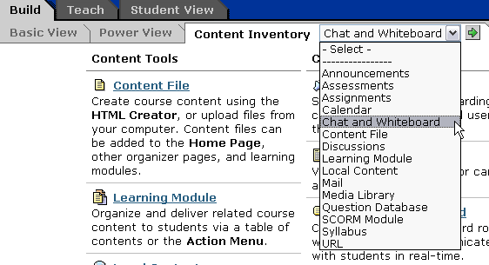
The main screen for the tool appears, listing all the tool’s components.
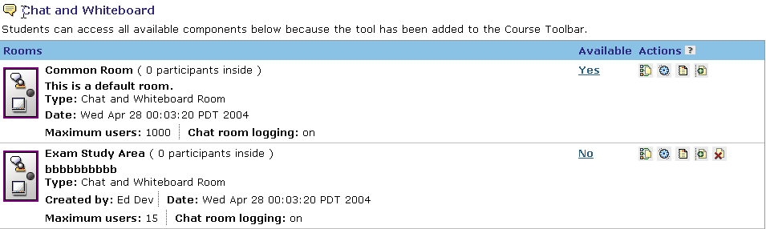

Via the Teach Tab
- To access a tool’s component list, from the Tool View sub-tab, from the drop-down menu, select the desired tool and click the Go icon.
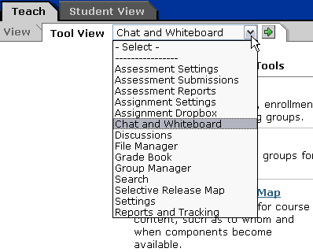
The main screen for the tool appears, listing all the tool’s components.

Setting Availability from a Component List
Component availability overrides all other release criteria. If a component is unavailable, students cannot access it regardless of other release criteria that may have been set.
- To change the availability of a component, locate the component and click its Yes/No toggle in the Available column.
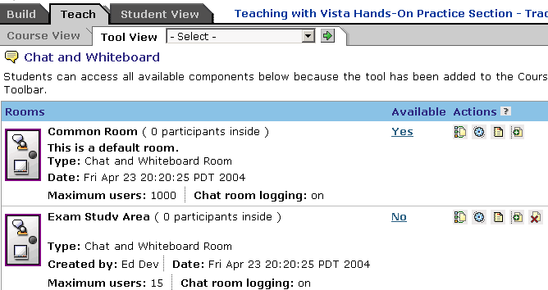
Yes/No toggle
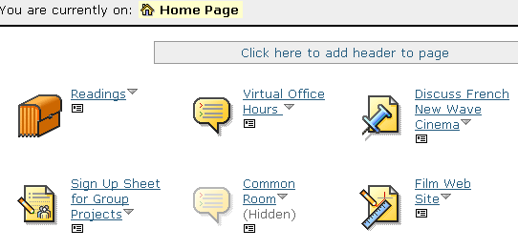
Unavailable components are labeled hidden and the icons are greyed out when viewed from the Teach or Build tab. Students cannot view unavailable components.

Setting Release Criteria from the Component List
Both Designers and Section Instructors can set release criteria on many components.
You can use release criteria to make components available to students only if specific criteria are satisfied. Release criteria can be based on:
- date – you select a date or date range during which the component is available.
Example: Learning modules can be initially hidden, and then revealed based on a pre-determined schedule. Structuring students’ learning by timing the release of content according to need will help keep them focused on the task at hand.
- member – you select specific students or auditors whom you want to allow or disallow access to. (Reminder: Member criteria are not available to template designers.)
Example: Remedial content can be selectively released to specific students.
- group – you select specific learning groups that you want to allow or disallow access to.
Example: You can create a learning group that consists of students who need more time to complete quizzes because of learning disabilities, low vision, or mobility problems. You can release a specially designed quiz to this learning group.
- Grade Book data – you select a Grade Book column and criteria which must be satisfied with respect to that column, in order for members to access the component.
Example: Enrichment or bonus materials can be released to students who scored particularly well on a quiz.
- To select release criteria from the component list:
- Locate the component, and under Actions, click its Set Release Criteria icon.
Set Release Criteria icon
- From the Set Release Criteria screen, click the criteria option: Date, Member, Group, or Grade Book.
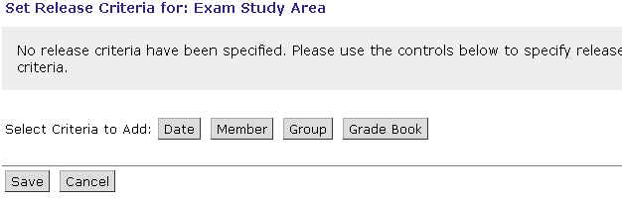
- From the pop-up criteria window, enter the specific criteria.
- For Date criteria, enter the starting and ending availability dates. You can also release the component immediately, and make it available for an unlimited time.
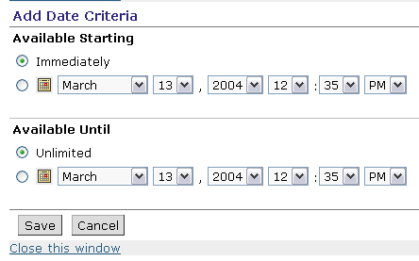
- For Member or Group criteria:
- to allow access, select Equals and choose the members or groups to which you want to release the component.
- to deny access, select Does not equal and choose the members or groups to which you want to deny access to the component,
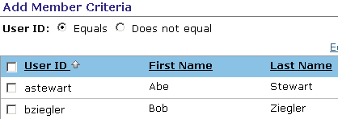
- For Grade Book, select the Grade Book column title from the criteria column. Select the condition and enter the value.
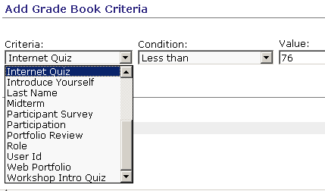
- Click Save.

Combining Release Criteria
You can also use Boolean operators (AND, OR) to combine release criteria. For example, you can set release criteria to make:
- a specific learning module available only to students who have passed two quizzes.
- an assignment only available to a specific learning group between specified dates.
You can create more complex expressions by grouping criteria and combining the groups with Boolean operators. For example, you can set release criteria to make:
- enrichment material available to students who have scored over 90% on at least one of three quizzes and who have obtained a grade of 90% or higher on at least one of two assignments.

Hands-on Practice: Setting Availability and Release Criteria
- From the Teach > Tool View sub-tab, select Discussions.
- Make the Cyber Café unavailable.
- Release the Case Study Topic only to students in the Communication 4 group.
- From the Build > Content Inventory sub-tab, select Assignments.
- Be sure the Web Portfolio is available.
- Release the Web Portfolio Critique to students who’ve received a grade on the Web Portfolio assignment.

Using the Selective Release Map
The Selective Release Map allows you to quickly set component availability, link visibility, and release criteria for all the components on the Home Page or organizer pages.
- To locate the Selective Release Map:
- From the Build tab, from the Basic View or Power View sub-tab, scroll down to the bottom of the screen and click Selective Release Map.

- From the Teach tab, do one of the following:
  - From the Course View sub-tab, click Selective Release Map in the Course Management Tools list.
  - From the Tool View sub-tab, do one of the following:
    - Under Course Management Tools, click Selective Release Map.
    - From the Tool View drop-down list, select Selective Release Map and click the Go icon.
The Selective Release Map is divided into two tabs:
- the Organizer Pages tab.
- the Members Tab (available only section instructors and designers).

The Organizer Pages Tab
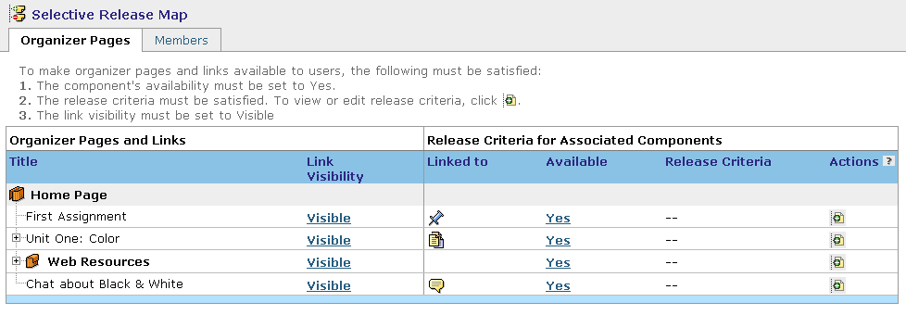
The Organizer Pages tab displays:
- all component links on the Home Page.
- all organizer pages and learning modules.
- To view the status of components within an organizer or learning module, click its Expand icon.

Setting Component Availability
- To make a component unavailable, under Available, click Yes. This results in:
- the Availability changing to No.
- the Link Visibility of any link to the component changing to No.
- on the Build tab in Basic View and on the Teach tab in Course View, the icon is grayed out and labeled Hidden.
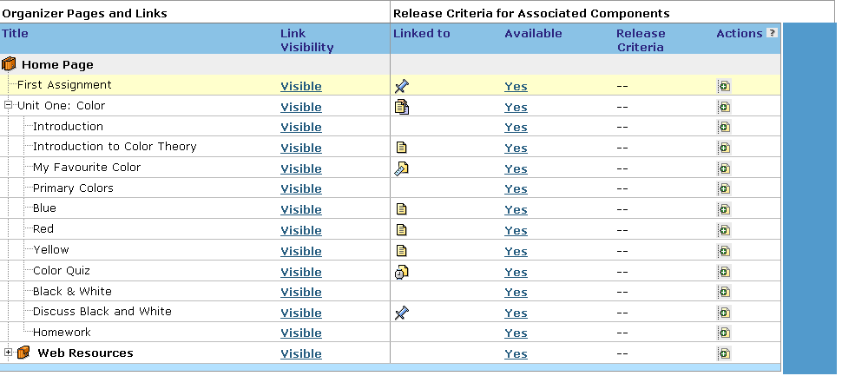
- To make a component available, under Available, click No. This results in:
- the Availability changing to Yes.
- the Link Visibility of any link to the component changing to Yes.
- on the Build tab in Basic View and on the Teach tab in Course View, the icon returns to unhidden state and is no longer grayed out.

Setting Link Visibility
Link visibility is set by toggling the status. If the link to the component is hidden, students may still be able to access the component if it has been linked on other organizer pages or learning modules, or if the tool is available from the Course Toolbar.
- To make a link to a component hidden, under Link Visibility, click Visible.
- To make a link to a component visible, under Link Visibility, click Hidden.
Note: If the component is unavailable, you cannot toggle the link visibility.

Hands-on Practice: Setting Release Criteria
- Release the Case Study URL only to students in the Case Study Group 1.
- Release the Proctored Exam Info on the Virtual Office organizer page only to students who are distance learners.
Hint: Use the Grade Book column.
- From Student View, sign up for the Case Study Group 1. Notice how the Case Study URL is released once you’ve signed up for the group.

How Availability, Release Criteria, and Link Visibility Work Together
For a student to access a component:
- The component must be available.
- All Selective Release criteria must be satisfied.
- The link to the component must be visible
OR
the tool which contains the component must be added to the Course Toolbar.

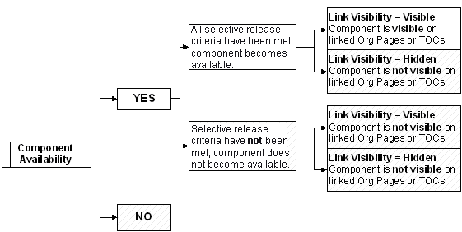

Using The Members Tab
The Members tab lists all the members in the section in alphabetical order by User ID. Members include students, auditors, and the WebCT Demo Student. You can select individual members and view the components that are currently available to them.
The Members tab is read-only; to set availability go to the Organizer Page tab.
Reminder: Template designers do not have access to the Members tab.
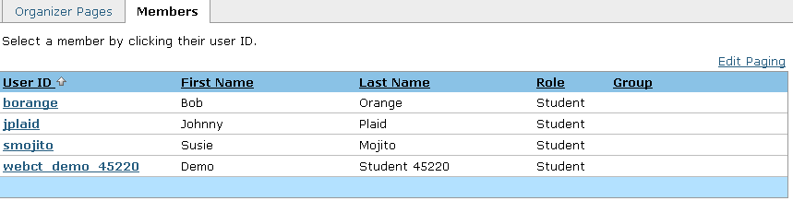
- To view a student’s status, click the student’s linked User ID. The components and their availability are shown.
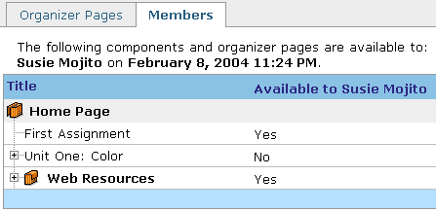
- To return to the member list, click the Members tab.

Hands-on Practice: Using the Member Map
- Use the Member Map to see which components are available for Abe and Kristie.

Optional Discussion: Leveraging Selective Release
Review the scenario below. Explain how you could use Selective Release to meet the three bulleted objectives. Be specific with your suggestions, by using timing, User ID and/or performance as criteria.
You are the instructor for an environmental science course that contains a WebCT Vista online component. Your institution offers both a 2-year degree and a 4-year degree. Your class is a mixture of candidates in both programs, and has two graduate students as well. Additionally, three of your students have special needs requirements.
You are required to deliver content that meets minimal objectives for the 2-year students and provides advanced topics and challenges for the 4-year and graduate students. All students share a common lecture and lab.
How could you use Selective Release to do the following?
- Provide a learning module each week to all class members and an additonal learning module containing advanced material and assignments to the 4-year and graduate students.
- Deliver weekly timed quizzes to the class but provide additional time for each quiz to those students with special needs. One of these is a graduate student and the other two are in the undergraduate programs.
- Provide remedial information to students who perform at a lower level on each quiz and an opportunity to take a makeup quiz.

